Facebook Social Media Toolkit Items
NFEF Summer Grant Programs Now Open for Applications
Summer CDM, CFPP Credentialing Exam Grant
To learn more about these programs and to apply online, visit: https://bit.ly/3gHDMQC.
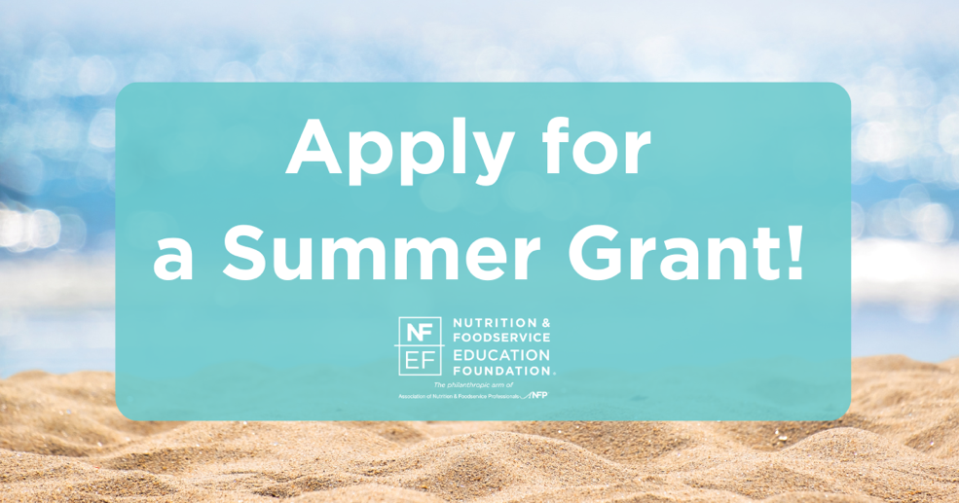

NFEF Fall Grant Programs Now Open for Applications
Fall CDM, CFPP Credentialing Exam Grant
Performance Foodservice CDM, CFPP Credentialing Exam Preparation Grant
Member Dues and Certification Fees Grant
Disaster Relief Grant
To learn more about these programs and to apply online, visit: https://bit.ly/3gHDMQC.
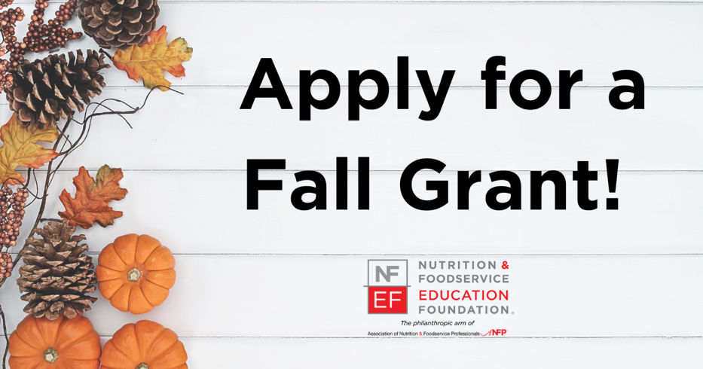
NFEF Winter Grant Programs Now Open for Applications
Winter CDM, CFPP Credentialing Exam Grant
Lyons Health Labs Student Grant
To learn more about these programs and to apply online, visit: https://bit.ly/3gHDMQC.
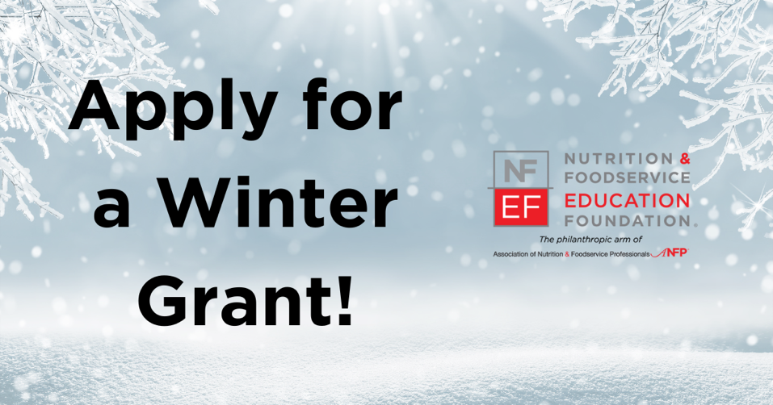
NFEF Spring Grant Programs Now Open for Applications
Spring CDM, CFPP Credentialing Exam Grant
DM&A CDM, CFPP Credential Grant
To learn more about these programs and to apply online, visit: https://bit.ly/3gHDMQC.
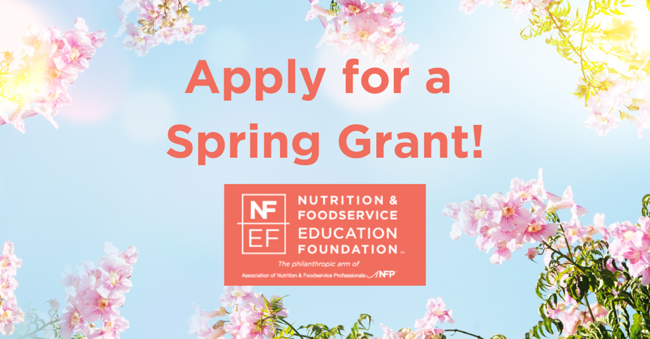
NFEF Awards Now Open for Applications
Apply today NFEF Foodservice Education Innovator of the Year Award and Foodservice Department of the Year Awards!
For award details and applications, visit: https://bit.ly/3or7AFd.
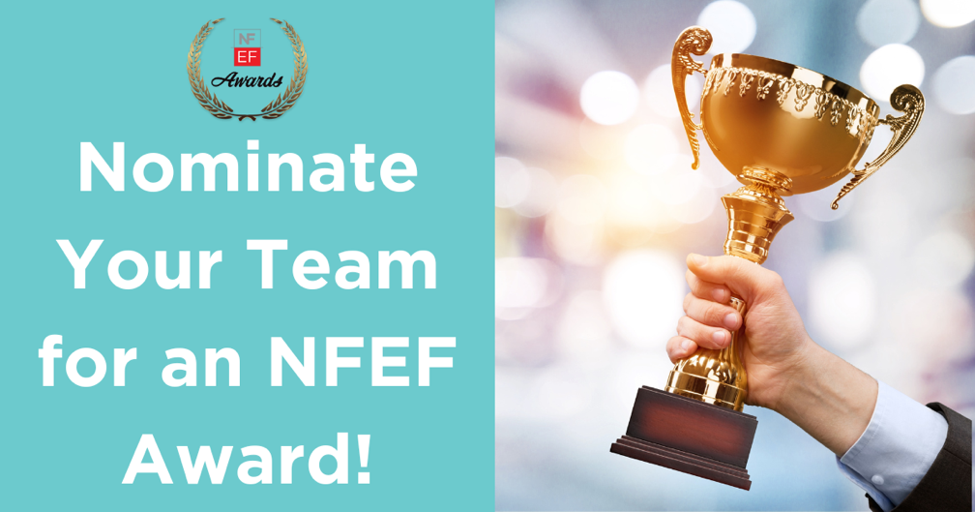
UND Scholarship Opportunities
NFEF is Proud to Support UND Scholarships for nutrition and foodservice professionals and students!
To learn more about these scholarships and to apply today, visit https://bit.ly/3r6AQRz.
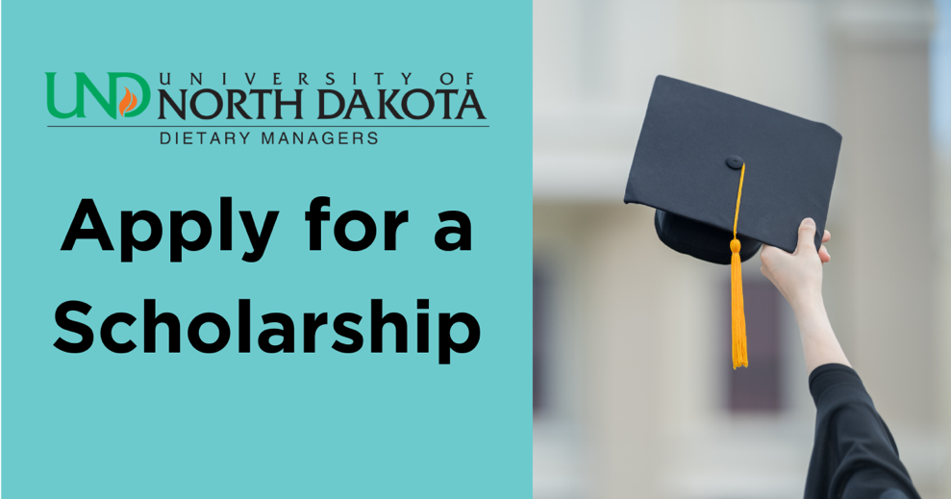
Become a Chapter Champion
Partner with NFEF today and become a Chapter Champion with a donation of $400 or more. All monetary donations received are used during ANFP’s dues season to assist credential holders experiencing financial difficulties that prevent them from paying their annual membership and certification dues.
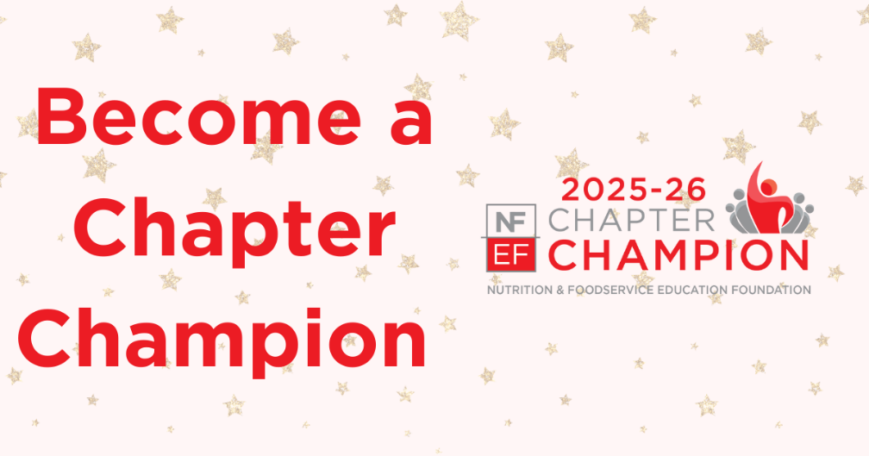

Text-to-Give!
Donors can now support NFEF on mobile devices, safely and securely by texting NFEF to 855.800.4975. All donations help support NFEF grants, research, and education!
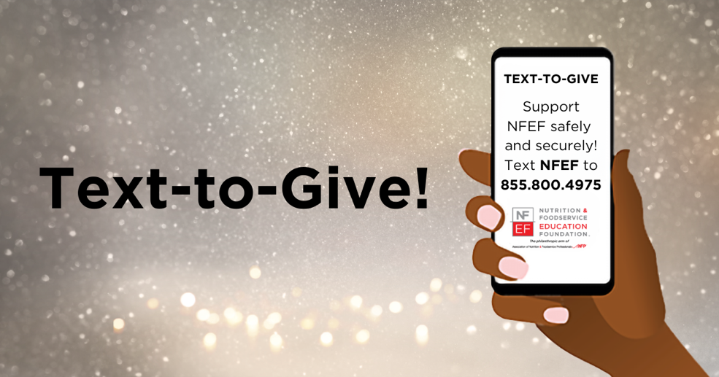
NFEF Impact Partner
Become an NFEF Impact Partner when you sign up for recurring donations. Donors can cancel or pause their recurring donations at any time and there is no minimum donation requirement.
Learn more about this partnership at https://bit.ly/46iuzI0.
