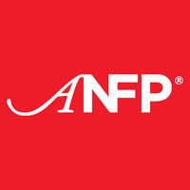
Wyoming
August 2022
Inside this Issue:
Chapter Leaders’ Updates
August Birthdays
Shelly Gray Jeanette Lee
Arika Long Jacqueline Prickett
Cara Siebigteroth Troy Strand
Richard Young Sandra Zarate
Jemma Merriel Carol Rice
Save the Dates
Fall Regional Meeting
Spokane WY Sept. 15-16, 2022
WY ANFP Fall Conference
Deadwood, SD Sept. 22-23, 2022
ACE- Annual Conference and Expo
New Orleans, LA June 25-28, 2023
We’re in this together! | August Membership Milestones  Congratulations Carol Cartwrights for 1 year as a member of ANFP.  Congratulations Alejandra Sanchez for 1 year as a member of ANFP.  Congratulations Von Roseberry for 25 years as a CDM CFPP.  Congratulations David Sanders for 1 year as a CDM CFPP.  Congratulations Timothy Freese for 5 years as a CDM CFPP.

Chapter Leaders’ Updates

Chapter President Update:
Greetings WY ANFP Family,
I hope everyone has a had a fantastic summer. We are busy making plans for our fall conference which we are holding in Deadwood, SD in partnership with the South Dakota ANFP Chapter. We will have the agenda out to you no later than the 15th of August. Currently we are working on a vendor show, Omar Humes will be presenting and much more.
If there is a particular topic you would like to see presented, please let me know and I will try go get it put on the agenda. We are also still needing a volunteer for our President – Elect position. If you are interested, please do not hesitate to contact any of the chapter leaders. Our members are our greatest asset and we want make sure we are supporting you in every possible way to set you up for success.
Have a great rest of your summer and I look forward to seeing you all in Deadwood!

Thanks, Felicia Smith WYANFP President

Chapter Leaders’ Updates

Chapter treasurer Update:
August Already . . . Happiness Month is here
Where has the summer gone. We have had incredible heat with the absence of moisture. We are fortunate this year, it is much better with less smoke in the air (so far.) Looking forward to our Wyoming ANFP Fall Conference partnering with South Dakota in Deadwood! Hope to see you there!
Living in Douglas, Wyoming, we are getting ready for the Wyoming State Fair which is held right here in our small town! Toni went with my Grandson and I to the Central Wyoming Fair in Casper. If we could stop and look at the world through the (almost) 4-year-old eyes, we would see the amazement and joy of even the smallest things. This ties right in with the “Family Fun Month” mentioned in The Spruce.
Take the time and have fun, relax, rejuvenate, and whatever helps you fill “your bucket” of positivity! The time we spend focusing on the happiness and positivity and gratefulness – the less time the negativity will have to creep in! I love spending time with Vorian, my Grandson! I know these days will not last forever and it is fun to explain and discuss all his “Whys!” It is amazing what a difference a positive-focused conversation with a 4-year-old can open my eyes to! I am truly blessed!

“THANK YOU” to each and every one of you for everything you do – you are making a difference in peoples’ lives on a daily basis! Every action and thought makes a difference and brings about change!

The checking account balance is: $2,016.06
The saving account balance is: $1,194.57

Thanks, Robin Hilbird-Bardgett WYANFP Treasurer

Chapter Leaders’ Updates

Chapter Communications leader Update:
I really enjoyed focusing on Happiness Happens Month last August! I check my Facebook Memories daily and when August’s first post from last year came up about how I was going to focus on making my own happiness every day, it made me happy all over again. I personally, and professionally, have had a lot of changes over the last 6 months and I have been working with a new team since April. Our engagement survey suggests that my people have a hard time with work life balance and that is understandable because of how shorthanded we are right now. Everyone is picking up extra hours and doing twice the work while they are here to make up for how short we are. We can’t make good candidates apply. We have to work with what we have. At our weekly meetings I try to focus in on making YOURSELF happy outside of work. I give a lot of suggestions that I use myself to enjoy my time away from the job. I have learned, through things like my Happiness Happens exercise from last year that you are responsible for making your own happiness.
You can change your situation or you can change your perspective of the situation. Either way, your happiness is in your own hands. I will be posting weekly about happiness on my personal Facebook if anyone would like to follow for ideas or inspiration.

Thanks, Toni Skaggs CDM CFPP WYANFP Communication Leader

Membership  13 Pre-professionals  72 Certified Professionals  1 Professionals  1 Retired Professional  Welcome new Pre-Professional Member: Christopher Scott Dailey | Membership Resources  Wyoming ANFP Facebook

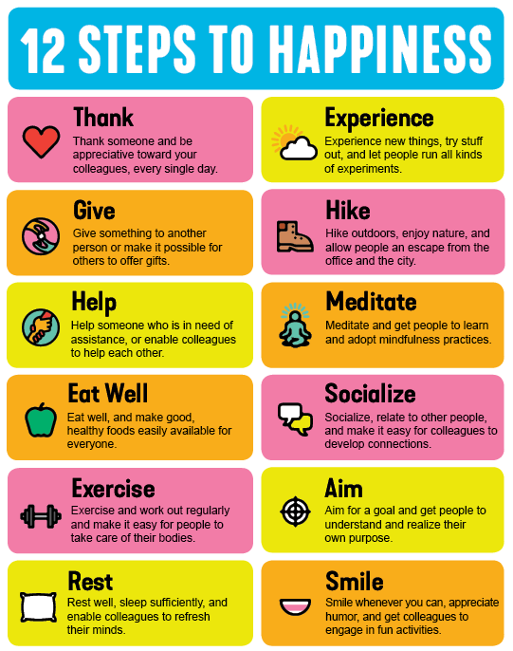

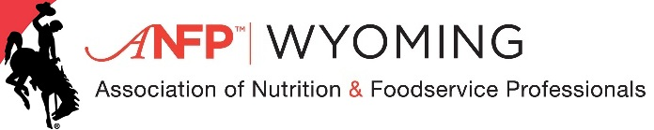
CDM of the Year Nomination Form
The purpose of this award is to recognize a Certified Dietary Manager in the State of Wyoming that has gone over and above expectations in their role. This individual portrays a passion for the CDM credential, has worked hard to provide high quality, safe meals for their customers and is a role model for others in the field, in their workplace and community.
Please nominate a Certified Dietary Manager so that they may be recognized by Wyoming ANFP and possible recognition from the National ANFP membership.
Name of nominee:
Reason for nomination (250-500 words) ________________________________________________________________________________________________________________________________________________________________________________________________________________________________________________________________________________________________________________________________________________________________________________________________________________________________________________________________________________
Your Name:________________________________________________
Contact Information: ______________________________________________________________________________________________________________________________________

Please email your nomination to fsmith@mhccwyo.org by September 1st, 2021.

