Wisconsin Spring Edition

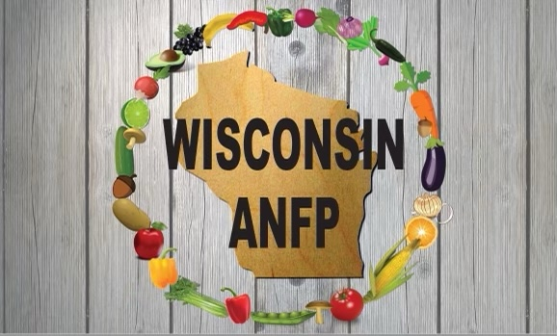

Pride in Food Service Week was the week of February 7-12, 2022. We hope you were all able to recognize your team members for their dedicated service, excellent teamwork, and resilience during the two yearlong COVID pandemic. Please share your photos by emailing them to Mel Kern at mkern@parkview-cc.com

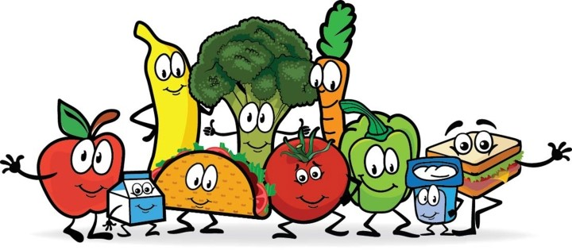

WI ANFP Spring and Fall State Conferences: 21st
See the attached flier for our upcoming one day state spring conference in Stoughton, Wisconsin and register for this discounted event for $25.00. Special thanks to WI ANFP members Millie Bailey, Renee Taylor , & Linda Halverson and other team members for planning this professional development conference to “refresh and recharge your batt
WI ANFP Spring Conference: Eau Claire April 28th
See attached flier for our upcoming one day state spring conference in Eau Claire, WI. Registration forms will be out by March 15th. We will be offering 6 CEU’s, free breakfast and lunch included. Cost $25, contact Mel Kern at mkern@parkview-cc.com for more info
Both of these are great ways to get your CEU’s and in two different parts of the State to make it easier for our members to get to.
Mark Your Calendar for September 15-16, 2022 for our Fall State Conference, “Recipes for Success”, returning to the beautiful Chula Vista Resort at Wisconsin Dells, Wisconsin. Innovative speakers, a mentoring leadership workshop and a networking opportunity for a Friday Vendor Fair. $119/night plus tax and a preplanned optional group cruise boat tour down the Wisconsin River so view Fall colors await our members.

April 21-22 Spring Regional Meeting, Nashville, TN. Register online at anfponline.org for up to 13 CEU’s.
June 27-June 29, 2022 ANFP Annual Conference and Expo (ACE), Talking Stick Resort, Scottsdale, AZ.

Have you thought about going to our national conference in Scottsdale Arizona? The board has budgeted $2000 for our members to help offset the price of registration/travel/hotel. The funds will be dispersed equally between members; the maximum reimbursement being $400.
Covid has made Celebrating Holidays fun but Millie Zarate brought the fun for Fat Tuesday so her residents could have some great food and fun! Great Job Millie! I am sure your residents appreciated it!
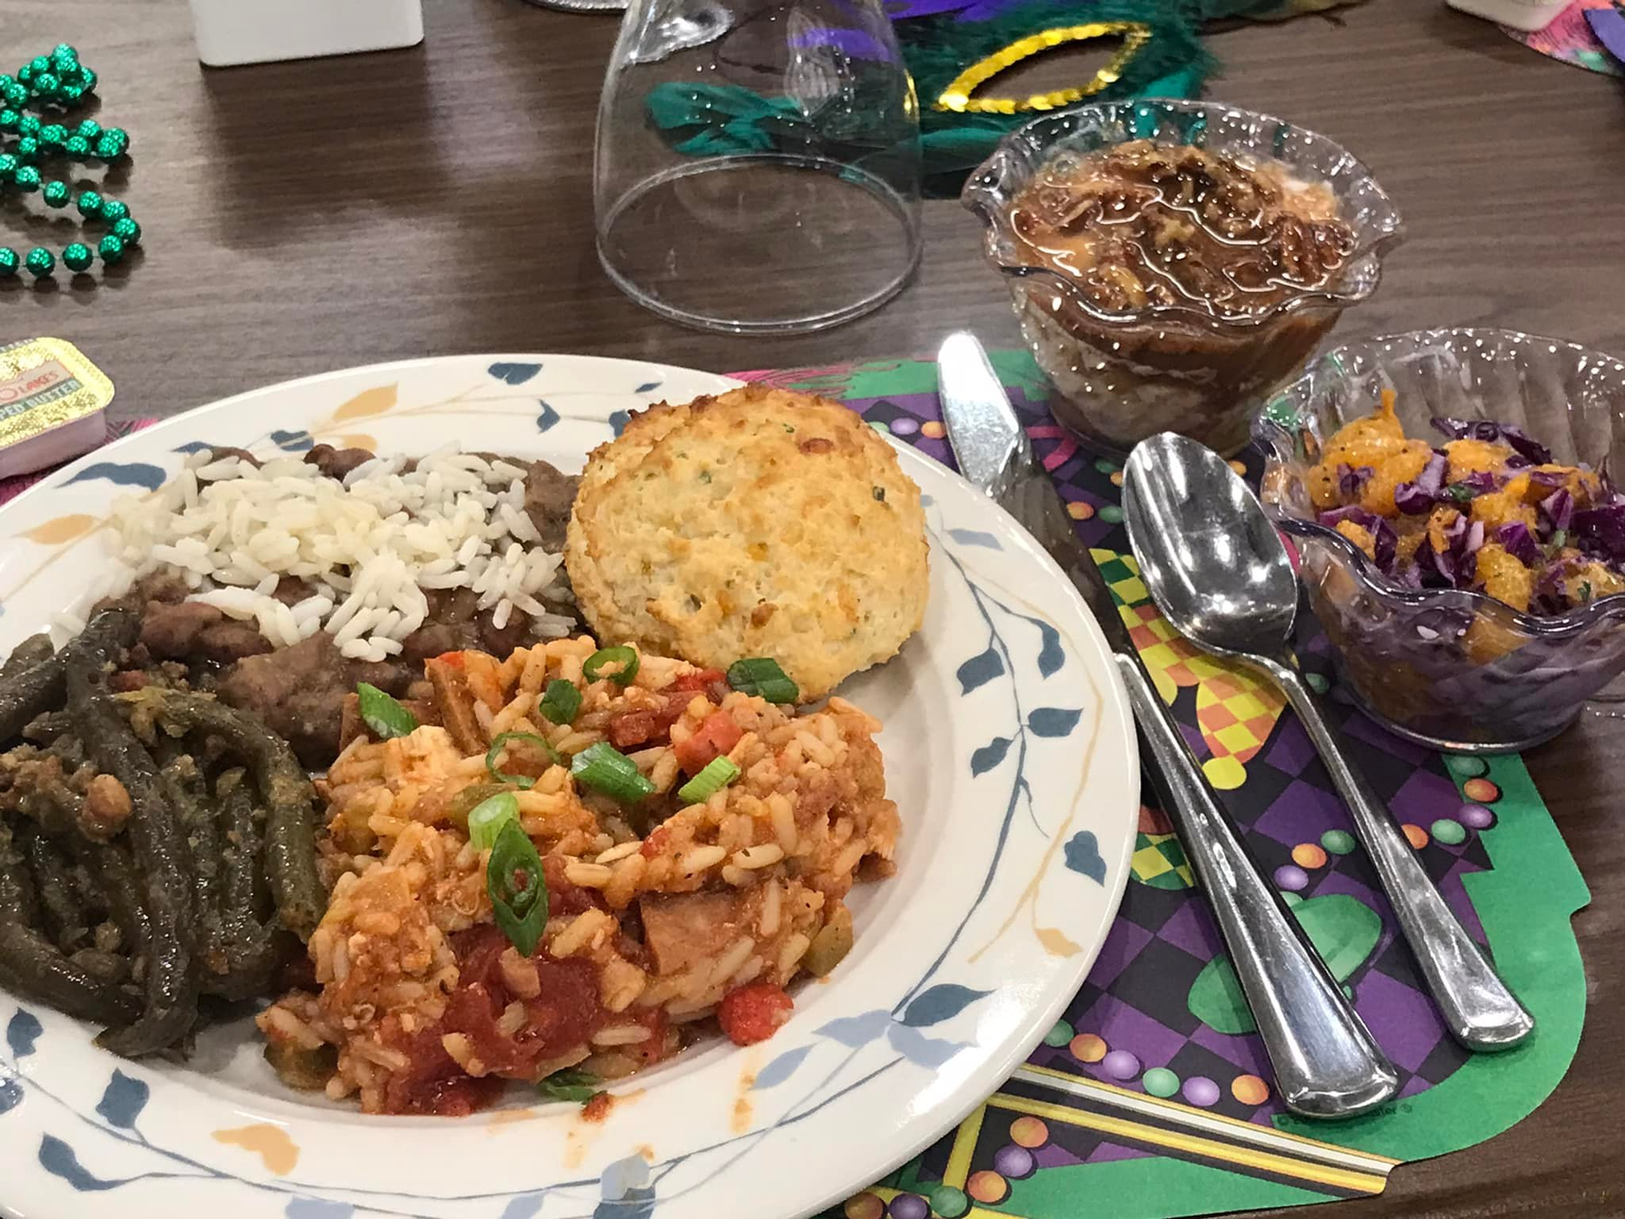

Your Response Requested: What Impact will you leave as a leader?
Compassionate, empathetic, bold, creative, innovative, passionate, team leader, resident centered, resilient are common responses to this question. As we look forward to the future, please email Rick at reggertknu@yahoo.com a key word that summarizes your leadership style in the email note with your name by April 1, 2022. These results will be featured in a special project at the Fall State Conference for our Members as a Group Project/Display for our ongoing Brand Ambassador Committee.
Thanks for your ongoing support and commitment to WI ANFP!!
Rick Eggert, President
Rick Eggert, President
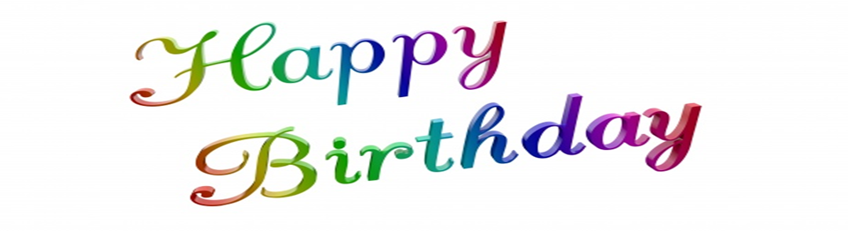

Marcia Below
Julie Clements
Barbara Dehnert
Christopher Erby
Melissa Geszvain
Shelly Holly
Melissa Jacobs
Theresa Kleinerts
Chloe Meilinger
Melanie Melgaard
Brandi Moon Bruley
Wendy Phillipi
Joshua Reiter
Scott Schuld
Vicki Sukow
Marilyn Webert
Sherry Jacobson

Please update your birthday (month and date), email address, to ensure timely communications for upcoming ANFP Wisconsin events, recognition of special events and special invitations for social Spring and Summer regional get togethers for networking and cookouts scheduled around the state.

Employment WI ANFP CDM Classified Sections
Looking for a new job? Check out new CDM opportunities throughout our state in our new special section. Email open positions in your region to reggertknu@yahoo.com to include in our monthly email blasts.
New Opportunity!!
Seeking a CDM in Mount Pleasant, Wisconsin to be the Dining Services Coordinator for the entire campus: Responsibilities include: meal planning, purchasing, training the caregivers regarding nutrition and food safety and daily cooking responsibilities. Chef/Hospitality background preferred. Please contact Beth Pahmeier, RD, CD, Owner, Executive Director at Harvest Home, bpahmeier@harvesthome.com, (920) 901-9482

Need a Cook, Chef or Dietary Aides for your long term care, acute care or School or correctional facility? Please email your position to reggertknu@yahoo.com to be included in the next monthly email.

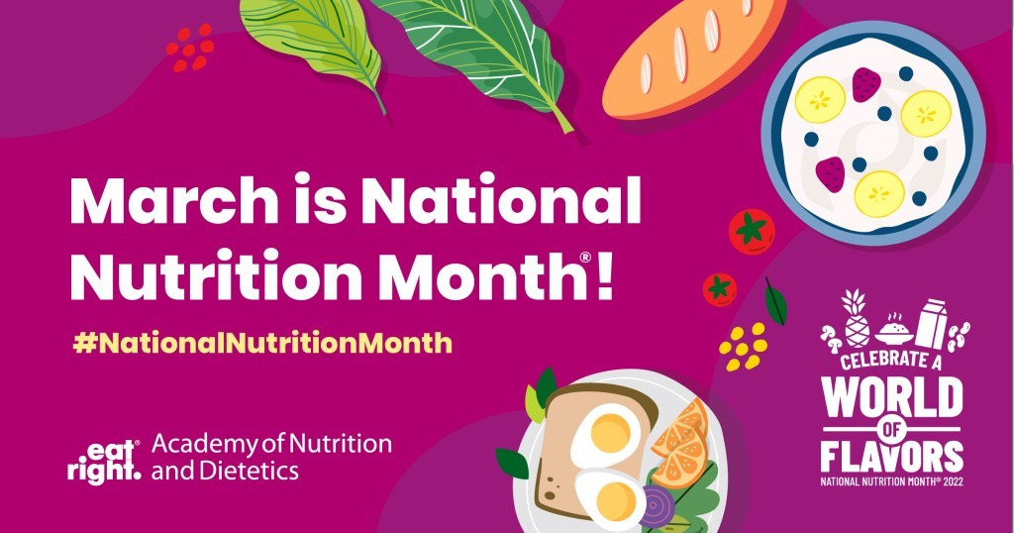

National Nutrition Month is an annual campaign created by the Academy of Nutrition and Dietetics. During the month of March, everyone is invited to learn about making informed food choices and developing healthful eating and physical activity habits to include:
- Week One: Eat a variety of nutritious foods from all food groups, learn how to ready Nutrition fact Labels and incorporate your favorite cultural foods and traditions.
- Week Two: See a registered Dietician Nutritionist (RDN). Find an RDN who specializes in your unique needs and receive personalized nutrition information to meet your health goals.
- Week Three: Plan your meals and snacks: choose healthful recipes to make during the week, use a nutritious foods grocery list and make healthful food and drink choices when away from home.
- Week Four: Create tasty foods at home: Learn cooking and meal preparation skills, try new flavors and foods from around the world and enjoy your meals with friends or family, when possible.
- Week Five: Put it all Together: Eat a variety of nutritious foods, see a RD Nutritionist (RDN), plan your meals and snacks, and create tasty foods at home.

