TXANFP
ON A JOURNEY,
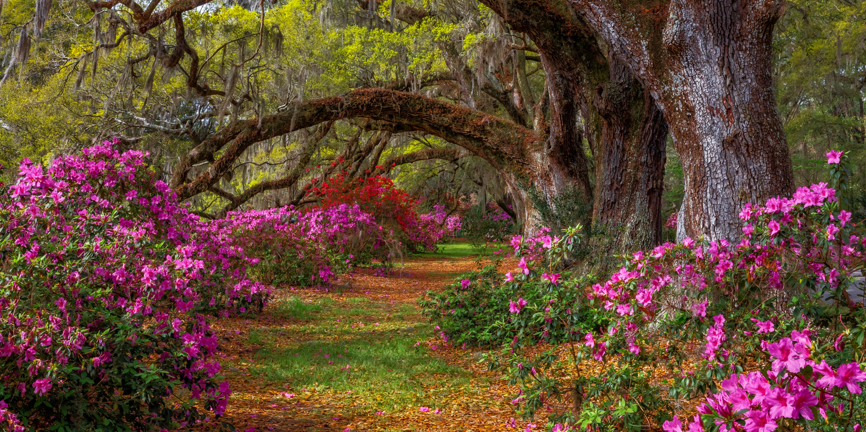
SPRINGING INTO EXCELLENCE!
17635 BEN E. KEITH WAY, Selma TX. 78154
Host Hotel: Spark by Hilton Selma
15771 IH 35N, Selma, Tx 78154

THANK YOU, SPEAKERS
$70.00
$80.00
$55.00
$50.00
$50.00

Deadline for Pre-Registration April 23rd, 2025.
$80.00
$90.00
$65.00
$60.00
$60.00
REGISTER USING THE QR CODE BELOW

GENERAL 8.75 | SANITATION 1.5 | FOOD SHOW 1.25 | TOTAL CEU 11.5

5:00PM-6:30PM **EXECUTIVE BOARD MEETING**
DAY 2 (05/01/2025)
8:15AM-8:30AM
ANNOUNCEMENTS

8:30AM-10:00AM
IDDSI TEXTURES AND TESTING, CHALLENGES & RESOLUTIONS, CYNTHIA GREEN, RDN/LD, REGIONAL MANAGER, SIMPLY THICK

10:00AM-10:15AM **BREAK**

10:15AM-11:45AM
SUPERCHARGE YOUR CAREER, JOYCE LAMILLA, M.Ed, RD/LD, FAND, BEN E. KEITH

12:00PM-1:30PM **VENDOR SHOW/LUNCH**

1:45PM-2:30PM **BUSINESS MEETING**

2:30PM-3:45PM **OFFICER’S TRAINING**
DEBORAH MCDONALD, CDM, CFPP, CHAPTER PRESIDENT
KENNETH OWENS, CDM, CFPP, NATIONAL CHAIR ELECT

3:45PM-4:45PM **IMPACT MEETING**

DAY 1 (04/30/2025)

7:30AM-10:00AM
REGISTRATION

8:15AM-8:30AM
WELCOME & ANNOUNCEMENTS

8:30AM-10:00AM
A JOURNEY TO GREAT LEADERSHIP, WILLIE FLORES, FCTD ASSISTANT DIRECTOR, NORTH TEXAS STATE HOSPITAL-WFC

10:00AM-10:15AM **BREAK**

10:15AM-11:45AM
TAKE THE HEAT OUT OF THE KITCHEN, DEWAYNE PACE, CDM, CFPP, AHF, COOKS CHILDREN PROSPER HOSPITAL

11:45AM-1:00PM **LUNCH**

1:00PM-2:30PM
PURCHASING USA GROWN AND CANNED FRUIT, STEPHEN REED, PACIFIC COAST PRODUCERS’ REP

2:30PM-4:00PM
PRINCIPLES OF HACCP SIMPLIFIED, BARRETT BROUSSARD, CDM, CFPP
DIRECTOR OF NUTRITIONAL SERVICES, ACADIA ST. LANDRY HOSPITAL

SPEAKING AGENDA

SPEAKING AGENDA

OUR SPEAKERS:

DEWAYNE PACE, CDM, CFPP, AHF, COOKS CHILDREN PROSPER HOSPITAL
JOYCE LAMILLA, M.Ed., RD, LD, FAND, BEN E. KEITH
STEPHEN REED, PACIFIC COAST PRODUCERS’ REP
CYNTHIA GREEN, RDN/LD, REGIONAL MANAGER, SIMPLY THICK
WILLIE FLORES, FCTD ASSISTANT DIRECTOR, NORTH TEXAS STATE HOSPITAL

BARRETT BROUSSARD, CDM, CFPP
DIRECTOR OF NUTRITIONAL SERVICES, ACADIA ST. LANDRY HOSPITAL

Contact: Deborah McDonald CDM, CFPP
940-689-5607 or 940-782-3027

