Deadline for Pre-Registration October 10th, 2026.
General: 6.75 | Sanitation 1.5 | Ethics 1.75 | Vendor Show 1.25
Dewayne Pace
P.O. Box 383149 Duncanville TX. 75138

THANK YOU, SPEAKERS

TXANFP
FALL WORKSHOP
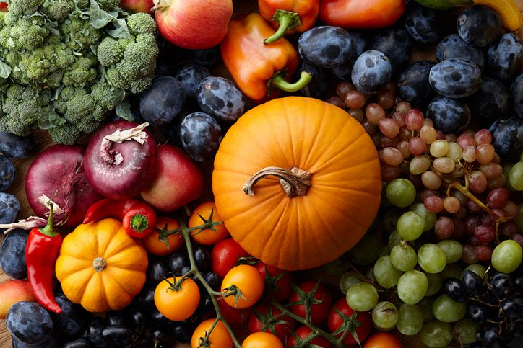

CDM’s Excelling in Performance & Growth
$70.00
$80.00
$55.00
$50.00
$50.00

$80.00
$90.00
$65.00
$60.00
$60.00
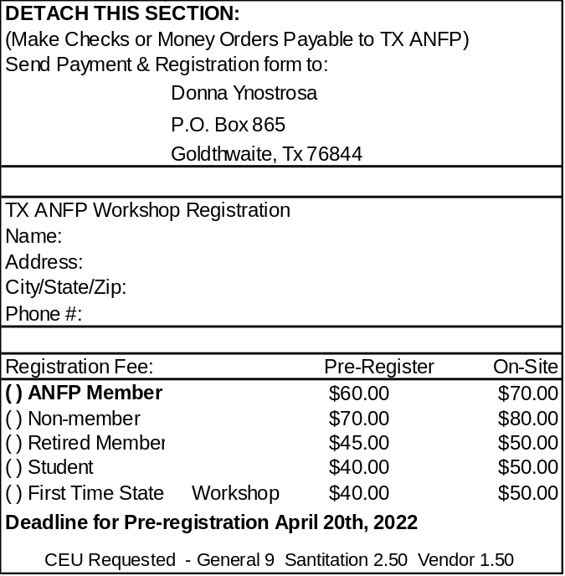
OUR SPEAKERS:
DEWAYNE PACE, CDM, CFPP
FREDERICK MAHAFFEY, CDM, CFPP
JESUS GARCIA, ADMINISTRATOR
KRISTINA HANNING, LNFA, ADMINSTRATOR
JOYCE LAMILLA - M.ED, RD, LD, FAND
MARY LIVELY, LDN, RDN
TIFFANY WENZEL, RDN

SPEAKING AGENDA

Day 1 (10/15/2026) Continued
3:30pm-5:00pm – Tiffany Wenzel, RDN - Foodborne Illness – A Recipe for Disaster?

Day 2 (10/16/2026)
8:30am-8:45am Welcome Members
8:45am-10:15am – Kristina Hanning, LNFA, Administrator - Communication and Leadership
10:15am-10:30am Break
10:30am-12:15pm- Fred Dewayne Pace, CDM, CFPP – Got A Big Ego
12:15pm-1:30pm Lunch/Business Meeting

Day 0 (10/14/2026)
4:00pm-5:30pm Officers Training
5:30pm-6:30pm Executive Board Meeting

Day 1 (10/15/2026)
8:30am-8:45am Welcome Members
8:45am-10:30am - Fred Mahaffey, CDM, CFPP – Ethics: Beyond the Rulebook
10:30am-12:00pm – Jesus Garcia, Administrator – World of the Types of Leaders
12:00pm-1:15pm Vendor Show/Lunch
1:30pm-2:30pm – Mary Lively, LDN, RDN – Communication and Employee Motivation
2:30pm-3:30pm – Joyce Lamilla - M.ED, RD, LD, FAND – Impact of Glp1 Medication Use on Older Adults and Practical Considerations in Food Service

SPEAKING AGENDA

EVENT LOCATION: PERFORMANCE FOODSERVICE – DALLAS/FORT WORTH
5401 E 1ST STREET



PLEASE USE THIS QR CODE TO PRE-REGISTER FOR THE SPRING MEETING

