“Improving People’s Lives By Changing The Way They Work”
SDANFP Spring Conference
March 29-31st
Sanford USD Medical Center
1305 W. 18th St.
Sioux Falls, SD 57117

Wednesday March 29th Agenda:
12-1 Check-In
1-2 Sanitation (Mike with Spartan)
2-3 Allergens (Joey Rost)
3-315 Break
3:15-4:15 Recognition Best Practices (Teresa Beach R.D.)

Thursday March 30th Agenda:
(May bring a guest this day for a additional fee)
8- Think 3D
9- Think 3D
10- Think 3D
11- Think 3D
12-1 Business Lunch
- Think 3D
- Think 3D
- Kitchen Tour
- Shane’s Food Demo

Friday March 31st Agenda:

8:15-9:30 Mayor of Sioux Falls (Motivational Speaker)
9:30-10:30 Renal Diet (Carri Oetken R.D.)
10:45-11:45 Cambro Rep Presentation

Valley Inn Motel: Located next to the Event

1000 S Grange Ave,Sioux Falls, SD 57105
Phone: 605-335-3040
$84 a night with king suite

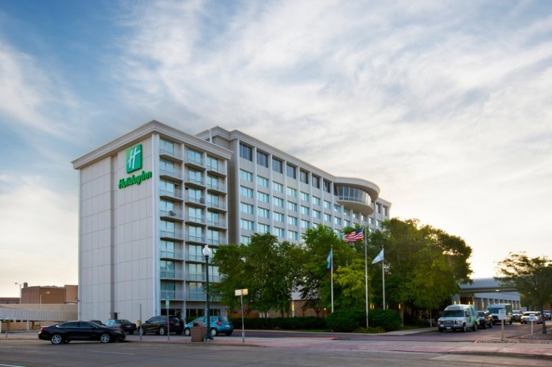

Holiday Inn City Center Downtown
100 W 8th St, Sioux Falls, SD 57104
Phone: (605) 339-2000

$109 a night with a king bed

Registration Form
SD ANFP Spring Conference
Name _________________________Facility _____________________________________
Address_____________________________________________________________________
City, State, Zip _____________________________________________________________
Phone _______________________ Email ___________________________________
Conference Pricing
Quantity
Wednesday only $45.00 ____
Thursday only $75.00 _____
Friday only $45.00 _____
Full Conference $150.00 _____

Total: _____
Make checks payable to SD ANFP
Send to: Julie Elsen, 413 9th Street, Britton, SD 57430

If Paying By Credit Card Fill out Below/ or write in that paying by CC upon arrival

Check Credit Card using for Payment
Visa MasterCard Discover American Express

Card Number __ __ __ __ __ __ __ __ __ __ __ __ __ __ __ __
Ex Date __ __/__ __ CVV__ __ __ Zip Code __ __ __ __ __
Signature___________________________________________ Amount Payed $____________

