South Dakota ANFP Chapter - Current Officers
President | Erin Nielson  18471 481 Ave., Brandt, SD 57218-5408 (605)-759-4299 | (319)230-8513
President Elect |  | (605)343-4738 (15)
Secretary | Jessica Wallace  106 S Elm St, Aberdeen SD 57401 (605)-228-4707 | 605-389-8606
Treasurer | Elsen, Julie  1312 1st ST Britton, SD 57430-2282 (605)- 448-2253 | (605) 448-2253
Education Chairperson | Rost, Joey  3113S Fernwood Ave, Sioux Falls, SD 57106-2614 (319)-230-8513 | (605)460-0247
Newsletter Editor | O’Daniel, Karla  37030 171st ST, Zell, SD 57469-7706 (605)-475-7482 | (605)475-7482
Membership Chairperson | Soulek, Vanessa  1329 Sherman ST Hot Springs, SD 57747-1464 (605-)-695-0163 | (605)695-0163
Past President | Budd, Mark  4117 West Main Street, Rapid City, SD 57701 (605)-430-0384 | (605) 940-1368


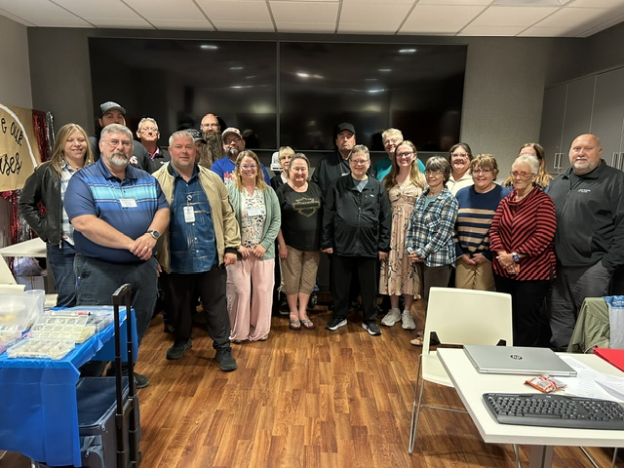
SOUTH DAKOTA ATTENDEES AT OUR SPRING CONFERENCE

Past President-
Thank you all for allowing me to have such a great opportunity to expand my knowledge and leadership skills while being the SD ANFP President. I highly encourage anyone who wishes to further their career to volunteer for board positions, committees, community service projects, and hosting meetings. All those activities are an excellent way to network with the amazing Dietary Managers we have not only in South Dakota, but throughout the USA. I am still the Past President and available to assist with questions, problems, and whatever else may be on your mind. Hope everyone has a great summer and hope to see you at the SD ANFP Fall conference hosted by Vanessa Soulek in Deadwood.

Thanks again,
Mark Budd

Hello SD ANFP Members,
The Spring Conference in Sioux Falls was my last one as a board member. You may see me at the meetings yet. I have retired and am loving having this summer to garden and walk and spend time with family and friends.

I have said more than once that this is an organization that has helped me improve my skills and that our conferences, including ACE, are right on target for what we do in our profession.
The networking and new friendships made along the years are invaluable. I hope you all will think about becoming officers and speaking up about what you want to learn about when the Spring and Fall Conferences are being planned.
Thanks to everyone along the way for being there for each other!
Sincerely,
Carol Rice
CDM, CFPP

Treasurer Report:
$6973.98
Julie Elsen, CDM, CFPP
SD ANFP Treasurer

ANFP MEMBER REPORT:
138 Members
6 new member

Reported by,
Vanessa Soulek, CDM, CFPP
SD ANFP Membership Chairperson

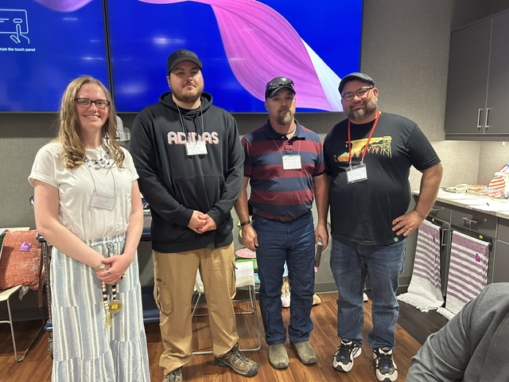
Four members that joined for the first time at our ANFP Conference
Jolene Post, Ashland Solway, Breckan Bies, Shane Copps



Bob Pacanovsky-Black Tie Experience-Motivational Speaker
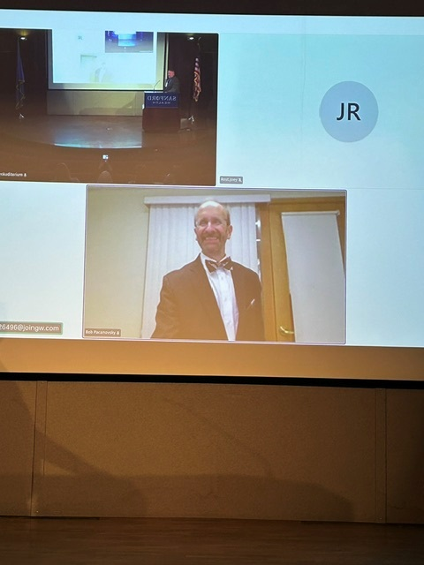

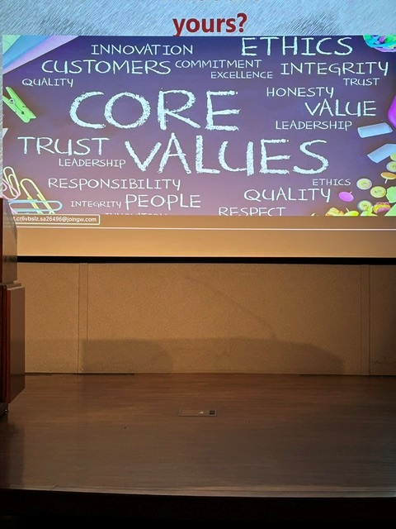

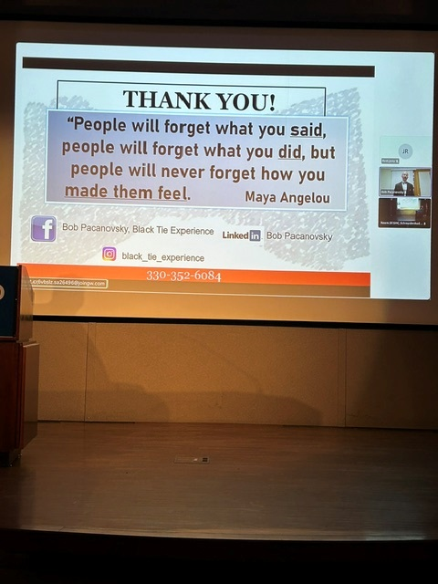

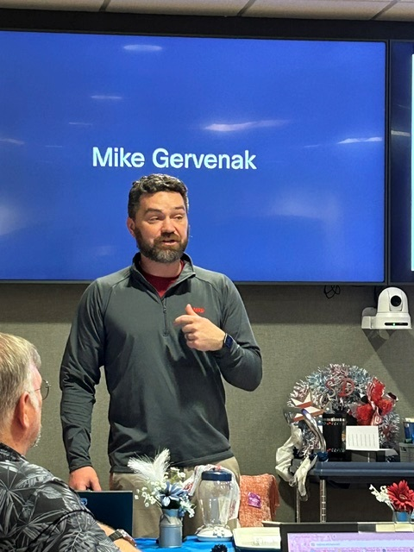
Mike Gervenak-CAMBRO
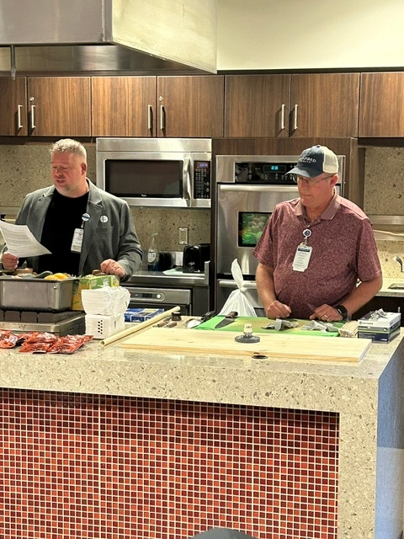
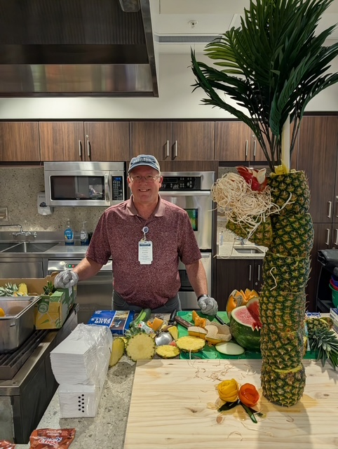
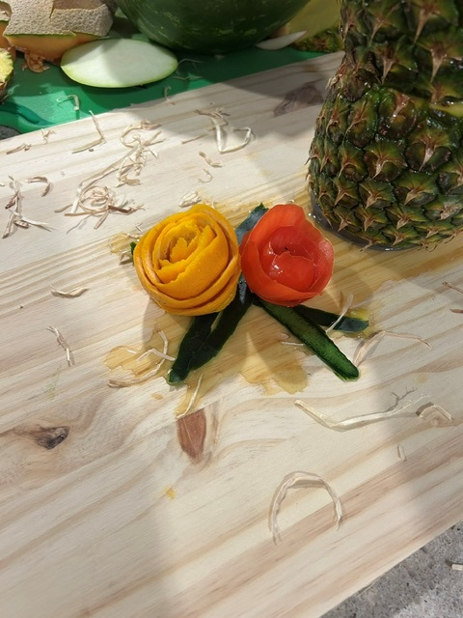
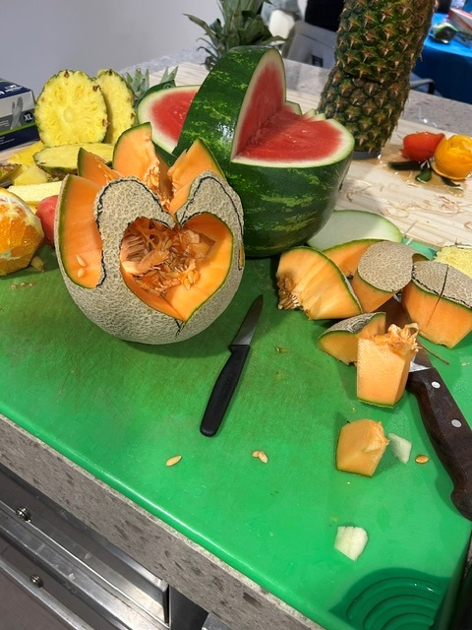
Chef Demo (Shane Kingbury and Joey Rost)
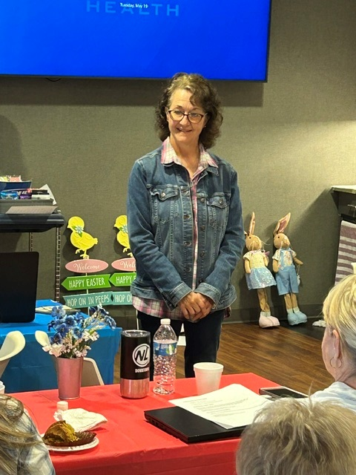
Lisa Smith (Master Gardner)

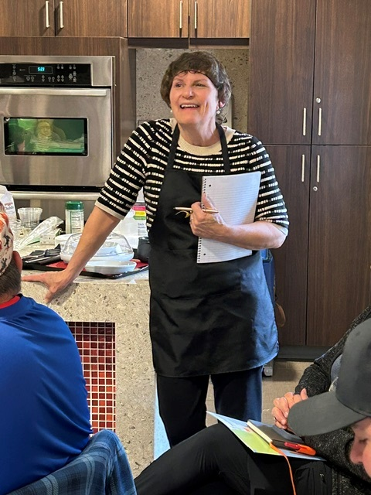
IDDSI Diets-Margene Reno
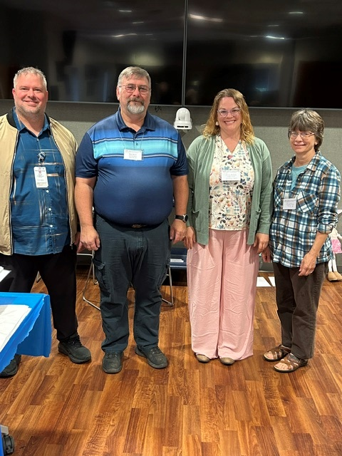
Joey Rost, Mark Budd, Erin Nielson, Carol Rice
Joey is our new Education Chair, Mark is our new Past President, Erin Nielson is our new President and Carol Rice retired her position on the board of Education Chair. Congratulations to all of you.

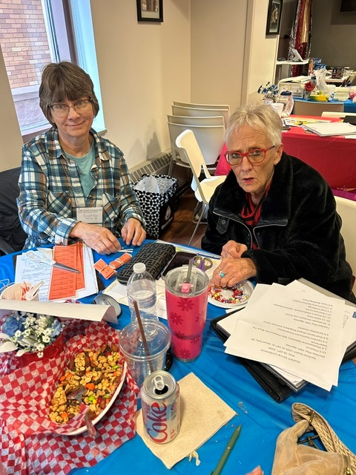
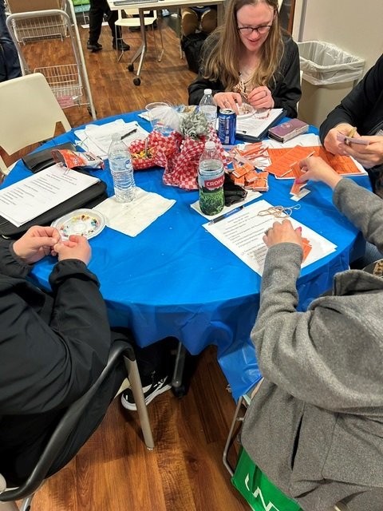
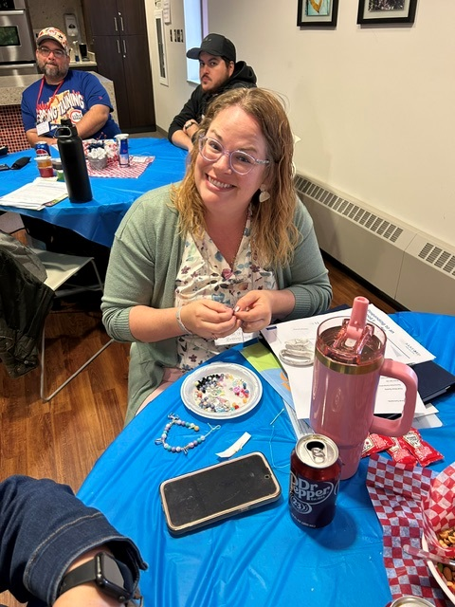
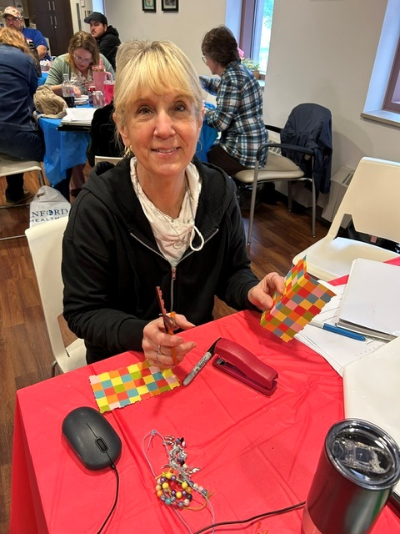
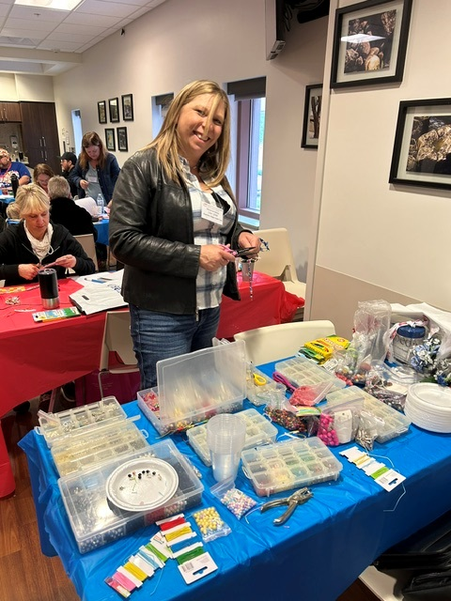
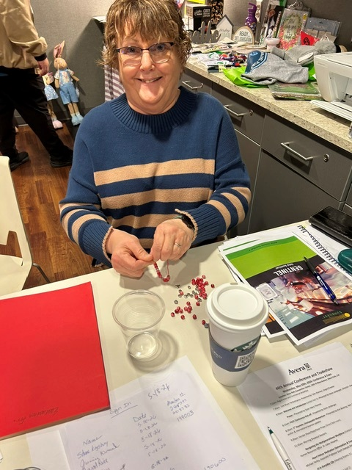
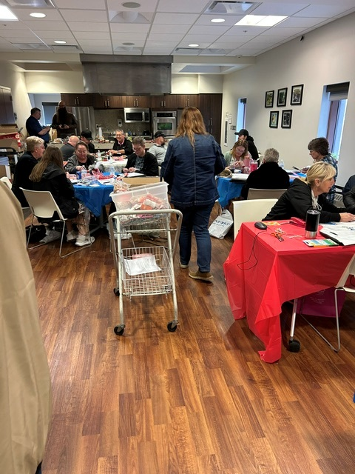
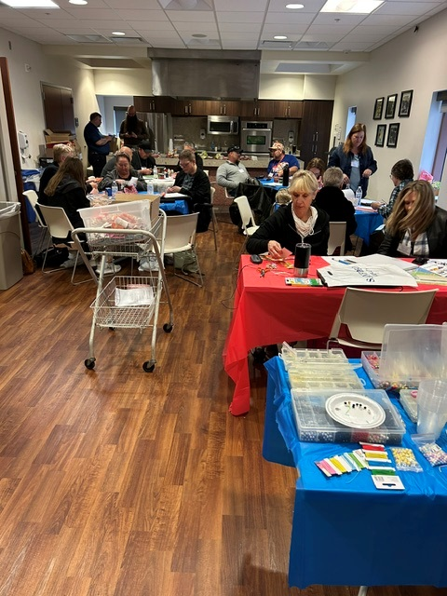
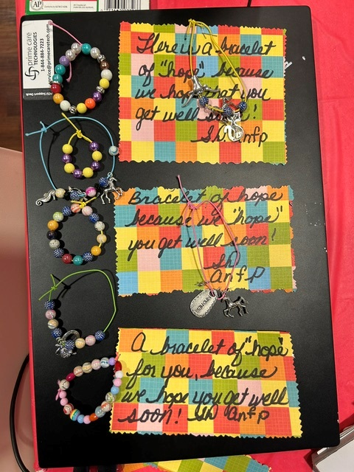
Community Service Project and Team Building Event


Hello,
Hope all is well! I enjoyed seeing everyone at the ANFP Spring meeting. I’m hoping you all can join us at the Fall Conference in Deadwood of 2026 hosted by Vanessa Soulek. More information to come on this. Have a great Summer and see you all in the Fall.
Karla O’Daniel, CDM, CFPP
SD ANFP Newsletter Editor

