

South Dakota ANFP Chapter - Current Officers

|  |
| --- |
|  |
| **President** | [**Rost, Joey**](mailto:Joey.Rost@sanfordhealth.org) 3113 S Fernwood Ave Sioux Falls, SD 57110-6017 (319)230-8513 | (319)230-8513 |
|  |  |  |
| **President Elect** | [**Budd, Mark**](mailto:mark.budd@avantarasaintcloud.com) 302 Saint Cloud ST Rapid City, SD 57701-3767 (605)343-4738) | (605)343-4738 (15) |
|  |  |  |
| **Secretary** | [**Kozlik, Dannielle**](mailto:dkozlik17@outlook.com) 1550 Seger DR Lot 110, Rapid City, SD 57701-7823 (605-389-8606) | 605-389-8606 |
|  |  |  |
| **Treasurer** | [**Elsen, Julie**](mailto:julie.elsen@avera.org) 1312 1st ST Britton, SD 57430-2282 (605) 448-2253 | (605) 448-2253 |
|  |  |  |
| **Education Chairperson** | [**Rice, Carol**](mailto:crice@nesdhs.org) 16739 368th Ave, Rockham, SD 57470 (605)460-0247 | (605)460-0247 |
|  |  |  |
| **Newsletter Editor** | [**ODaniel, Karla**](mailto:Karla.O) 37030 171st ST, Zell, SD 57469-7706 (605)475-7482 | (605)475-7482 |
|  |  |  |
| **Membership Chairperson** | [**Soulek, Vanessa**](mailto:vansoulek@legacyhc.com) 1329 Sherman ST Hot Springs, SD 57747-1464 (605)695-0163 | (605)695-0163 |
|  |  |  |
| **Past President** | [**Robinson, Arien**](mailto:arobin57105@gmail.com) 5808 W. 53rd Street, Sioux Falls, SD 57106-2614 (605) 940-1368 | (605) 940-1368 |

SOUTH DAKOTA MEMBERS

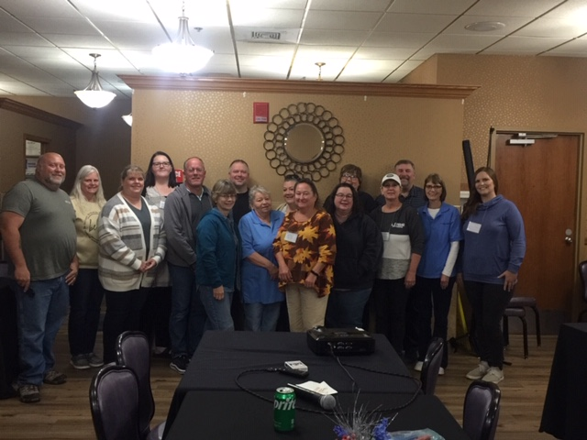

Greetings SD ANFP Family

First off I just want to give a big shoutout thank you to everyone and everything they do for there organization. The work we do everyday does matter and I challenge everyone to email me a story that how you made someones day. Also, do not forget November 28 is national cdm,cfpp day and make sure you celebrate with your team that day. This time of the year is very busy for everyone and we can tend to get overwhelmed and overworked. So always remember to find your passion and purpose that the work we do everyday does make a difference.

Thank you and see you this Spring in Sioux Falls

Joey Rost CDM,CFPP

Room Service Manager

Sanford USD Medical Center

Office: 605-333-7218

[joey.rost@sanfordhealth.org](mailto:joey.rost@sanfordhealth.org)

ANFP Board of Directors

ANFP SD Chapter President

|  |  |  |
| --- | --- | --- |
|  |  |  |
|  |  |  |

Hello all SD ANFP members. Hope the upcoming busy holiday season is good to you. I am grateful for the turnout we had at the fall conference. Big thank you to all those who helped make it a success. I know we are all looking forward to the spring conference in Sioux Falls. Just wanted to make sure that everyone is aware of the opportunities available with SD ANFP with volunteering, ongoing education, and stepping up to fill board positions. I hope to see everyone at the spring conference to have the chance to network and get valuable input and suggestions from membership moving forward.

Thanks, and have a great holiday season!

Mark Budd CDM, CFPP

SD ANFP President Elect

Treasurer’s Report:

$2400.39-Savings

$2941.84-Checking

$1509.29-CD

Warm wishes,

Julie Elsen CDM, CFPP

SD ANFP Treasurer



The SD ANFP Fall Conference in Deadwood was a success! With the theme “How to Establish the Best Culture and Team”, we were on the right track. Every presenter engaged our members in discussions.

Felicia Smith from Wyoming ANFP, and the current Chair of the ANFP Board shared her knowledge and useful checklists to help with survey preparedness. She also gave us work situations to evaluate ethical responses.

As a group, members got creative and made cards with messages for children who have cancer. We have some pretty good artists among our members! We sure have a lot of caring members too. Several shared community efforts to help others in need.

Kevin Knebl was a fabulous presenter. He travels within the United States and abroad teaching the value of establishing relationships with others. He gave us great tips for setting up a LinkedIn account to help us connect with others professionally. LinkedIn can be used in the search for a new job and for finding potential employees. He encouraged us to add information in a more conversational manner. Each word used in the filters we complete helps when searching to link folks with similar interests.

Joey Rost, our President, had us writing poetry as a team building exercise. We learned a bit more about each other. He also shared the traits of each generation to help us relate to our work teams.

Mark Budd, President-elect and conference host, shared tips for professionalism as a CDM. Thank you for sharing your knowledge and hosting the conference!

Just a reminder to keep your email updated at [www.anfponline.org](http://www.anfponline.org)

The email listed is where you will receive information from ANFP and SD ANFP. ANFP and SD ANFP are on Facebook also.

The ANFP website has a lot of links on the first few pages (on the left side of the screen). You can visit the section on *regulations* to see what each state has for requirements for hospitals and long-term care facilities. You can also find information on grants for the CDM course, exam or for attending ANFP events.

A very big thank you to Dawn Strand for 16 years as our chapter Membership Chair. That is commitment!!!

Carol Rice, CDM, CFPP

SD ANFP Education Chair

|  |  |  |  |  |  |  |  |  |  |  |  |  |  |  |  |  |  |  |  |  |  |  |  |  |  |  |  |  |  |  |  |  |  |  |  |  |  |  |  |  |  |  |  |  |  |  |  |  |  |  |  |  |
| --- | --- | --- | --- | --- | --- | --- | --- | --- | --- | --- | --- | --- | --- | --- | --- | --- | --- | --- | --- | --- | --- | --- | --- | --- | --- | --- | --- | --- | --- | --- | --- | --- | --- | --- | --- | --- | --- | --- | --- | --- | --- | --- | --- | --- | --- | --- | --- | --- | --- | --- | --- | --- |
| |  | | --- | | [ANFP_1782725.jpg](https://protect2.fireeye.com/v1/url?k=e35e5d34-8224a802-e35f626e-74fe485c1bdc-6d56f604a284493b&q=1&e=9452f59b-4a08-4d94-86c2-cd408e1fe14a&u=http%3A%2F%2Fwww.mmsend90.com%2Flink.cfm%3Fr%3DLqOd5-befU4O_IwM3pS_dg%7E%7E%26pe%3DTwQ0sDzay5pmJzjE_j1wE67szBrfNupJAfXg8VIklCFiKkZCPTqke_iKSNmkN4qhCVS9_X6fHfmZwnhiZG5hew%7E%7E%26t%3DyAnLwTvkamgB9GgqyMmCvA%7E%7E) | |  | | |  |  |  |  |  |  |  |  | | --- | --- | --- | --- | --- | --- | --- | --- | | |  |  |  |  |  |  |  | | --- | --- | --- | --- | --- | --- | --- | | |  |  |  |  |  |  | | --- | --- | --- | --- | --- | --- | | |  |  |  |  |  | | --- | --- | --- | --- | --- | | |  |  |  |  | | --- | --- | --- | --- | | |  | | --- | |  | | |  | | --- | |  | | | | | | | | Mark your calendars for our 2024 live events! We  hope you will join us for a Regional Meeting and/or  the Annual Conference & Expo (ACE)!    Stay tuned over the coming months for more information  on registration, educational content, and more! | | |  |  |  |  | | --- | --- | --- | --- | | |  | | --- | | 2024 Spring Regional Meeting | | |  | | --- | | **2024 Spring Regional Meeting**    April 4-5, 2024  Cleveland, OH    [Learn More](https://protect2.fireeye.com/v1/url?k=fb8400e1-9afef5d7-fb853fbb-74fe485c1bdc-939eb3023e950043&q=1&e=9452f59b-4a08-4d94-86c2-cd408e1fe14a&u=http%3A%2F%2Fwww.mmsend90.com%2Flink.cfm%3Fr%3DLqOd5-befU4O_IwM3pS_dg%7E%7E%26pe%3D0F3RY8OzYAbEapMbp4zltIO6o4Y52LdCamy9zYiaNEfdUVrj63MAIl28mbyraVd_qkTj3l9DPOaFP-NjCfmRgA%7E%7E%26t%3DyAnLwTvkamgB9GgqyMmCvA%7E%7E) | | | |  | | |  |  |  |  | | --- | --- | --- | --- | | |  | | --- | | ACE24-200_2647510.png | | |  | | --- | | **2024 Annual Conference & Expo**    June 10-13, 2024  Reno, NV    [Learn More](https://protect2.fireeye.com/v1/url?k=45eaf049-2490057f-45ebcf13-74fe485c1bdc-e7d203d4802571b8&q=1&e=9452f59b-4a08-4d94-86c2-cd408e1fe14a&u=http%3A%2F%2Fwww.mmsend90.com%2Flink.cfm%3Fr%3DLqOd5-befU4O_IwM3pS_dg%7E%7E%26pe%3DTLUnKF5tCYgs3IKvZZwtiAz_mfz344ildopDmUucCi-rC71Zo5bpFlS-f9piid92aBfmmuEMGV0m7yg5PqR4Vw%7E%7E%26t%3DyAnLwTvkamgB9GgqyMmCvA%7E%7E) | | | |  | | |  |  |  |  | | --- | --- | --- | --- | | |  | | --- | | 2024 Fall Regional Meeting | | |  | | --- | | **2024 Fall Regional Meeting**    Dates and location will  be announced soon! | | | | |  |  |  |  |  |  |  |  | | --- | --- | --- | --- | --- | --- | --- | --- | | |  |  |  |  |  |  |  | | --- | --- | --- | --- | --- | --- | --- | | |  |  |  |  |  |  | | --- | --- | --- | --- | --- | --- | | |  |  |  |  |  | | --- | --- | --- | --- | --- | | |  |  |  |  | | --- | --- | --- | --- | | |  | | --- | |  | | |  | | --- | |  | | | | | | | | Learn more about ANFP live events [here](https://protect2.fireeye.com/v1/url?k=1a327fde-7b488ae8-1a334084-74fe485c1bdc-c9e12659892c49dc&q=1&e=9452f59b-4a08-4d94-86c2-cd408e1fe14a&u=http%3A%2F%2Fwww.mmsend90.com%2Flink.cfm%3Fr%3DLqOd5-befU4O_IwM3pS_dg%7E%7E%26pe%3D4CNwEKHhJqCziiy3Q72Be_HRU3XpcNSKJNtcNW54tLBE-mA8rWtZ6G_FDpQ6VEWJEyqmuxJiLiIKoExl-9t4pA%7E%7E%26t%3DyAnLwTvkamgB9GgqyMmCvA%7E%7E). | | |  |  |  |  |  |  |  |  | | --- | --- | --- | --- | --- | --- | --- | --- | | |  |  |  |  |  |  |  | | --- | --- | --- | --- | --- | --- | --- | | |  |  |  |  |  |  | | --- | --- | --- | --- | --- | --- | | |  |  |  |  |  | | --- | --- | --- | --- | --- | | |  |  |  |  | | --- | --- | --- | --- | | |  | | --- | |  | | |  | | --- | |  | | | | | | | |  | |  | |  | |  | |

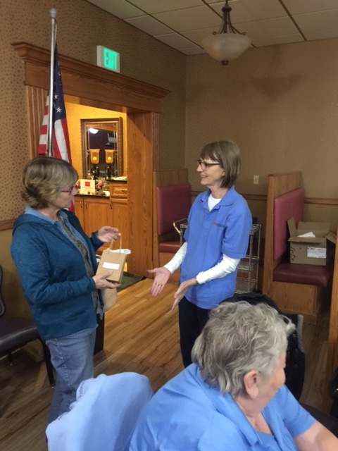

Dawn Strand has been our Chapter Membership Chairperson for 16 years.

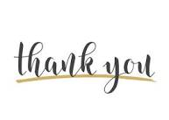

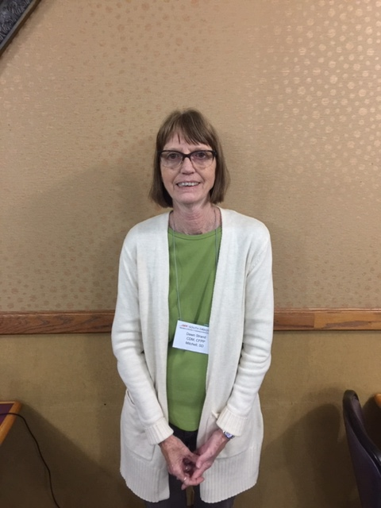

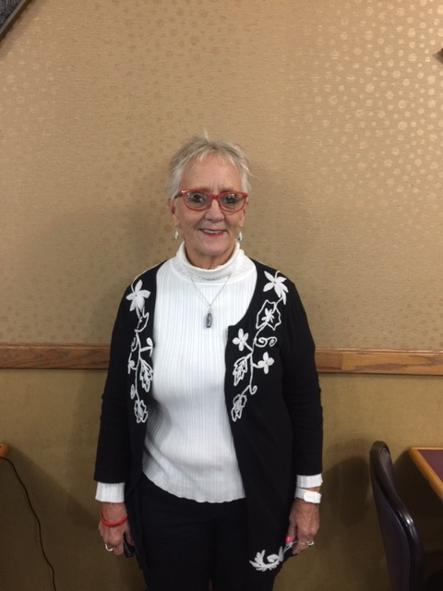

Vanessa Soulek will be taking the new role as Membership Chairperson.

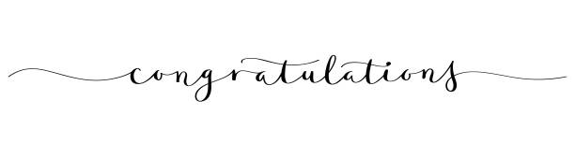

Felicia Smith MHA, CDM,CFPP did a Virtual speaking on Survey Prepardness and Community Service Project

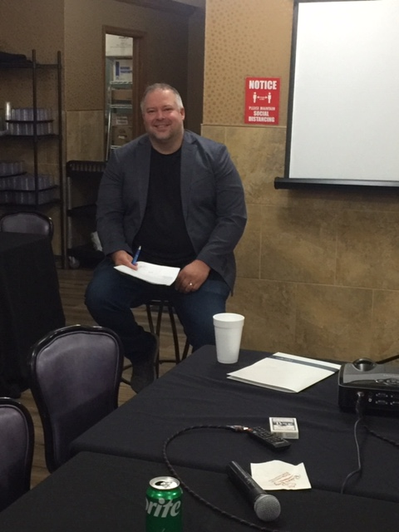

Joey Rost CDM, CFPP speaking on Team bulding Exercises and DEI Generational Differences

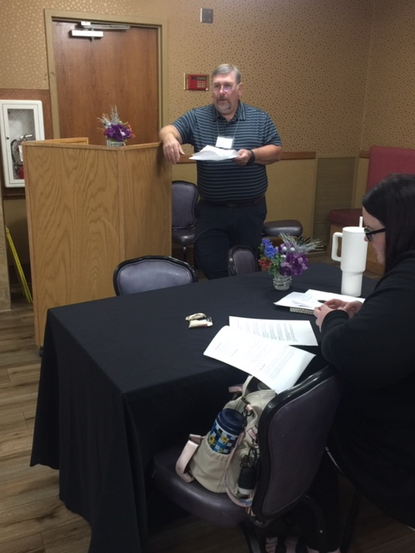

Mark Budd CDM, CFPP speaking on Professionalism as a CDM

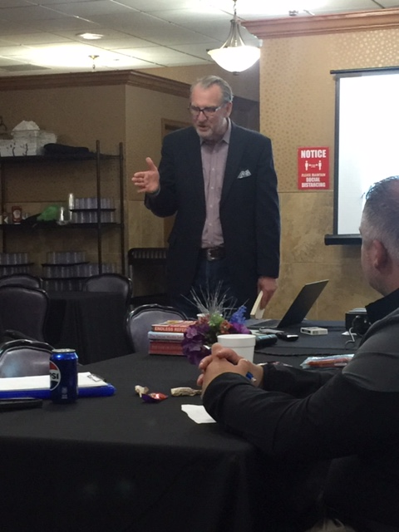

Kevin Knebl Motivational Speaker

Creating Online and Offline Know/Like/Trust for Huge Sales, Referrals and Bussiness Success Boot Camp!

VENDOR FOOD SHOW

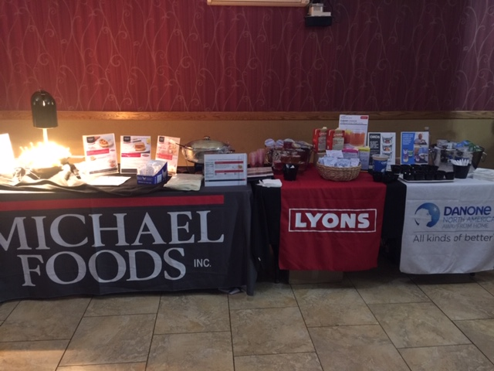

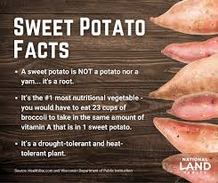

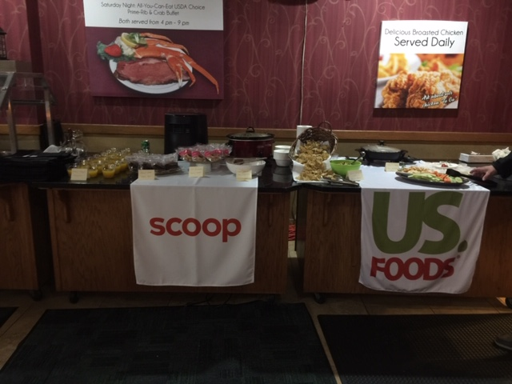

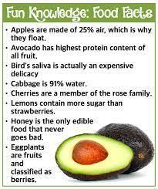

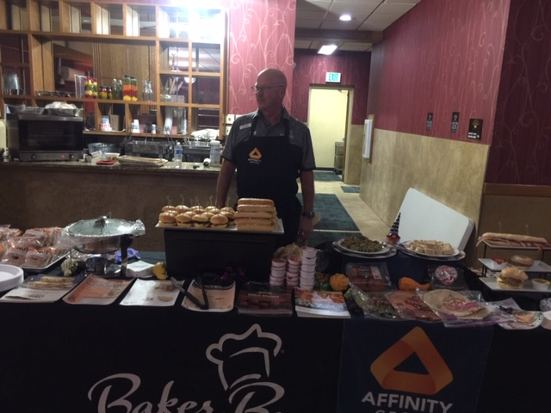

**November food holidays:**

November is National Peanut Butter Lovers Month!

* Nov 1: National Calzone Day
* Nov 3: National Sandwich Day
* Nov 6: National Nachos Day
* Nov 7: National Pad Thai Day
* Nov 9: National Fried Chicken Sandwich Day
* Nov 9: National Cappuccino Day
* Nov 10: National Vanilla Cupcake Day
* Nov 11: National Sundae Day
* Nov 12: National French Dip Day
* Nov 14: National Pickle Day
* Nov 16: National Fast Food Day
* Nov 17: National Baklava Day
* Nov 18: National Apple Cider Day
* Nov 20: National Peanut Butter Fudge Day
* Nov 23: Thanksgiving
* Nov 26: National Cake Day
* Nov 28: National French Toast Day

Hello,

Glad to see everyone at the ANFP Fall Conference in Deadwood! I would like to thank all the Speakers and Vendors, ANFP Members and the Chapter Officers for helping to make this Conference a great success! Thanks Mark Budd for hosting the conference. Hope to see you all at the Spring Conference 2024!

Wishing you a Blessed Holiday Season!

Karla O’Daniel CDM, CFPP

SD ANFP Newsletter Editor