South Dakota ANFP Chapter - Current Officers
President4117 West Main | Budd, Mark  4117 West Main Street, Rapid City, SD 57701 (605)-430-0384 | (319)230-8513
President Elect | Erin Nielson  18471 481 Ave., Brandt, SD 57218-5408 (605)-759-4299 | (605)343-4738 (15)
Secretary | Jessica Wallace  106 S Elm St, Aberdeen SD 57401 (605)-228-4707 | 605-389-8606
Treasurer | Elsen, Julie  1312 1st ST Britton, SD 57430-2282 (605)- 448-2253 | (605) 448-2253
Education Chairperson | Rice, Carol  16739 368th Ave, Rockham, SD 57470 (605)-460-0247 | (605)460-0247
Newsletter Editor | O’Daniel, Karla  37030 171st ST, Zell, SD 57469-7706 (605)-475-7482 | (605)475-7482
Membership Chairperson | Soulek, Vanessa  1329 Sherman ST Hot Springs, SD 57747-1464 (605-)-695-0163 | (605)695-0163
Past President | Ross, Joey  3113S Fernwood Ave, Sioux Falls, SD 57106-2614 (319)-230-8513 | (605) 940-1368



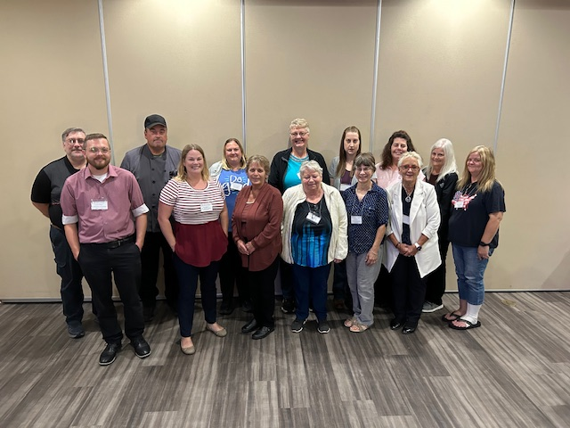
SOUTH DAKOTA ATTENDEES AT OUR FALL ANFP MEETING

Hello!
Hope everyone is getting ready for the upcoming holiday season! We just finished our Fall SD ANFP Conference in Aberdeen and had a wonderful event. The vendors were great, and our speakers were spot on. A big thank you to the board members who helped pull it together and to Jessica Wallace who hosted us.
We are planning to hold the Spring 2026 SD ANFP meeting in Sioux Falls this time. We have been discussing holding a ServSafe Certification training and testing day prior to the conference for those who need to renew. Hope to announce dates for this soon.
For our Spring Conference we will need to elect a President Elect as the current term is ending. Erin Neilsen will be transitioning to President, I will become Past President, which means we will need a President Elect. SD ANFP does offer a trip to ACE the annual national convention one time for the President and one time for the President Elect. Anyone interested in being on the ballot please E-Mail me at mbudd@avantaranorth.com and I can add you. I want to thank all our members for being a part of the SD ANFP and for all the dedication and professionalism you bring every day to your work. We are here for you to help you learn, and to help grow, as the reputation CDM’s have of being the best in the foodservice industry.
Happy holidays and hope to see you in the spring!
Mark Budd CDM, CFPP
President SD ANFP
Treasurer Report:
$8836.84

Hello SD ANFP Members,
We enjoyed seeing several members at the Fall SD ANFP Conference held in Aberdeen September 24-26th. Thank you for attending! Thanks also to all the board members who helped organize this event.
A BIG thank you to our Food Show Vendors:
US Foods
doTerra International
Medtrition
The Spring Conference will be in Sioux Falls and we are planning Fall 2026 to be held in Deadwood. Please reach out to any board member with speaker and topic input for the next conferences.
Keep in touch and stay well,
Carol Rice, CDM, CFPP
SD ANFP Education Coordinator

ANFP MEMBER REPORT:

147 Members
1 new member

Reported by,
Vanessa Soulek, CDM, CFPP
SD ANFP Membership Chairperson
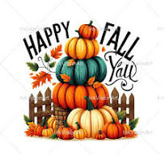

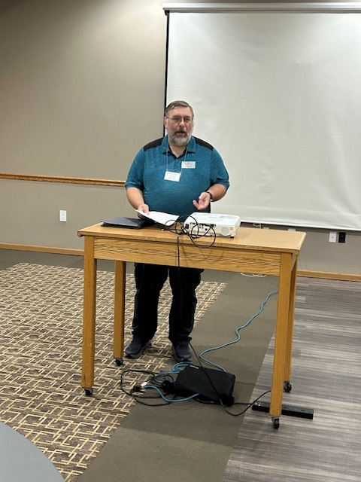
Mark Budd-Ethics in the Workplace
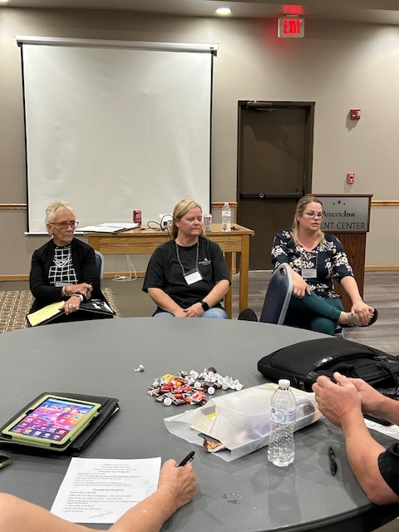
Topical roundtable discussion with Vanessa Soulek, Jessica Wallace, and Erin Nielson
BEST PRACTICE PANEL-
Facilitators: Jess Wallace, Vanessa Soulek, Carol Rice, Mark Budd, Erin Nielson and Karla O’Daniel
Topics for the best practice panel were Staffing, Creative Menu Planning, and Career Growth.

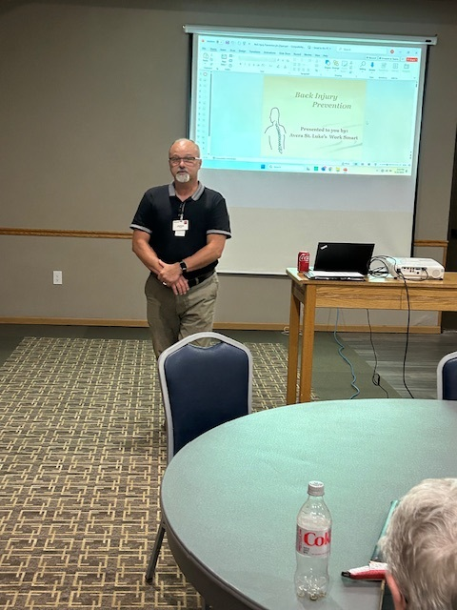
Avera Physical Therapy-Proper Lifting by James Kokales
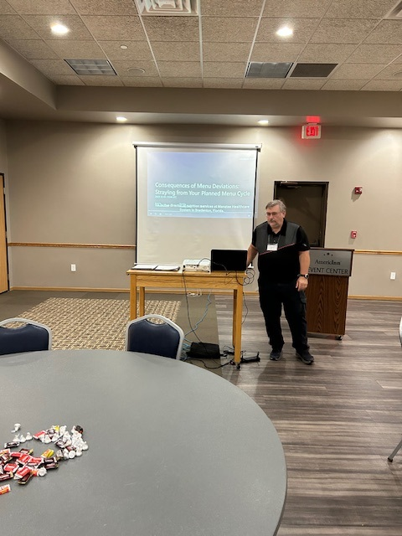
Consequences of Menu Deviations: Straying from Your Planned Menu Cycle

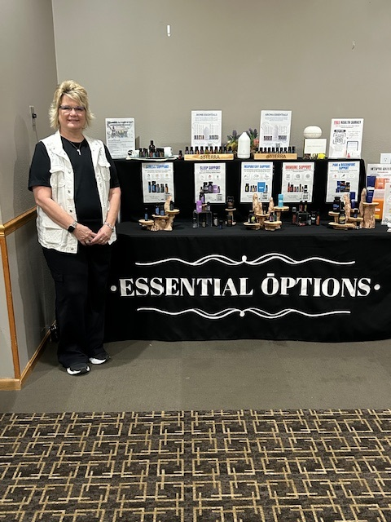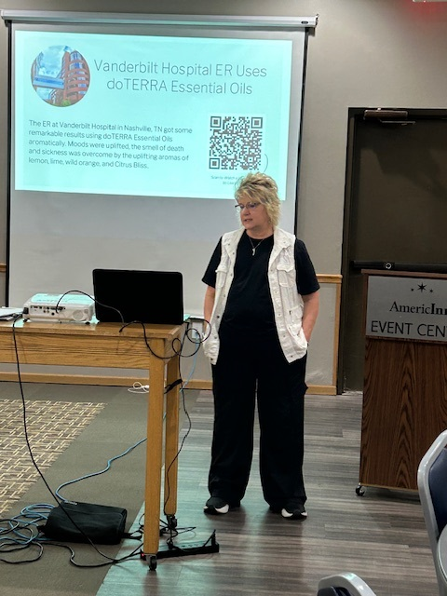
Jerri Vedvei from DoTerra-Presented on Essential Oils & Nutrition and Gut Health

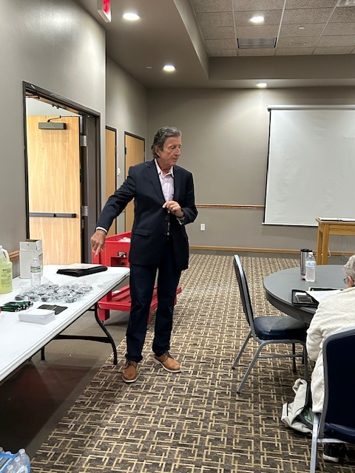
John Skorjanec from Sunburst-Proper Chemical Usage

Medtrition had a table of information and samples to give out to our ANFP Members.

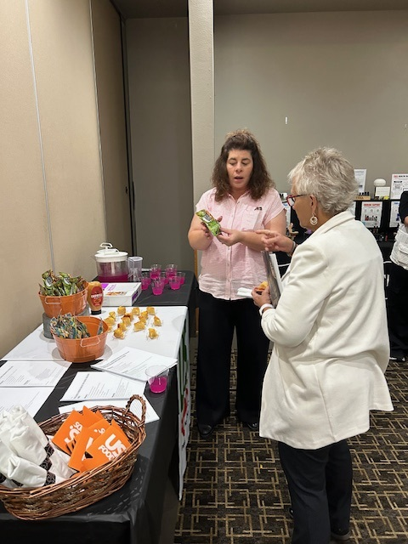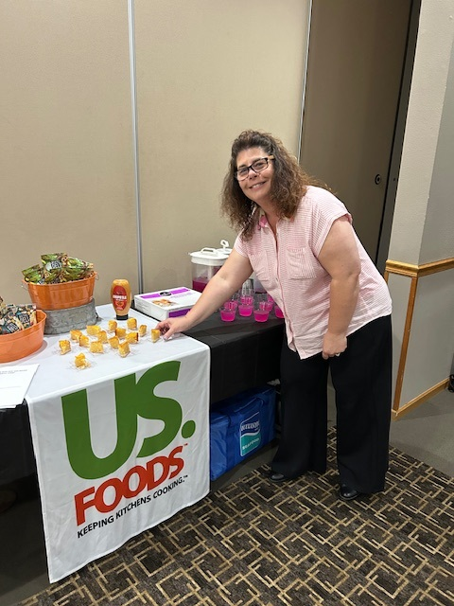
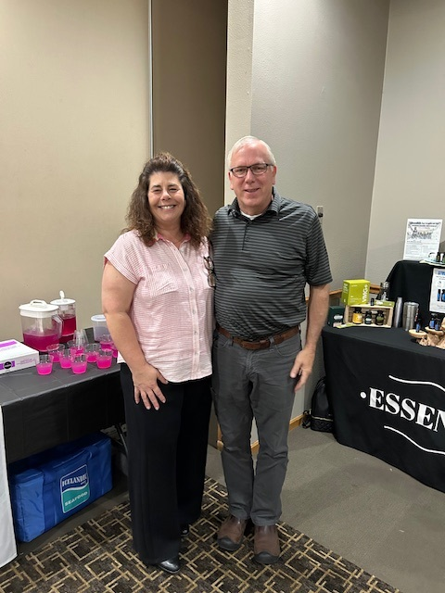
US. Foods -Food Show


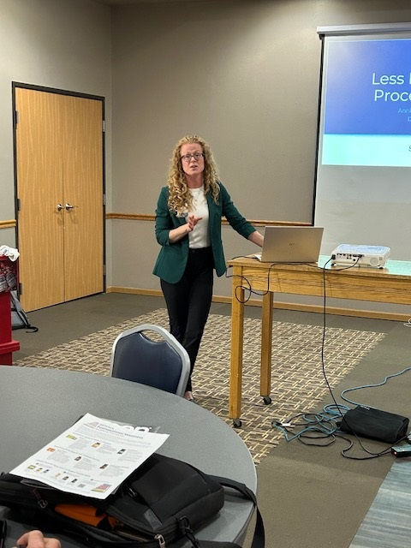
Annie Jacobson-Processed Foods
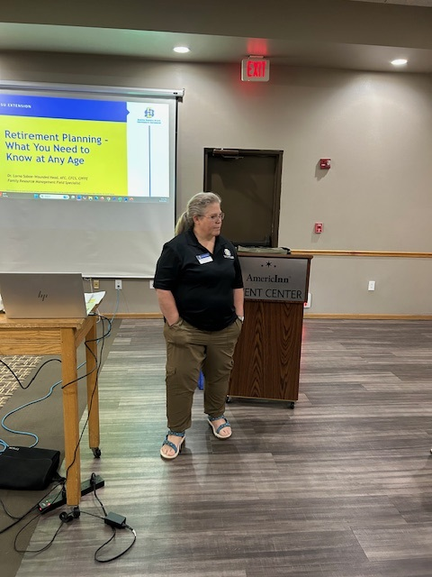
Lorna Woundedhead-SDSU Financial Planning
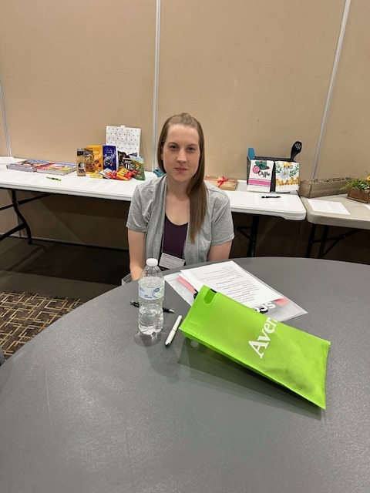
SD ANFP member-Ember Englund This is her first time joining one of our conferences.
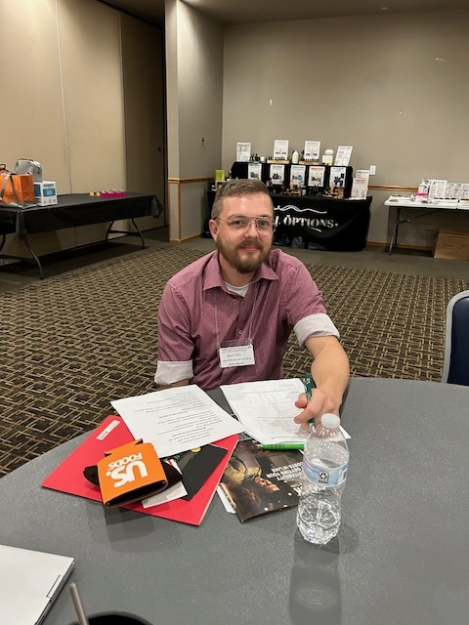
SD New ANFP member- Austin Ehlers

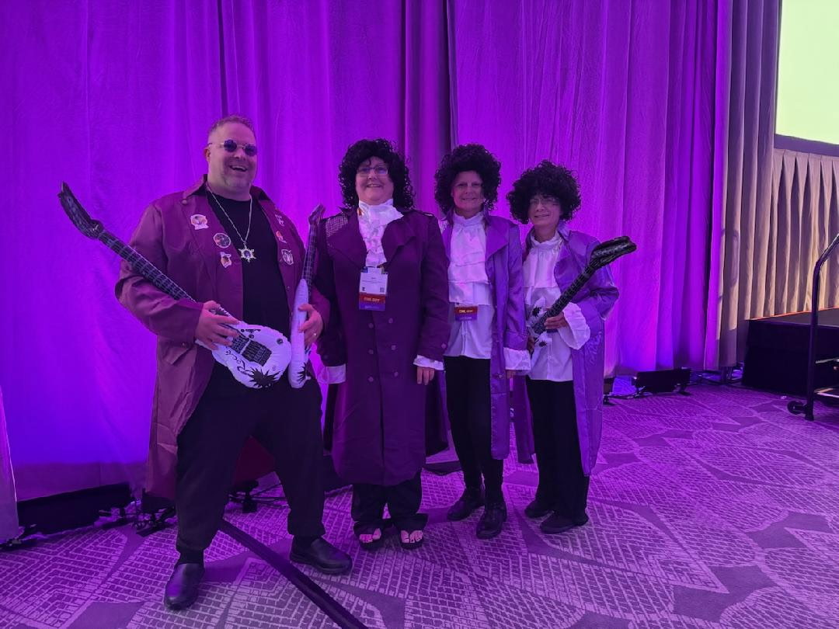
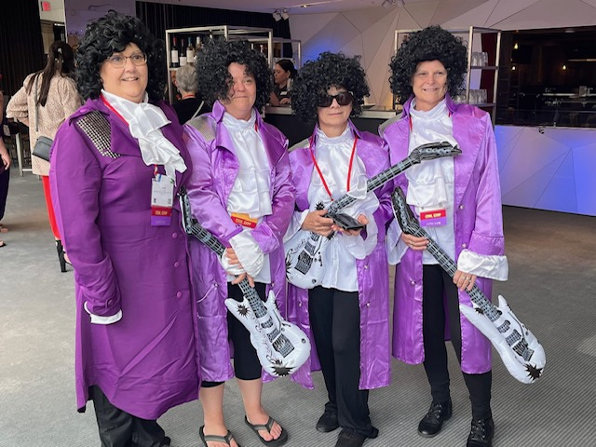
Having some fun at the 2025 Annual Ace Conference & Epo in Bloomington, Minnesota at that Gala. The theme was Purple Rain.
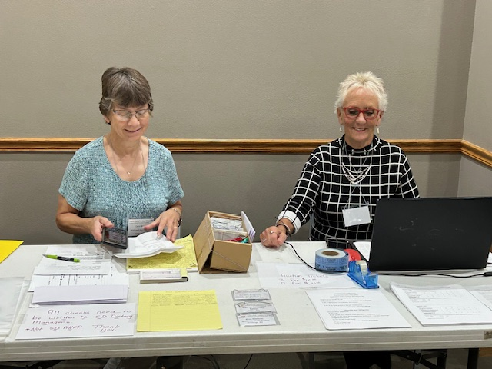
Carol Rice-Education Chair and Vanessa Soulek-Membership Chairperson helping with Registration

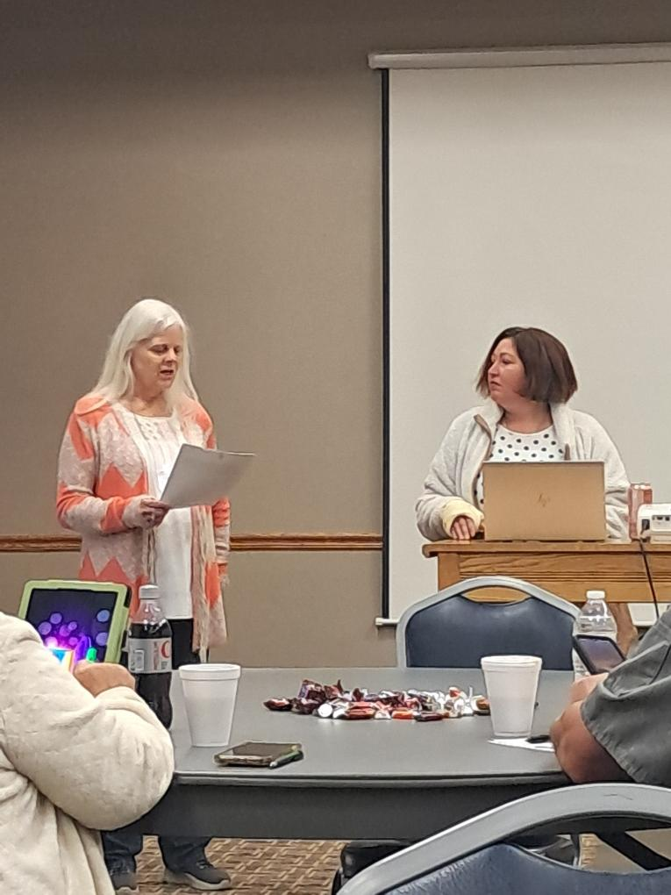
Jamie Bertsch-Dining Environment
Delaine Rasmussen, RD-She presented on Ready, Set, Start Counting (Carb Counting)
Joey Rost-Presented on How to build a great culture.

Happy Thanksgiving

COMMUNITY SERVICE PROJECT- ANFP MEMBERS
DONATED ITEMS TO THE ABERDEEN AREA HUMANE SOCIETY LIST. WE HAD A TABLE FULL OF WONDERFUL DOG AND CAT DONATIONS.
THANK YOU ALL!




Hello,
Hope all is well! I enjoyed seeing everyone at the ANFP Fall meeting. I’m hoping you all can join us at the Spring Conference in Sioux Falls of 2026 and the Fall Conference in Deadwood of 2026. More information to come on this. Wishing you a happy and blessed Holidays!
Karla O’Daniel, CDM, CFPP
ANFP Newsletter Editor

