South Dakota ANFP Chapter - Current Officers
President4117 West Main | Budd, Mark  4117 West Main Street, Rapid City, SD 57701 (605)-430-0384 | (319)230-8513
President Elect | Erin Neilsen  18471 481 Ave., Brandt, SD 57218-5408 (605)-759-4299 | (605)343-4738 (15)
Secretary | Kozlik, Dannielle  1550 Seger DR Lot 110, Rapid City, SD 57701-7823 (605)-389-8606 | 605-389-8606
Treasurer | Elsen, Julie  1312 1st ST Britton, SD 57430-2282 (605)- 448-2253 | (605) 448-2253
Education Chairperson | Rice, Carol  16739 368th Ave, Rockham, SD 57470 (605)-460-0247 | (605)460-0247
Newsletter Editor | O’Daniel, Karla  37030 171st ST, Zell, SD 57469-7706 (605)-475-7482 | (605)475-7482
Membership Chairperson | Soulek, Vanessa  1329 Sherman ST Hot Springs, SD 57747-1464 (605-)-695-0163 | (605)695-0163
Past President | Rost, Joey  3113S Fernwood Ave, Sioux Falls, SD 57106-2614 (319)-230-8513 | (605) 940-1368

SOUTH DAKOTA ANFP MEMBERS

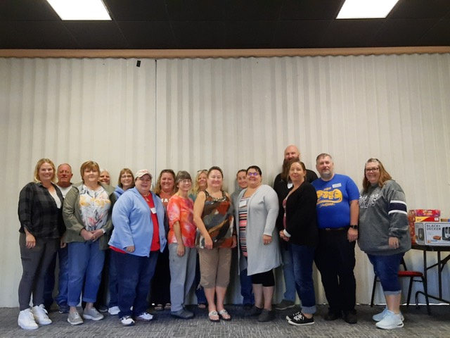
SOUTH DAKOTA ATTENDEES AT OUR FALL ANFP MEETING

Treasurer Report:
$10, 269.39
We donated $400.00 to the NFEF-Nutrition and Foodservice Education Foundation to support various grants and research initiatives that strengthen the role of Nutrition Foodservice Professional.
Reported by Julie Elsen-ANFP Treasurer

SD ANFP Newsletter item:
We had another informative SD ANFP meeting this fall in beautiful Hot Springs, SD. What a great opportunity to meet members face to face and learn what challenges and successes everyone is experiencing.
Thank you to Vanessa Soulek and Tracy Buckley for co-hosting! The facility was very accommodating. I don’t know how you got such great weather for the entire conference.
I hope everyone will consider attending the national meeting in Bloomington, MN. We will continue to share information on Facebook and by email. (Be sure to keep ANFP updated on your current email, address, etc.). This meeting will be in place of the South Dakota spring meeting.
Take care and keep in touch with questions or ideas for our next meeting (topics, speakers etc.).
Carol Rice, CDM, CFPP
SD ANFP Education Chair

ANFP MEMBER REPORT:

150 Members
3-students
3-new Certified Dietary Managers

Reported by,
Vanessa Soulek, CDM, CFPP
SD ANFP Membership Chairperson

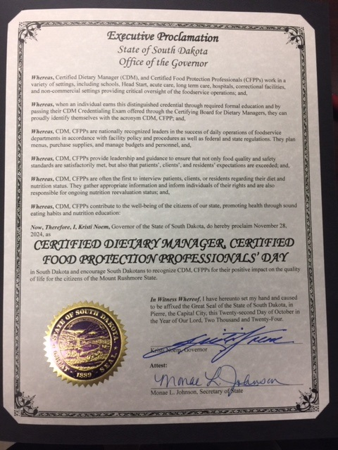
CERTIFIED DETARY MANAGER, CERTIFIED FOOD PROTECTION PROFESSIONAL’S DAY
NOVEMBER 28TH 2024

Reminder
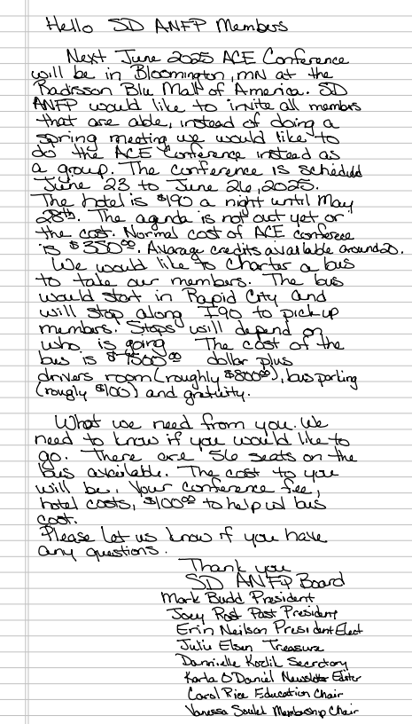

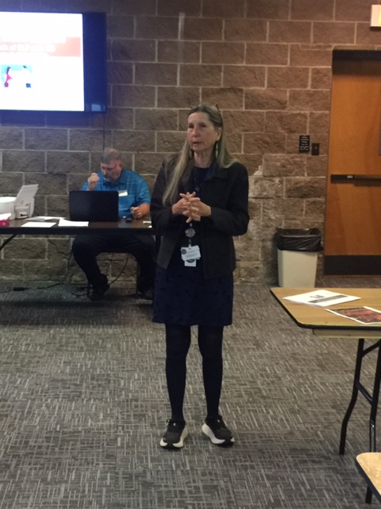
The beginning to the end for the speech process as we age – presented by Annie Parsells, CCC-SLP
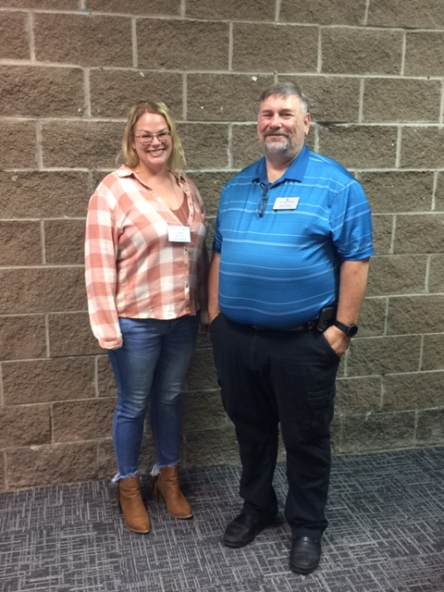
Erin Nielsen sworn in for President Elect and Mark Budd sworn in for President

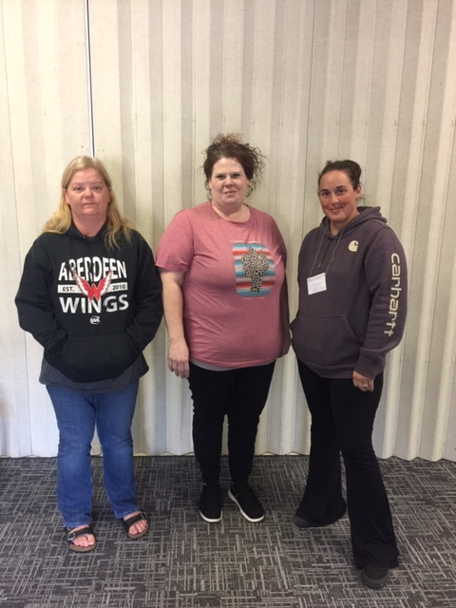
Jessica Wallace-Advantara-Groton
Sarah Freeman-Advantara-Norton-Sioux Falls
Krista Shurger-Advantara-St Cloud-Rapid City

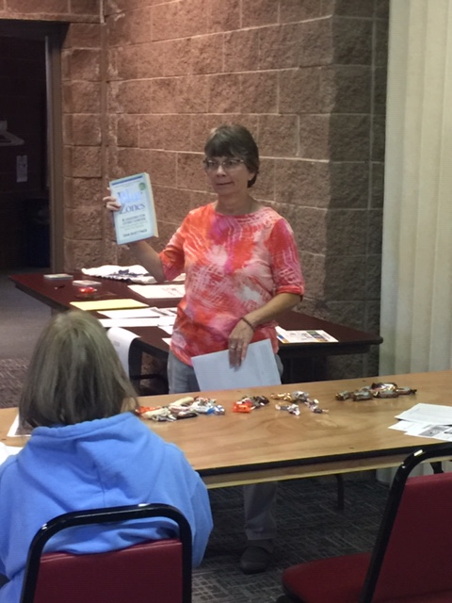
Carol Rice Presentation on Nutrition Tidbits

COMMUNITY SERVICE PROJECT- ANFP MEMBERS
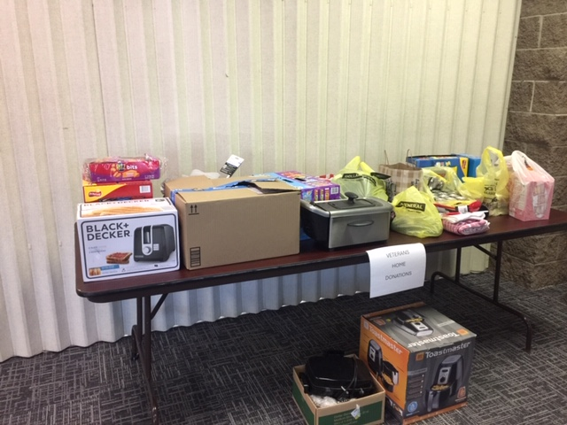
Donated items to the Veterans Home in Hot Springs, SD

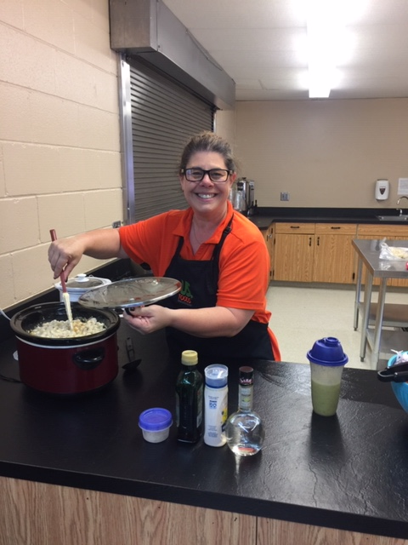
Lunch provided by US FOODS-Evanthea Georgas-Long

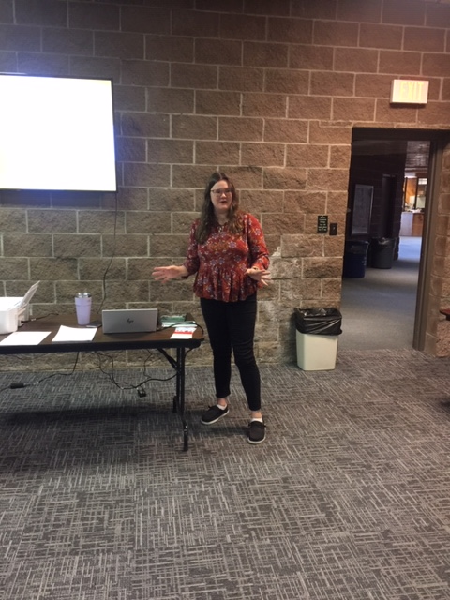
Kitchen and Dining Pathways presented by Rachel Landmark, MS,RD,LN

The Mammoth Site
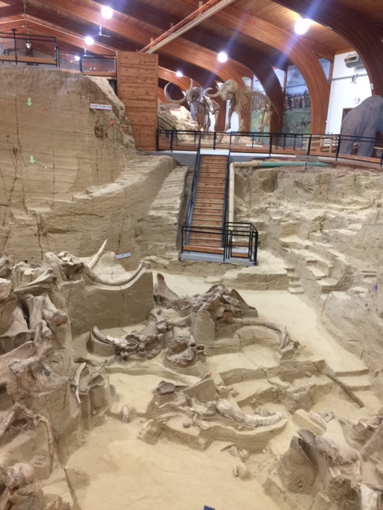
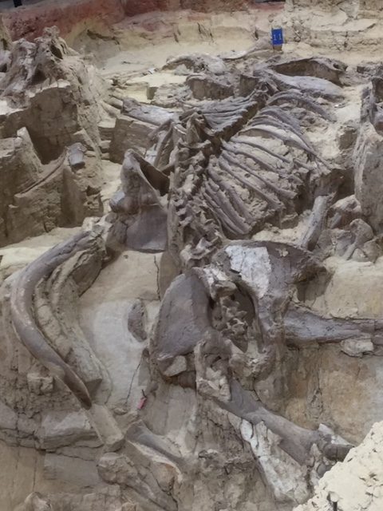

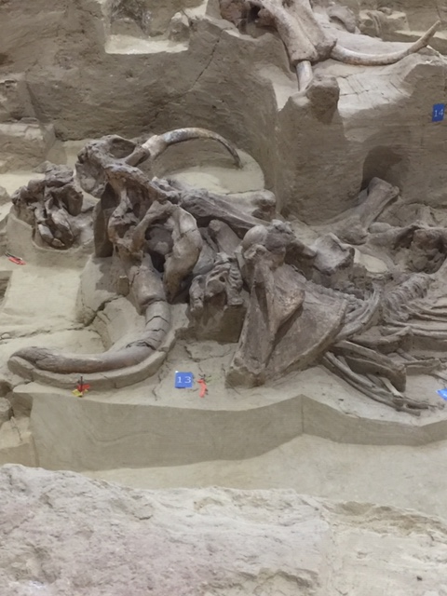

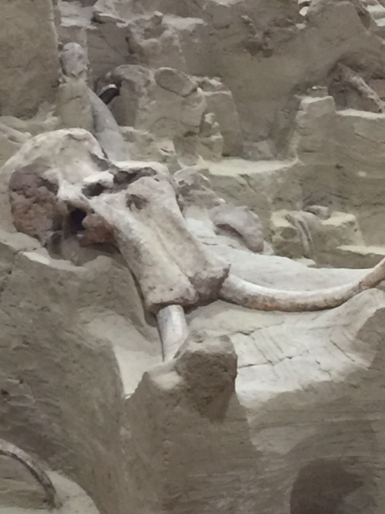

Greetings,
Hope all is well! I enjoyed seeing everyone at the SD ANFP Fall meeting. I’m hoping you all can join us at the ANNUAL CONVENTION AND EXPO (ACE) ANFP NATIONAL CONFERENCE 2025 in Bloomington, MN in June 2025. The weather this October and November (so far) has been great. Wishing everyone Happy Holidays!
Take care,
Karla O’Daniel, CDM, CFPP
ANFP NEWSLETTER EDITOR

Hello all!
I hope everyone has had a great year so far and are looking forward to the holidays! I enjoyed the Fall meeting in Hot Springs and thank you to the members & students who attended. A big thank you to Vanessa and Tracy for hosting! I am glad that our new banking system, Crowded, was easy to use and hope everyone felt that way also. We have been informed that the processing fee for checks will now be waived for us, making it even easier to use.
Anyone who wishes to attend ACE should know that you must register on the ANFP website. SD ANFP will be providing a bus from Rapid City to Minneapolis in June at the cost of $100 per person. This includes round trip fuel, event parking fees, and driver fees. I highly encourage our membership to attend as it is not only educational, but also a lot of fun and an awesome networking opportunity. Meeting members, board members, and vendors from other states is a great experience as well.
As you may have seen, it is also time to volunteer for National board positions, as well as put in for recognition of your achievements with awards. Stand up and be recognized as there are definite benefits to being a volunteer and/or and award recipient. Hope to see everyone at ACE!
Happy Holidays!
Mark Budd, CDM, CFPP
SD ANFP President

