
January- March 2024
February 5th thru the 9th 2024

This Photo by Unknown Author is licensed under CC BY-NC

Hello ND ANFP Members. I am Melanie Elverud CDM CFPP Chapter President. I hope you all had a great time at the fall conference in Fargo. Hope to see more of you at our spring meeting in Bismarck starting May 7th 2024. We are still looking for Volunteer’s for some committee’s. I will be calling on the list I received from ANFP for volunteer’s. It nice to see that members are willing to help out.
Enclosed in the Newsletter is information on the New Apprenticeship program and the programs that UND offers to receive the ceu’s you need for your crediental.
Don’t forget about the AC&E Confrenece in Reno NV June 10th -13th 2024
If members are wanting to go arrangements can be made. Please contact one of the officer’s
Don’t forget to check us out anf join our Facebook page NDANFP .
Thanks, Melanie Elverud,
Chapter President, Melverud@lhgs.org
701-260-4805

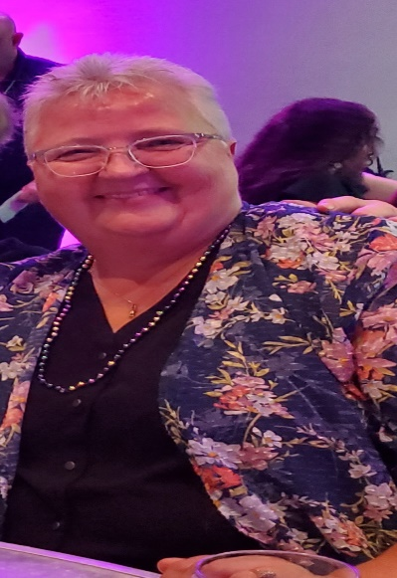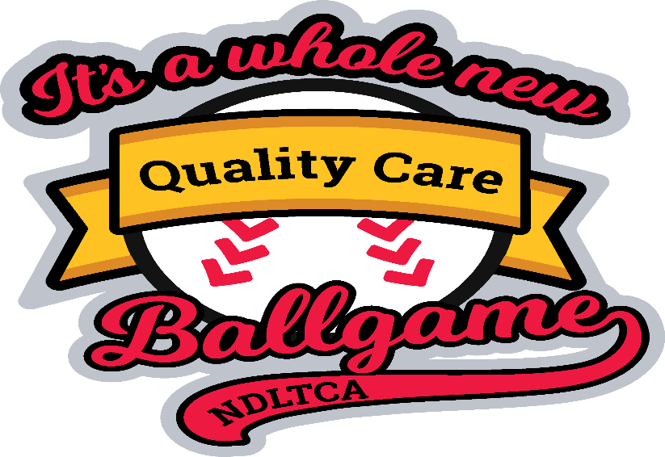
May 7-10-2023



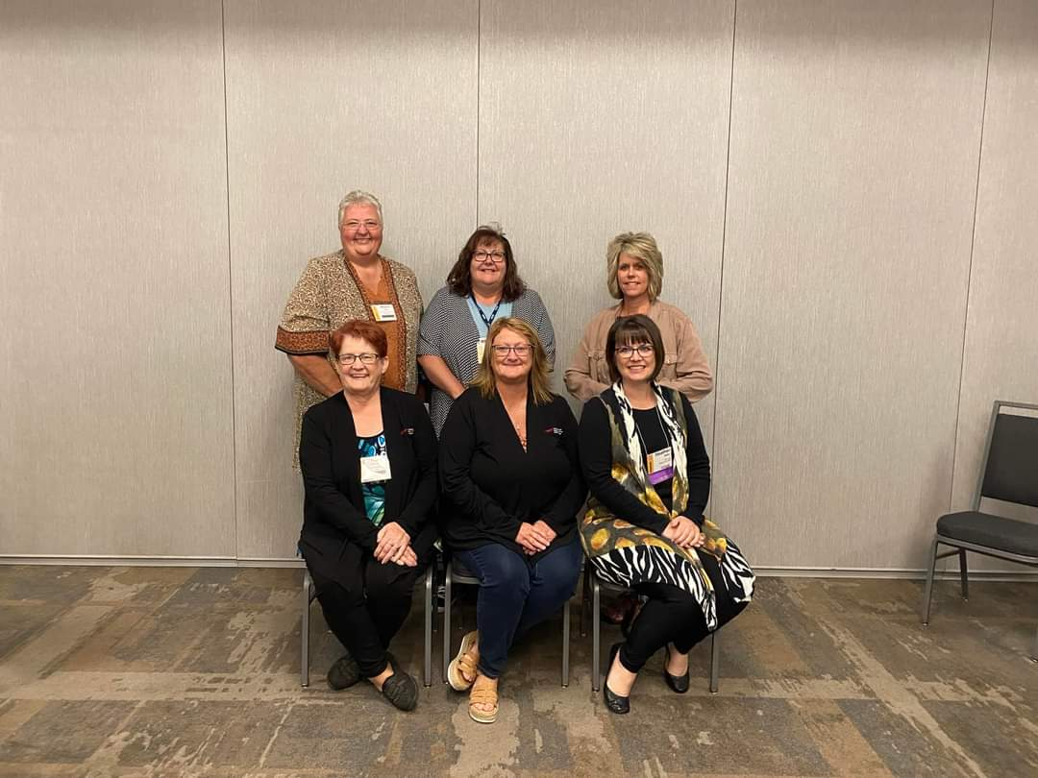
ND ANFP Board Members:
Melanie Elverud President, Laura Hahn Treasurer, Melisa Roehrich Secretary,
Yvonne Foyt Retired, Corrina DesRoches Past President, Heather Weber Mentor

Call to order – President Corrina DesRoches 6:03pm
Welcome and Roll Call –
President – Corrina DesRoches
President Elect – Melanie Elverud
Secretary – Melissa Roehrich (absent)
Treasure – Laura Hahn
Past President/ Fundraising (Open, Yvonne retired)
Government Affairs - (Open, Yvonne retired)
Newsletter Editor – Kristi Nelson (absent)
NDLTCA Education Committee – Corrina DesRoches
Angela Collins (Absent)
Membership Committee – Heather Weber (absent)
Finance Committee – Laura Hahn, Heather Weber, Melanie Elverud and Margie F
New ones in the Spring
Mentors Heather Weber and Corrina DesRoches

Mission statement New – Build an inclusive and diverse community of experts in food service management and food safety through: Education, Advocacy and Research
Vision Statement – Enhance health and wellness through optimum nutritional care

Approval of Minutes from May 2nd, 2023
- Motion: Laura Hahn Second: Melanie Elverud
Motion Approved: Yes

Unfinished Business: None

Reports
Secretary – Absent
Treasure Report – Balance of our account as of September 20th is $11,109.10
-New worksheet for Budget will start in January 2024. Will share with everyone once completed
-Got more signatures for checks
- Audit was completed by the board at this meeting
- Jalicia Hanson will be taking over in the Spring for Treasurer
Jhanso23@goodsam.com

President Elect – Opening for this officer
Past President – No report
Government Affairs/Fundraising – Opening for this officer
Day at Capitol 2025
Bucket draw for fundraiser in this fall meeting
PAC is a political Action Committee
Newsletter Editor/Webmaster – Kristi Nelson (Absent
NDLTCA Education Committee – Corrina DesRoches
Need topics for spring conference
Membership Committee – Heather Weber (Absent) 103 Members
Job Fairs at High Schools to get information out to the students about being CDM
Nominating Committee / Awards
Need new finance committee members
Angela Collins received the Horizon Award at ACE Conference
We received the Government Affairs Award at ACE Conference

New Business:
- New Finance Worksheet to start Jan 1st
- Continued Competence for ANFP Chapter Leadership can get CEU’s for this
- ACE Conference – Corrina and Melanie update on the conference
- Surveys to distribute to get membership input on the leadership positions
- June 1st new Competency Guidelines came out for CDM’s, You should receive an email if you are due for this new Competencies
- New Practitioner Certification – for Nutrition Care and Sanitation. Through UND to get CDM. Another way to renew your license.
- Apprentice Program was discussed and it’s a way we can get younger people interested in CDM

Open Floor – Serv Safe November 6th in Bismarck and November 14th in Grand Forks

Next Meeting
Spring Conference 2024 May 7th

Installation of President – Melanie Elverud was sworn in for President so Corrina will be our past president.

Meeting adjourned by Corrina at 1:00pm.

Call to order – President Corrina DesRoches 6:03pm
Welcome and Roll Call –
President – Corrina DesRoches
President Elect – Melanie Elverud Secretary – Melissa Roehrich (absent)
Treasure – Laura Hahn
Past President/ Fundraising (Open, Yvonne retired)
Government Affairs - (Open, Yvonne retired)
Newsletter Editor – Kristi Nelson (absent)
NDLTCA Education Committee – Corrina DesRoches
Angela Collins (Absent)
Membership Committee – Heather Weber (absent)
Finance Committee – Laura Hahn, Heather Weber, Melanie Elverud and Margie F
New ones in the Spring
Mentors Heather Weber and Corrina DesRoches

Mission statement New – Build an inclusive and diverse community of experts in food service management and food safety through: Education, Advocacy and Research
Vision Statement – Enhance health and wellness through optimum nutritional care

Approval of Minutes from May 2nd, 2023
- Motion: Laura Hahn Second: Melanie Elverud
Motion Approved: Yes

Unfinished Business: None

Reports
Secretary – Absent
Treasure Report – Balance of our account as of September 20th is $11,109.10
-New worksheet for Budget will start in January 2024. Will share with everyone once completed
-Got more signatures for checks
- Audit was completed by the board at this meeting
- Jalicia Hanson will be taking over in the Spring for Treasurer
Jhanso23@goodsam.com

President Elect – Opening for this officer
Past President – No report
Government Affairs/Fundraising – Opening for this officer
Day at Capitol 2025
Bucket draw for fundraiser in this fall meeting
PAC is a political Action Committee
Newsletter Editor/Webmaster – Kristi Nelson (Absent
NDLTCA Education Committee – Corrina DesRoches
Need topics for spring conference
Membership Committee – Heather Weber (Absent) 103 Members
Job Fairs at High Schools to get information out to the students about being CDM
Nominating Committee / Awards
Need new finance committee members
Angela Collins received the Horizon Award at ACE Conference
We received the Government Affairs Award at ACE Conference

New Business:
New Finance Worksheet to start Jan 1st
Continued Competence for ANFP Chapter Leadership can get CEU’s for this
ACE Conference – Corrina and Melanie update on the conference
Surveys to distribute to get membership input on the leadership positions
June 1st new Competency Guidelines came out for CDM’s, You should receive an email if you are due for this new Competencies
New Practitioner Certification – for Nutrition Care and Sanitation. Through UND to get CDM. Another way to renew your license.

Open Floor –
Next Meeting s
Spring Conference 2025

Meeting adjourned by Melanie and Laura 2nd it.

New Member’s
Courtney Archamnbeau CDM, CFPP
Marcus C Bicknese, CDM, CFPP
Breana Buringrud- Student
Ryan Gray- Student
Samantha Hulse- Student
Halle Johnsrud – Student
Kristi Lynn Moch- Student
Sheri Struxness, CDM, CFPP

Chapter Events:

2024 LTCA Spring Conference & Expo

May 6th – May 9th Bismarck, ND

2024 Annual Conference & Expo (ACE)
JUNE 10 - JUNE 13, 2024
2024 Annual Conference & Expo
June 10-13, 2024
Grand Sierra Resort and Casino
Reno, Nevada

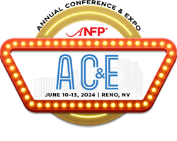

Join ANFP members in your state!
Volunteering with your state ANFP chapter is a great way to begin your volunteer career. There are a variety of positions available for chapter members - including on chapter Boards and Committees. Below is a sample organizational chart of an ANFP chapter structure:
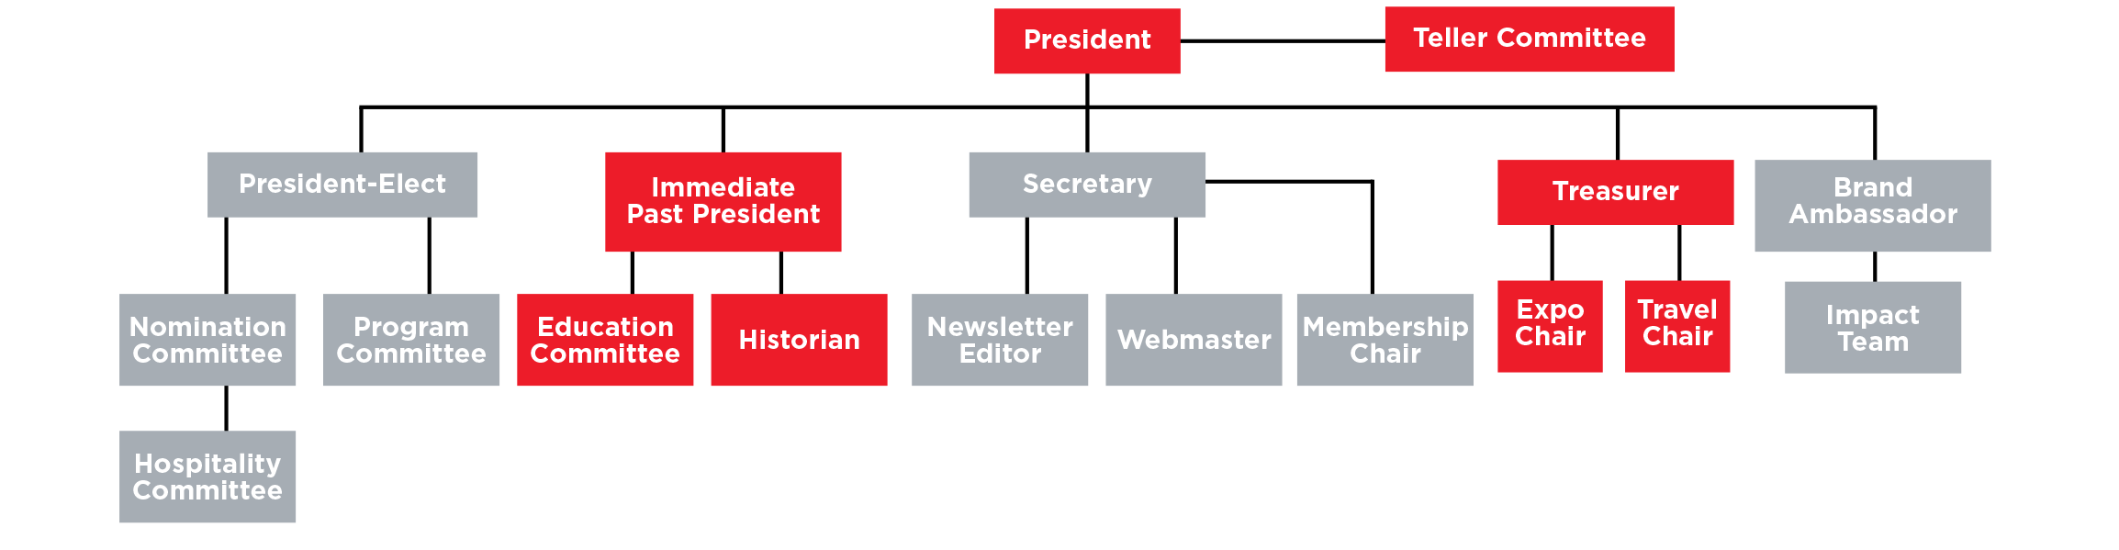

Get started with your chapter today!



Exit

Please fill out the form below and a representative from the selected Chapter will reply to you as soon as possible.

Question Title

* 1. Contact Information:
Name
Email Address
Phone Number

Question Title

* 2. Are you currently a member of ANFP?
Yes
No

Question Title

* 3. Please select your state/chapter:

Question Title

* 4. Please select any chapter board/committee positions you are interested in learning more about:
President
President-Elect
Secretary
Treasurer
Treasurer-Elect
Brand Ambassador
Program Committee
Education Committee
Newsletter Editor
Membership Chair
Expo Chair
Hospitality Committee
)
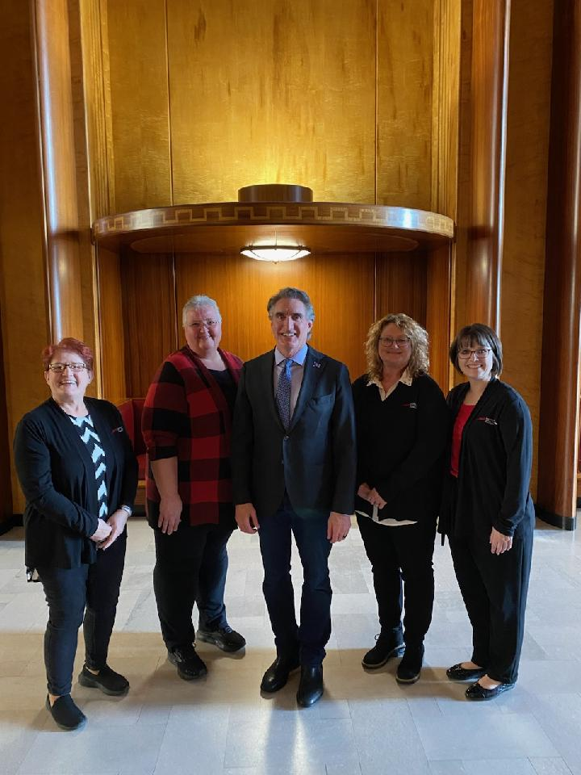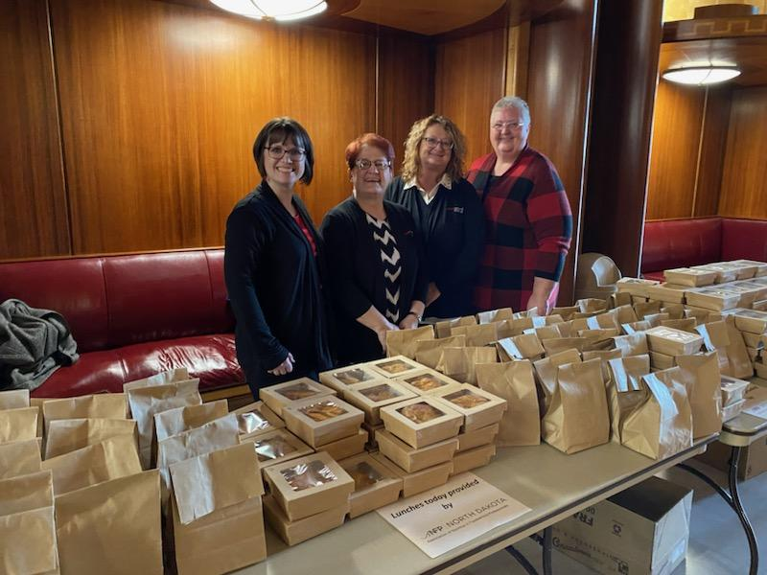
Another successful Day at the Capitol
Yvonne Foyt, Melanie Elverud, Governor Bergum, Corrina DesRoches, Heather Weber
Day at the Capital February 6th 2023, Government Affairs Committee.
We also received Government Affairs award at the ACE Conference in New Orleans in June 2023

National CDM, CFPP Day of the Year is a celebration of the impact that Certified Dietary Managers, Certified Food Protection Professionals have made in the foodservice management profession. It also recognizes the date that the Centers for Medicare & Medicaid Services (CMS) implemented regulatory language that includes my CDM, CFPP credential as the primary qualification for the Director of Food and Nutrition Services in the absence of a full-time dietitian in long-term care settings.
This national day gives ANFP members and their employers the opportunity to recognize the vital work that foodservice professionals perform daily. Spread the word and share this information with your employer and local healthcare associations so they can join in the inaugural celebration!



Practitioner Certificate in Nutrition Care for the CDM, CFPP
A 45 hour CE course, that takes an in-depth look at Nutrition Care and earns all your CE's for your 3-year certification period to maintain your credential.

Enroll Anytime
- The University of North Dakota provides a variety of, CBDM approved, CE (continuing education) courses that will assist you in meeting your required training; and maintaining your CDM, CFPP credential.
- Up to six months of access. There are no refunds and no extensions offered.
- With independent study courses you can enroll anytime and work at your own pace.
- Course cost is $299, which includes tuition and online learning materials.

In this course you will:
- Watch the UND Training video presentation and additional learning videos found in the course
- Read and review the additional learning resources found in each lesson
- Complete each of the learning activities & quiz for each lesson
- Print your certificate of completion for your records

Course at a Glance
- Practitioner Certificate in Nutrition Care for the CDM, CFPP takes in-depth look at Nutrition Care. It covers the ethical standards for clinical documentation, food safety & sanitation compliance vignettes, and a deeper dive into the nutrition care and the power of the pen focusing on communication in charting.
- Students will have access to this online course for up to six (6) months.
- Upon completion of the course, you will be able to print a certificate of completion 45 hours of CE (1 hour of ethics, 9 hours of sanitation & safety and 35 hours of general CE) to meet your 3-year certification period.
- You have six months from your enrollment date to access this course. There are no refunds and no extensions offered.

Practitioner Certificate in Sanitation for the CDM, CFPP
A 45 hour CE course, that takes an in-depth look at sanitation and safety for health care and earns all your CE's for your 3-year certification period to maintain your credential.

Enroll Anytime
- The University of North Dakota provides a variety of, CBDM approved, CE (continuing education) courses that will assist you in meeting your required training; and maintaining your CDM, CFPP credential.
- Up to six months of access. There are no refunds and no extensions offered.
- With independent study courses you can enroll anytime and work at your own pace.
- Course cost is $299, which includes tuition and online learning materials.

In this course you will:
- Watch the UND Training video presentation and additional learning videos found in the course
- Read and review the additional learning resources found in each lesson
- Complete each of the learning activities & quiz for each lesson
- Print your certificate of completion for your records

Course at a Glance
- Practitioner Certificate in Sanitation for the CDM, CFPP takes in depth look at sanitation and safety for health care. It covers the ethical standards for the Dietary Manager Practitioner in Sanitation, sanitation regulation vignettes, and a deeper dive into the federal agencies and regulations that govern food safety and sanitation in healthcare, focusing on the foodservice operation.
- Students will have access to this online course for up to six (6) months.
- Upon completion of the course, you will be able to print a certificate of completion 45 hours of CE (1 hour of ethics, 9 hours of sanitation & safety and 35 hours of general CE) to meet your 3-year certification period.
- You have six months from your enrollment date to access this course. There are no refunds and no extensions offered.

ANFP APPRENTICESHIP PROGRAM
On November 16, 2022, ANFP received final approval of our Apprenticeship Program by the Department of Labor (DOL). Eighteen months prior the DOL recognized the Certified Dietary Manager (CDM) as an Approved Occupation for a Registered Apprenticeship Program. The first apprentices were enrolled in early 2023. When the apprentices graduate from the program they will be a Certified Dietary Manager Apprentice and eligible to sit for the CDM, CFPP Credentialing Exam.
The ANFP Apprenticeship Program is another innovative strategy in our strategic plan goal of member recruitment and retention. It is also part of our partnership with healthcare administrators who require the CDM, CFPP credential in their facilities. Apprentices may receive a $2,000 stipend to offset the cost of the program.
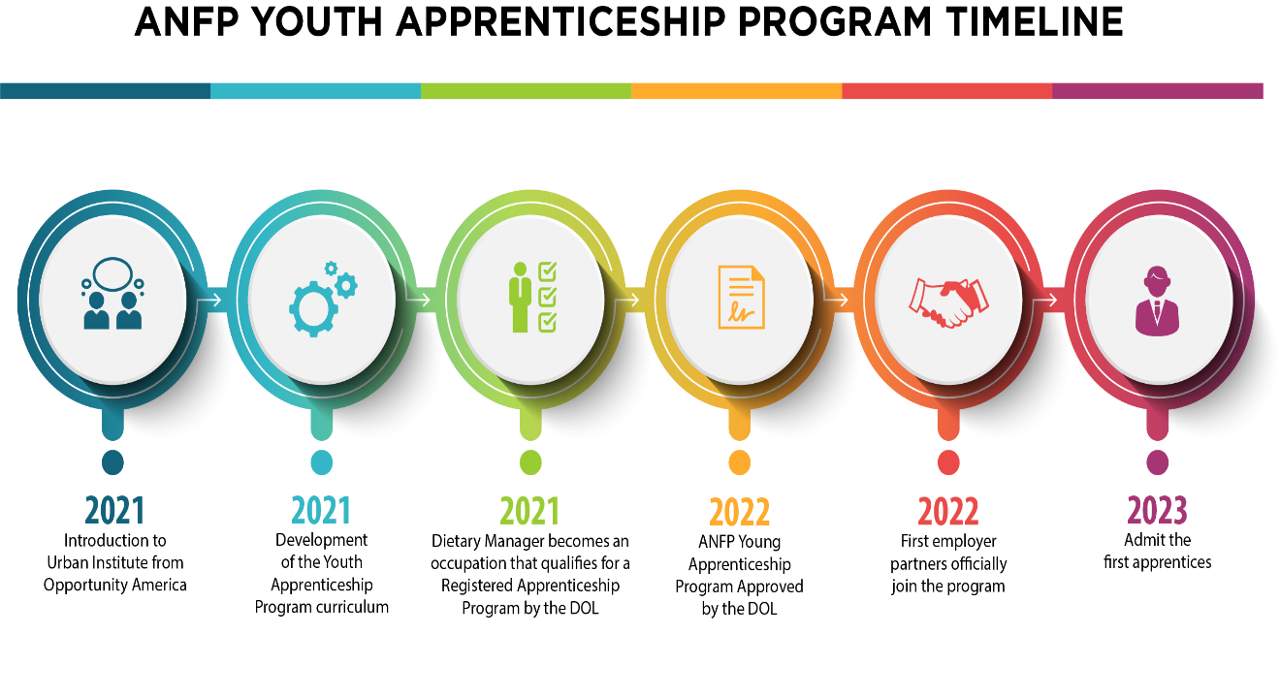

What is the ANFP Apprenticeship Program?
The ANFP Apprenticeship Program provides structured opportunities for those interested in becoming a Certified Dietary Manager, Certified Food Protection Professional (CDM, CFPP). For students ages 16-21, the Youth Apprenticeship Program provides a stipend to offset the cost of the program. Apprenticeships combine academic and competency based technical instruction with paid work experience across healthcare. The ANFP Apprenticeship offers graduates expanded pathways in foodservice management as a CDM, CFPP

e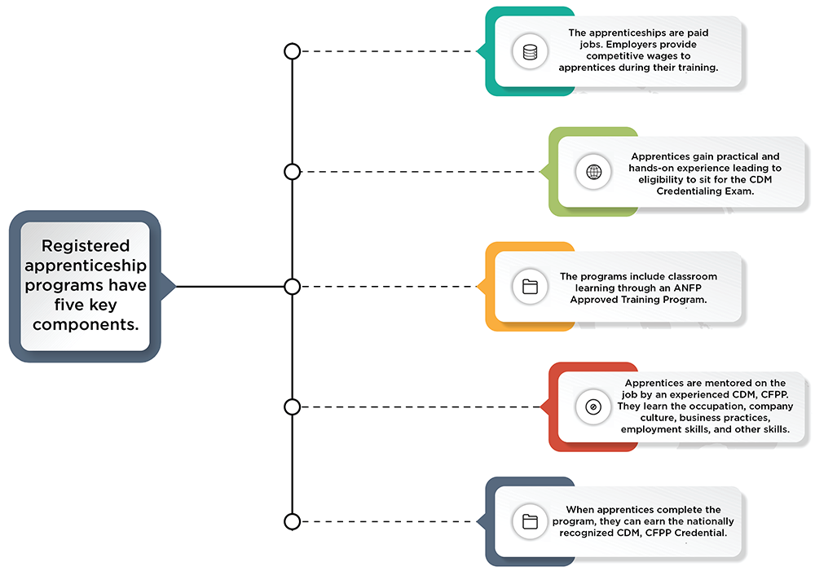

The ANFP Apprenticeship Program is unique, in that we use our Certified Dietary Manager curriculum offered through ANFP Approved Training Programs. Our program offers the following:
- ANFP as the sponsor
- An approved ANFP education provider with an established curriculum to provide the related competencies instruction
- The following employers have partnered with ANFP and agree to hire and pay apprentices:
  - Compass Group
  - Creative Solutions in Healthcare
  - Presbyterian Homes
  - Sodexo
- CDM, CFPP professionals to support the apprentices' learning

ANFP is the sponsor organization that operates the ANFP Registered Youth Apprenticeship Program. The sponsor assumes full responsibility for the administering and operating the program. As the sponsor, we are responsible for the following:
- Designing and registering the program standards with the U.S. Department of Labor's (DOL) Office of Apprenticeship (OA) or State Apprenticeship Agency (SAA)
- Engaging with, supporting, and signing up employer partners to employ apprentices (as applicable)
- Collecting and submitting apprenticeship agreements
- Registering apprentices in the Registered Apprenticeship Partners Information Database System (RAPIDS) or a state data system; RAPIDS is the OA's software database for collecting information about RAPs and apprentices
- Maintaining records including records documenting the following:
  - Apprentices' competency completion
  - Apprentices' progress through the program's on-the-job training
  - Showing required wage increases during the program
  - The sponsor's affirmative action plan (due after the program has been operating for two years)
  - Employer hiring procedures and human resources records
- Reporting apprentice progress to the DOL through RAPIDS
- Participating in periodic DOL program and EEO reviews

More About the Program
The ANFP apprenticeship program meets National Program Standards (NPS) of Apprenticeship consisting of uniform occupational standards, which were developed and sponsored by ANFP. Our program is demonstrably national and multistate in its design, suitability, and scope based on consideration of the NPS criteria; and we comply with DOL registered apprenticeship requirements.
ANFP Apprentices learn their occupation through on-the-job training (OJT) in a healthcare setting. It provides them structured on-the-job learning that apprentices will receive from an experienced CDM, CFPP mentor for at least one year. The training was developed by mapping the competencies and knowledge the apprentice must learn throughout the program to be fully proficient as a CDM, CFPP.
The ANFP Youth Apprenticeship Program is a competency-based apprenticeship; the apprentice's progress is measured by their ability to demonstrate and apply relevant knowledge, competencies, and abilities on the job. Though no requirement for time spent in OJT exists, the apprenticeship must last at least 12 months.

Probationary Period
The apprentice will spend 200 hours of OJT over the course of the program. There is a 1-1-1 ratio of apprentice to CDM, CFPP mentor. All registered apprenticeships have a probationary period. During this period, either the apprentice or the sponsor may terminate the apprenticeship agreement, without stated cause, by notifying the other party in writing.
- After reviewing the probationary period, any probationary apprentice evaluated as satisfactory must be given full credit for the probationary period and continue in the program.
- A probationary period is set at 25% or less of the apprenticeship program's total length.

Additional Information
An ANFP Approved Training Program or school will provide the organized and systematic curriculum designed to provide the apprentice with the knowledge of the theoretical and technical subjects directly related to becoming a CDM, CFPP. In registered apprenticeships, programs will provide at least 144 hours of RTI a year.
The ANFP Youth Apprenticeship Program was developed in partnership with Urban Institute through a project developed with the U.S. Department of Labor. Pursuant to the National Apprenticeship Act, the Department of Labor works to expand opportunities related to apprenticeship programs. This project has been funded, either wholly or in part, with federal funds from the Department of Labor, Employment & Training Administration under contract number/work order 47QRAA18D003Z/1630DC-19-F-00038. The contents of this portal do not necessarily reflect the views or policies of the Department of Labor, nor does mention of trade names, commercial products, or organizations imply endorsement of the same by the US government.

