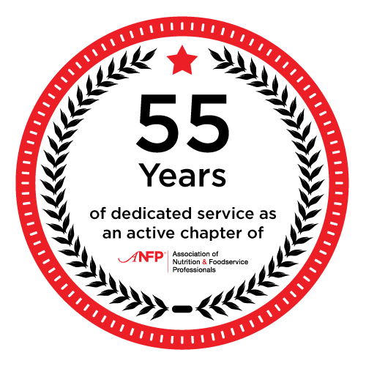
The North Dakota Chapter of ANFP is an affiliate of the national not-for-profit association. ANFP was established in 1960 that today has over 14,000 professionals dedicated to the mission of providing optimum nutritional care through foodservice management.
ANFP is the premier resource for food service managers, directors, and those aspiring to careers in food service management. ANFP members work in hospitals, long-term care, schools, correctional facilities, and other non-commercial settings. The association provides foodservice reference, publications and resources, employment services for members, continuing education and professional development, and certification programs. ANFP monitors industry trends and legislative issues, and publishes one of the industry's most respected magazine.
Vision - Enhance health and wellness through optimum nutritional care.
Mission - Build an inclusive and diverse community of experts in foodservice management and food safety through: Education, Advocacy, and Research.
For more information about ANFP please contact Association of Nutrition & Foodservice Professionals by telephone at 800.323.1908 or 630.587.6336, or by e-mail.
If you have any questions regarding North Dakota ANFP, our activities or events, or if you would like to employ a CDM, CFPP in your facility, please contact us through the Chapter Contact Form.

North Dakota ANFP would like to wish you a Merry Christmas and Happy New Year. We are also reaching out to any members that would like to help with the sack lunch that we are providing at the capital. Please contact me if you can help. Melanie 701-260-4805


This Photo by Unknown Author is licensed under CC BY

MEETING MINUTES


ND ANFP Executive Board Meeting Minutes

Holiday Inn – Fargo, ND
Sept 23, 2024

- Call to Order – President Melanie Elverud

- Welcome and Roll Call

Attendance | Role | Volunteer
Present | President | Melanie Elverud
Present | President Elect
Absent | Secretary | Open
Absent | Treasurer | Laura Hahn to Jalicia Hanson
Absent | Past President / Fundraising | Corinna DesRoches
Present | Government Affairs Committee | Open
Absent | Newsletter Editor / Webmaster | Open
Present | NDLTCA Education Committee | Corinna DesRoches  Need Volunteer
Present | Membership Committee/ | Heather Weber
 | Finance Committee | Laura H, Corinna D, Melanie E, Brandy Marchand
 | Mentors | Yvonne Foyt, Heather Weber

Guests: _______________________________________________________________________________

- Vision/Mission: The Certified Dietary Manager is the cornerstone of the collaborative Dietetics profession. Position the Certified Dietary Manager as the expert in foodservice management and food safety. – Read by Corinna.

- Approval of Minutes from May 7, 2024 Meeting Reviewed.
  - Motion: 1st 2nd
  - Motion Approved: Yes

- Unfinished Business
  - Did everyone update their Board Orientation Binders with the files?

- Reports
  - Secretary – Will be installed in membership meeting

  - Treasurer / Finance Committee – Laura Hahn/ Jalicia Hanson – Laura was not able to be at the meeting but did provide a report.
    - Treasurer’s Report – Report Filed Pending Audit $ is the balance in the account
    - IRS 990 Filing – completed
    - Audit of Books –
    - Finance Committee –
  - President-Elect – Melanie

  - Past President / Fundraising –

  - Government Affairs Committee –

  - Newsletter Editor / Webmaster–

  - NDLTCA Education Committee –

  - Membership Committee –

  - Nominating Committee / Awards –

- New Business

- Open Floor

- Next Meetings –
- Meeting Adjourned – The meeting adjourned at

Meeting Adjourned – The meeting adjourned at the conclusion of business

  - Motion to adjourn: 1st Jalicia Hanson 2nd : Mary Gereszek
  - Motion Approved: Yes

ND ANFP Membership Meeting Minutes

Holiday Inn Fargo, ND - September 24, 2024

- Call to Order: President Melanie Elverud at 12n

- Welcome and Roll Call: President Melanie Elverud
  - New and Student Members and recognized first time attendees and newly certified members: None
  - Members in attendance: Mary Gereszek, Ashley McBroom, Sonja Hathaway, Jalicia Hanson, Corinna Desroches, Deborah K. Strand, Sandy Youngquist, Melisa Roehrick, Brenda Austin, Melanie Elverud, Jennifer Wolfgang, Darla Kuhn, Laura Hahn, Nettie Senger
  - Introduction of officers and committee members

- Vision/Mission: President Melanie Elverud Read the Vision/Mission.

- Approval of Minutes from Board Meeting May 7th, 2024 Meeting
  - Motion: 1st Laura Hahn 2nd Jalicia Hanson
  - Motion Approved: Yes
- Unfinished Business
  - No unfinished business
- Reports
  - Secretary – President Melanie Elverud reviewed minutes from Membership Meeting May 7th 2024 membership meeting

  - Treasurer / Finance Committee – Laura Hahn to Jalicia Hanson
    - Treasurer’s Report – Transition to the new checking account through the ANFP. Checking balance 11107.49
    - IRS 990 Filing
    - Audit of Books – Finance committee will audit Spring 2025
    - Finance Committee – Members: Laura (as reviewer), Corrianna, Brandy Marchand. All members can access financial reports

  - President-Elect – Need a volunteer to fill this role

  - Past President / Fundraising – Corinna Desroches – Basket Bucket Draw at Spring and Fall conference. Great turn out of baskets

  - Government Affairs Committee – Open Melanie reminded Yvonne Foyt Discussed CMS regulations & Day at the Capitol (Feb 6th, 2023). Please contact Yvonne if interested in helping this day.

- New Board Photo and Membership Photo taken..

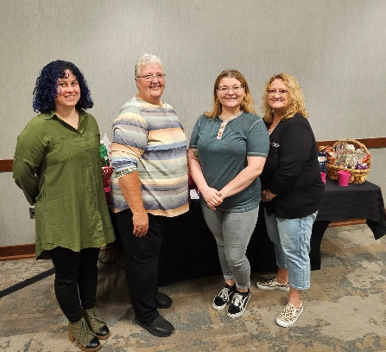

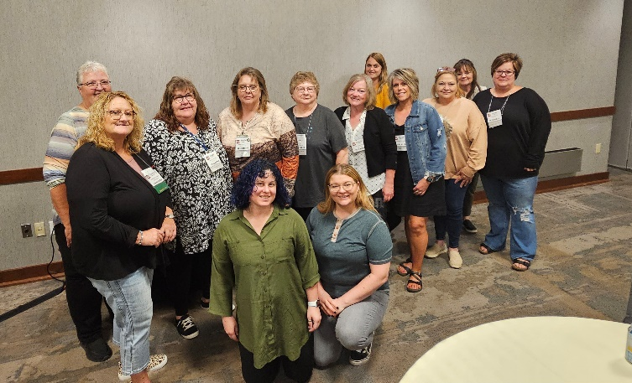

Top 10 Tips for Documenting in the Medical Record

List Compiled by: DeLaine Rasmussen, MS, RDN, CDE, CDM, CFPP

1. Ensure Policies and Procedures are in Place: The CDM, CFPP participates in the nutrition care process and collaborates with the dietitian to establish nutritional screening and assessment documentation policies and procedures. The policies state which qualified interdisciplinary team member will ask client interview questions regarding nutritional status, the care planning process, and how this information is communicated to the interdisciplinary team.
2. Complete Training and Maintain Your Credentials: CDM, CFPPs receive training on navigating the electronic medical records and how to obtain nutritional screening information. Records of staff training are filed within the facility. The CDM, CFPP maintains required credentials and continuing education within the facility.
3. Use Standardized Forms: CDM, CFPPs document using standardized forms such as components of the Resident Assessment Instrument (RAI), Minimum Data Set (MDS), Care Area Assessment (CAA), and care plan. Standardized parameters for anthropometric, biochemical, physical exam, and client history data have been established by the facility and acknowledged by the CDM, CFPP and the dietitian.
4. Interview the Client: Nutritional screening data is obtained from client interviews in a timely manner that complies with your facility policy and regulatory standards. CDM, CFPPs document data such as observed food and fluid intake, calculation of nutrient intake, heights, weights, lab values, changes in diagnosis or health status, oral health, or other nutritional problems and status parameters for further assessment by the dietitian.
5. Identify Nutritional Problems: Through interviewing and observation, identify nutritional problems. Examples include:
- Consistently leaves greater than 25% of meals uneaten
- Does not consume adequate fluids on a daily basis
- Chewing, mouth pain, swallowing problems
- Difficulty using feeding utensils or dinnerware
- Unable to feed self
- Usual routines, behaviors and appetite have significantly changed
- Significant change in weight
- Skin breakdown
6. Document the Client’s Response: Progress notes reflect the observation of a client’s response to the dining environment and dining preferences, food and fluid intake, and usual dining routines and behaviors.
7. Maintain a Care Plan: Nutritional interventions are care planned with appropriate interdisciplinary team members to address family, staff, or the client’s nutritional concerns. CDM, CFPPs collaborate with the dietitian and client to establish goals and approaches for a nutritional care plan that are routinely monitored, reviewed, and revised.
8. Document Progress: Sufficient documentation of progress toward achieving care plan goals and the rationale for changes in plans of care are documented by the CDM, CFPP and the dietitian.
9. Follow Medical Record Guidelines: Medical records are legal documents. An electronic health record system has:
- A written protocol describing the attestation policy in force
- An individual identifier for each person responsible for an attestation
- Built in safeguards to minimize the possibility of fraud and HIPAA violation
- Date and time recorded from the computer’s internal clock at time of entry
- Control of areas and actions an individual can access or enter data
*If using paper medical records, entries are in black ink, dated and signed with full name and title, and never backdated or erased. Medical record errors are connected by a one-line strike out, initialed, dated and labeled “error.”
10. Audit Medical Records: Copies of recent surveys indicate compliance with regulatory guidelines regarding documentation in the medical record. Problem areas are noted and plans of correction are developed by the CDM, CFPP in collaboration with the dietitian and facility administrator. Routine audits are completed for accuracy and appropriateness per facility policy.
Download a printable flyer below with the information on this page.

top 10 Ways to Motivate Employees

List Compiled by: Milton McGowian, MBA, CDM, CFPP, FMP, MCP
1. Align an employee’s personal goals with a higher purpose through work.
2. Ensure that employees’ work needs & desires are realized.
3. Foster a relationship before task culture.
4. Show commitment to training and development for all employees.
5. Adopt direction-giving, which is a form of speech that brings transparency to work by articulating all the crucial information that is necessary to perform one’s job.
6. Show team members the bigger picture by communication to the employee that his/her skill sets are distinctly appreciated and helps guide the employee’s talents toward organizational contribution.
7. Convey support & compassion for an employee to relay genuine care for an employee’s well-being.
8. Encourage team members to control their own destiny.
9. Inspire employees to be creative at work and to think outside the box to generate innovative ideas.
10. Exhibit intrinsic motivation qualities, which shows that the leader possesses interest and enjoyment in the task of helping and supporting team members.

pride in Foodservice Week

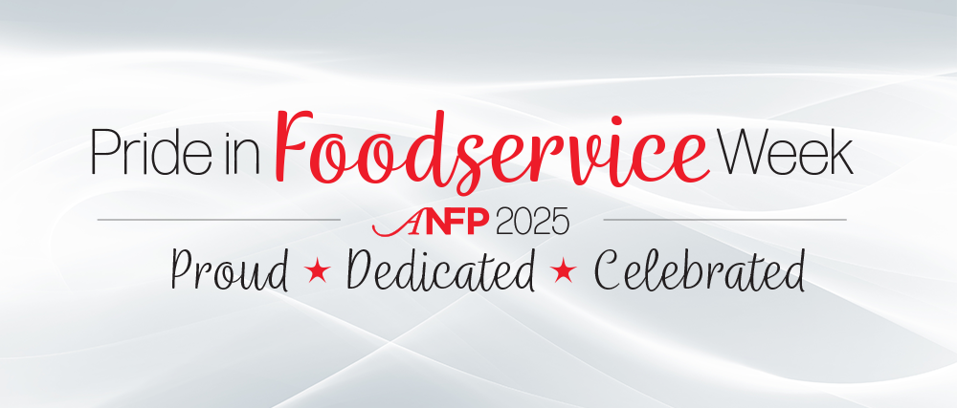

Save the Date for 2025 Pride in Foodservice Week!
ANFP will celebrate our annual Pride in Foodservice Week February 3-7, 2025! This week of celebration encourages foodservice industry employees, employers, and friends to celebrate the vital work non-commercial nutrition and foodservice professionals perform on a daily basis.

Day at The Capital will be Tuesday February 4th, 2025 We will be providing a sack lunch for the legislature. If your available to help please contact Melanie 701-260-4805.

This Photo by Unknown Author is licensed under CC BY-ND

Five Reasons to Attend ACE in 2025

The ANFP Annual Conference & Expo (ACE) is the premier conference for foodservice professionals. ACE is designed for CDM, CFPPs, ANFP leaders, industry stakeholders, and corporate partners.
Spend four engaging and motivational days participating in education sessions, networking events, and the can't-miss expo featuring a wide variety of foodservice vendors.

1. Network with Your Fellow Foodservice Professionals
One of the best benefits of an in-person conference is the opportunity to meet or reconnect with your industry peers! Come to ACE ready to meet with like-minded individuals who uniquely understand your workplace trials and day-to-day experiences.

2. Gain Continuing Education to Nurture Your Career
To maintain the Certified Dietary Manager, Certified Food Protection Professional (CDM, CFPP) credential, you must earn 45 hours of continuing education (CE) every three years. Attending ACE gives you the opportunity to earn CE hours! Foodservice is an ever-evolving industry, and education plays a primary role in helping you stay up-to-date with the latest technology and trends.

3. Expand Your Connections with Expo Vendors
The Expo at ACE hosts a number of exhibitors that cover a wide array of foodservice industry companies and organizations. The Expo Hall will be full of innovative products and services. You will have the opportunity to sample, test, and evaluate the latest technology in foodservice. Whether you are happy with your current vendors or are interested in seeing what other opportunities are available, the Expo is the perfect event to meet face-to-face with the companies whose products and services you may use every day!

4. Gather Knowledge to Implement and Impress
To attend ACE, your supervisor may prefer a written request for your professional development. We took care of that for you with our Letter to Your Supervisor template. Simply fill in all applicable information including your supervisor’s name and the education sessions that you are specifically interested in (the schedule will be available in the coming months). Feel free to customize and edit this document to your specific preference, but this should serve as a place to start!

5. Enjoy Some Much-Deserved Time Away!
We know that CDM, CFPPs and other non-commercial foodservice professionals work in stressful and demanding environments. This year’s ACE is the perfect opportunity to engage in professional development, but also to take some time for yourself! Fun ACE events like the Honors Gala are the perfect opportunity to leave your stress behind and take some time with yourself and your ANFP friends. You can also take advantage of the Mall of America and nearby Minneapolis to return to your facility feeling refreshed, recharged, and armed with useful knowledge to continue navigating workplace changes.

Save the Date for the 2025 Annual Conference & Expo!

June 23-26, 2025 | Bloomington, MN

Radisson Blu Mall of America



1. Know Your Menu
It is important to balance high and low food cost items. Be aware of products that are “special order” items so you stay within your budget.

2. Use your Menu to Help Control Food Costs
When planning your menu, utilize each ingredient to maximize the value each one brings to your menu. Cook seasonally and use standardized recipes for consistency and to control your costs.

3. Order Food with Quantity in Mind
Develop and update production sheets often and order in bulk for certain items you use in large quantities. It is important to understand your product types, (cuts of meat, styles of pasta, grades of food, etc.) Additionally, you should know your yields and Edible Portion (EP) and check package sizes and quantities. To prevent food waste, do not order food too far in advance, and place orders after all stock is organized on your shelves.

4. Make Sure Your Food Orders are Correct
Do not be afraid to send a product back if it is not up to your expectation or if it is incorrect! Be sure to check all items when you receive them, for accuracy.

5. Utilize Portion Control When Serving
Serve correct portion sizes, using appropriate serving utensils and measurements, weighing as needed. This will ensure consistent portions for your customers and as a result, you will not exceed the amount of product you plan to use.

6. Decrease Waste
If you have extra product or leftovers, get creative! Treat each product or leftover with value and use it where possible. To further decrease waste, establish a waste log to help you track your waste and take steps to decrease it.

7. Keep Track of Your Food Inventory
It is imperative that you maintain a proper and detailed inventory. Do not conduct an inventory from your desk. You need to physically know what is actually on your shelves. Establish a sheet-to-self method. This will help save time as you walk around your kitchen. Depending on your facility, you can check inventory weekly or monthly. If you order items electronically, set up a tracking system on your computer or tablet so you can easily input order details.

8. Attend Food Shows and Sample Items
Food shows are a great resource for you to learn about new products and rediscover forgotten items you may now need. It is the perfect opportunity for you to try a product first-hand before implementing it in your facility.

9. Create and Maintain an Order Guide
Keep an order guide up to date on items you want. This will save you time and prevent you from ordering incorrect items or pack sizes. The guide should only have items you want to order in it, to keep you organized. If you can customize “lists” in your order guide, go for it! This will ensure that you order the correct sizes, and you will save time and effort by keeping a record of the product numbers. Ultimately, this will improve your time management efforts!

10. Establish a Good Working Relationship with Your Vendor
Vendors want to help you. In addition to vendors being a great resource, they are aware of product recalls and food trends.

.

