
July- Sept 2024
NORTH DAKOTA LONG TERM CARE CONFERENCE

Fall Conference
Join us for this year’s Fall Conference scheduled for September 23rd thru-26th, 2024 at the Holiday inn in Fargo ND! Hope to see everyone there.
Holiday Inn
3803 13th Ave S.
Fargo, ND 58103
Phone: 701-282-2700
Block Name: ND Long Term Care Association
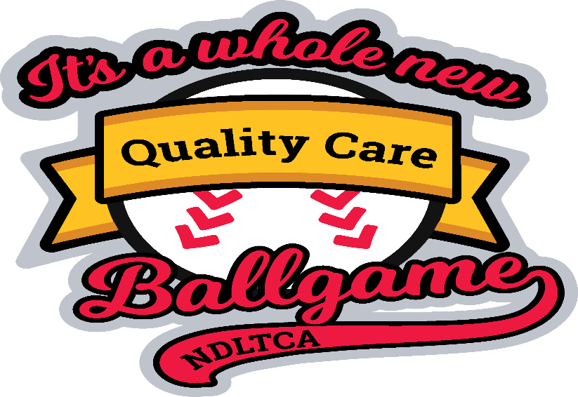

ND ANFP Board Meeting Monday Sept 23rd 2024 from 6:00pm to 8:pm
ND ANFP Lunch and Membership Meeting Tuesday Sept, 24th from 12:00pm to 2:pm
Come join us for the upcoming meetings and networking. There will be bucket draws if anyone is willing to bring a bucket for our fundraising that would be great. Also think about volunteering for our committees and offices that are open on the board.
Remember we are all in this together. Thanks, Melanie Elverud

Event Information
2024 Fall Regional Meeting - Springfield, MA
Date: September 18 — 19, 2024
Location: Sheraton Springfield Monarch Place Hotel

Hi everyone, hope your summer is going well. Just an update on the event’s that are coming up.
We are still looking for volunteers for chapter offices and committees. There is not that much involvement, only when we had conference meetings. Hope you all have a great year.
Thanks for all you do!
Melanie Elverud, Chapter President



Board of Directors Meeting Agenda

Raddison Hotel – Bismarck, ND
May 7th, 2024 – 4:00 pm – 5:30 pm

- Call to Order – President, Melanie Elverud
- Welcome and Roll Call

Attendance | Role | Volunteer
 | President | Melanie Elverud
 | President Elect | open
Absent | Secretary | Melisa Roehrich
 | Treasurer | Laura Hahn
 | Past President / Fundraising | Corinna DesRoches
 | Government Affairs Committee | open
 | Newsletter Editor / Webmaster | open
 | NDLTCA Education Committee | Corinna DesRoches
 | Membership Committee | Corinna DesRoches
 | Finance Committee | Laura H, Jalicia H, Corrina D,
 | Mentors | Corinna DesRoches, Heather Weber

Guests: _______________________________________________________________________________

- Vision/Mission: Build an inclusive and diverse community of experts in food service management and food safety through, Advocacy and Research.
Vision Statement: Enhance health and wellness through optimum nutritional care.
- Approval of Minutes from Sept 26, 2023Meeting
  - Motion: ___Jalicia Hanson_________ Second: ___Corinna DesRoches
  - Motion Approved: Yes

- Unfinished Business:
Recruitment of volunteers
Reliability

- Reports
  - Secretary – Melisa Roehrich absent

  - Treasurer / Finance Committee – Laura Hahn
    - Treasurer’s Report – $10899.27 as of Sept, 20th 2023, Report Filed Pending Audit, New worksheet for budget started Jan 2024, Audit of books were completed at board meeting. Picked up all items for CDM of the year. Gift card, flowers, certificate and card. Webinar on 5/27/2024 on Crowded new banking system.
Jalicia Hason will be new Treasurer 2024
    - IRS 990 Filing –
    - Audit of Books – Do annually
    - Finance Committee – Needs new members yearly

  - President-Elect – Position open
    - CDM of Year Award - Deb Muhus from Hatton Prairie Village

  - Past President –Corrina DesRoches, did a job fair at Minot High School, 10 pamphlets were taken and went well. Should send pamphlets to the school principals.

  - Government Affairs Committee / Fundraising –position open, We discussed Day at the Capital Jan 2025, Discussed bucket draw for spring meeting.
  - Newsletter Editor / Webmaster– Melanie Elverud has been doing Newsletters this year. Position is open.

  - NDLTCA Education Committee – Corinna DesRoches, Needs topics for fall conference
    - Conference Updates

  - Membership Committee – Heather Weber absent
    - Currently 101 Members
    - 5 new students

  - Nominating Committee / Awards – ND ANFP Board
    - Need new Finance Committee Annually

- New Business New Financial worksheet to start Jan 1st, new banking system call crowded.
  - Continued Competence for ANFP Chapter Leadership
  - ACE Conference Melanie is attending in June in Reno
  - Review NDLTCA Contract and Deadlines
  - Need a CEU Drawing at membership meeting.
  - Jalicia will be sworn in as treasurer.

- Open Floor

- Next Meetings
  - Fall Conference – Sept 23 – 26, 2024– Fargo, ND

- Meeting Adjourned
- Motion made by Laura Hahn, Corrina DesRoches, Jalicia Hason, 5:24pm

Membership Meeting Minutes

Bismarck Event Center – Bismarck, ND - May 7th, 2024

- Call to Order – by President Melanie Elverud

- Welcome and Roll Call-

  - Melanie asked if there were Any new Members, Student Members, First Time Attendees, or Newly Certified Members? Student- Kayla Wehr, New CDM- Sonja Hathaway,
  - Members Present – Denny Hoffman, Deborah Strand, Tillie Holzer, Antionette Senger, Margie Fiedler, Darla Kuhn, Bonnie Krushevsky, Jalicia Hanson, Sandy Youngquist, Brandi Marshall, Paulette Schrirado, Kim Ramen, Sonja Hathaway, Corinna DesRoches,,Deb Mehus, Cathy Imdieke,Terri Calvillo, Kaya Wehr, Melanie Elverud, Laura Hahn

- Introduction of Officers and Committee Members – completed by Melanie

- Vision/Mission: Build an inclusive and diverse community of experts in food service management and food safety through: Education, Advocacy and Research. Vison Statement: Enhance health and wellness through optimum nutritional care. Recited by Melanie

- Approval of Minutes from Sept 26th, 2023 Meeting
  - Motion made by Nettie Senger and Seconded by Brandi Marshall
  - Motion Approved: Yes

- Unfinished Business- None

- Reports
  - Secretary – Melisa Roehrich
    - No Report

  - Treasurer / Finance Committee – Laura Hahn
    - Treasurer’s Report – Report Filed Pending Audit - Checkbook balance is $10,899.27.
    - IRS 990 Filing – To be completed after June 1st
    - Audit of Books – Completed yesterday
    - Finance Committee – Needs new members yearly, Brandi Marshall ,Corrina DesRoches, Laura Hahn
    - The new banking system Crowded will be installed this summer.

  - President-Elect – Position Open
    - CDM of Year Award- Deb Mehus– Will be recognized during the Gala event.
  - Past President – Nothing to report.

  - Government Affairs Committee / Fundraising – Corinna DesRoches
    - Day at the Capitol – Will be held February 2025
    - Fundraising –We will be having bucket draw at spring meeting.
  - Newsletter Editor / Webmaster– Position open, Melanie Elverud has done 2 newsletters so far this year. If anyone would like to help that would be great.

  - NDLTCA Education Committee – Corinna DesRoches / need one volunteer for this role/
    - Conference Updates given by Deborah Strand, committee member.
    - Request for speaker suggestions was discussed.

  - Membership Committee – Heather Weber -absent
    - Currently 101 Members
    - It was suggested that we send letters about the ANFP Programs to the School Counselors and include the info on the programs available for students for funding assistance.

  - Nominating Committee / Awards – ND ANFP Board
    - Need new Finance Committee Annually – We had 3 volunteers – Brandi Marshall, Laura Hanh, Corinna DesRoches

- New Business
  - Installation of New treasurer- Jalicia Hanson.
  - ACE Conference Melanie is planning on Going to Reno.

- Open Floor –
a. Margean Reno talked on promoting healing.
b Deb Strand having serve safe May 21st in Dickinson, and June 4th in Fargo.

- CEU Drawing – Terri Caloillo was the winner of the $150 – Needs to be used within 1 year and reach out to the Treasurer for reimbursement.

- Next Meetings
  - Fall Conference – Sept 23rd thru 26th, 2023 – Fargo, ND

- Meeting Adjourned – Melanie thanked everyone for coming and reminded them to stop at the booth and shop during the tradeshow.

Regulatory

Hot beverages and F689
NF
The State Agency (SA) has received questions and understands there has been discussion regarding the temperatures of hot beverages served in skilled nursing facilities. The regulations at F689 require the facility to ensure that the resident environment remains as free of accident hazards as is possible and that each resident receives adequate supervision and assistance devices to prevent accidents.
The CMS regulations and guidance do not specifically provide a temperature for hot beverages; however, CMS does provide information related to time and temperature relationship to serious burns. See table from F689 Free of Accidents Hazards/Supervision/Devices:

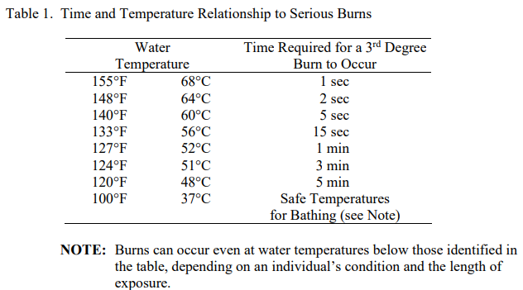

The following are points to consider:
- Know what the serving temperature is as it may be different from the brewing temperature.
- Has your facility assessed each resident’s ability to handle hot beverages and their individual safety needs?
- Does the resident have a diagnosis or condition that may put them at an increased risk for burns due to scalding?
- What type of cups is the facility using and are they easy for residents to handle? Do they need lids? Does a certain resident receive half a cup full? Where is the resident seated while drinking? What is the level of supervision?
As with many things that involve resident care, each situation can be different depending on the resident’s medical condition, abilities, and functional status. CMS expects facilities to identify, evaluate, and analyze hazards and risks, implement interventions to reduce hazards and risks, monitor for effectiveness, and modify interventions when necessary.
Questions? Contact Kathy Laxdal klaxdal@nd.gov or 701.328.2352

