
April-June 2024
NORTH DAKOTA LONG TERM CARE CONFERENCE

MAY 7TH THRU THE 10TH BISMARCK, NORTH DAKOTA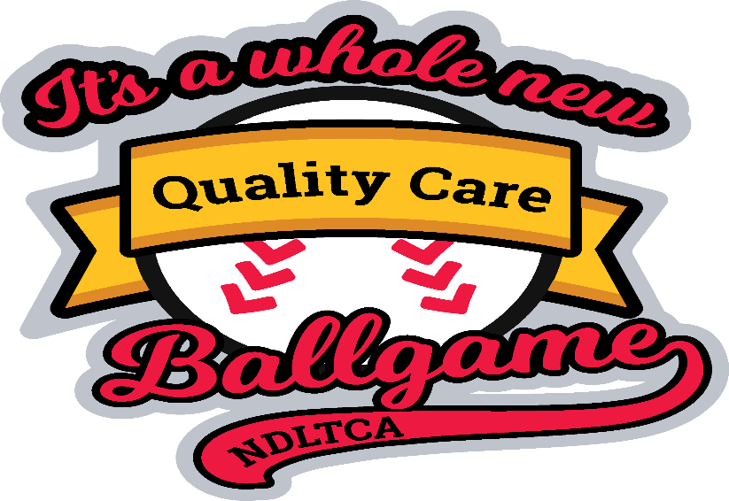
ND ANFP Board Meeting Tuesday May 7th 2024 4:00pm to 5:30pm at the Radisson
ND ANFP Lunch and Membership Meeting 11:30am to 1:pm,
Come join us for the upcoming meetings and networking. There will be bucket draws if anyone is willing to bring a bucket for our fundraising that would be great. Also think about volunteering for our committee’s and office’s that are open on the board.
Remember we are all in this together. Thanks, Melanie Elverud

Chapter Events:

2024 LTCA Spring Conference & Expo

May 7th – May 10th Bismarck, ND

2024 Annual Conference & Expo (ACE)
JUNE 10 - JUNE 13, 2024
2024 Annual Conference & Expo
June 10-13, 2024
Grand Sierra Resort and Casino
Reno, Nevada

Hi everyone hope your spring is going well. Just a update on the event’s that are coming up.
If anyone is interested in going to ACE Conference in Reno please contact me as ND ANFP will pay for expenses. I plan on attending as well. We are still looking for volunteer’s for chapter office’s and committee’s. There is not that much involvement only when we had conference meeting’s. hope you all have a great year.
Thanks for all you do!
Melanie Elverud, Chapter President
FRESH BERRIES AND FRUIT ARE ALWAYS A TREAT FOR THE RESIDENT’S


USE YOUR FAVORITE PASTA FOR SUMMER SALAD’S FOR YOUR RESIDENT’S


Join ANFP members in your state!
Volunteering with your state ANFP chapter is a great way to begin your volunteer career. There are a variety of positions available for chapter members - including on chapter Boards and Committees. Below is a sample organizational chart of an ANFP chapter structure:

Get started with your chapter today!



GRILLING IS A GREAT SUMMER EVENT FOR THE RESIDENT’S


Practitioner Certificate in Nutrition Care for the CDM, CFPP
A 45 hour CE course, that takes an in-depth look at Nutrition Care and earns all your CE's for your 3-year certification period to maintain your credential.

Enroll Anytime
- The University of North Dakota provides a variety of, CBDM approved, CE (continuing education) courses that will assist you in meeting your required training; and maintaining your CDM, CFPP credential.
- Up to six months of access. There are no refunds and no extensions offered.
- With independent study courses you can enroll anytime and work at your own pace.
- Course cost is $299, which includes tuition and online learning materials.

In this course you will:
- Watch the UND Training video presentation and additional learning videos found in the course
- Read and review the additional learning resources found in each lesson
- Complete each of the learning activities & quiz for each lesson
- Print your certificate of completion for your records

Course at a Glance
- Practitioner Certificate in Nutrition Care for the CDM, CFPP takes in-depth look at Nutrition Care. It covers the ethical standards for clinical documentation, food safety & sanitation compliance vignettes, and a deeper dive into the nutrition care and the power of the pen focusing on communication in charting.
- Students will have access to this online course for up to six (6) months.
- Upon completion of the course, you will be able to print a certificate of completion 45 hours of CE (1 hour of ethics, 9 hours of sanitation & safety and 35 hours of general CE) to meet your 3-year certification period.
- You have six months from your enrollment date to access this course. There are no refunds and no extensions offered.

Practitioner Certificate in Sanitation for the CDM, CFPP
A 45 hour CE course, that takes an in-depth look at sanitation and safety for health care and earns all your CE's for your 3-year certification period to maintain your credential.

Enroll Anytime
- The University of North Dakota provides a variety of, CBDM approved, CE (continuing education) courses that will assist you in meeting your required training; and maintaining your CDM, CFPP credential.
- Up to six months of access. There are no refunds and no extensions offered.
- With independent study courses you can enroll anytime and work at your own pace.
- Course cost is $299, which includes tuition and online learning materials.

In this course you will:
- Watch the UND Training video presentation and additional learning videos found in the course
- Read and review the additional learning resources found in each lesson
- Complete each of the learning activities & quiz for each lesson
- Print your certificate of completion for your records

Course at a Glance
- Practitioner Certificate in Sanitation for the CDM, CFPP takes in depth look at sanitation and safety for health care. It covers the ethical standards for the Dietary Manager Practitioner in Sanitation, sanitation regulation vignettes, and a deeper dive into the federal agencies and regulations that govern food safety and sanitation in healthcare, focusing on the foodservice operation.
- Students will have access to this online course for up to six (6) months.
- Upon completion of the course, you will be able to print a certificate of completion 45 hours of CE (1 hour of ethics, 9 hours of sanitation & safety and 35 hours of general CE) to meet your 3-year certification period.
- You have six months from your enrollment date to access this course. There are no refunds and no extensions offered.



ANFP APPRENTICESHIP PROGRAM
On November 16, 2022, ANFP received final approval of our Apprenticeship Program by the Department of Labor (DOL). Eighteen months prior the DOL recognized the Certified Dietary Manager (CDM) as an Approved Occupation for a Registered Apprenticeship Program. The first apprentices were enrolled in early 2023. When the apprentices graduate from the program they will be a Certified Dietary Manager Apprentice and eligible to sit for the CDM, CFPP Credentialing Exam.
The ANFP Apprenticeship Program is another innovative strategy in our strategic plan goal of member recruitment and retention. It is also part of our partnership with healthcare administrators who require the CDM, CFPP credential in their facilities. Apprentices may receive a $2,000 stipend to offset the cost of the program.
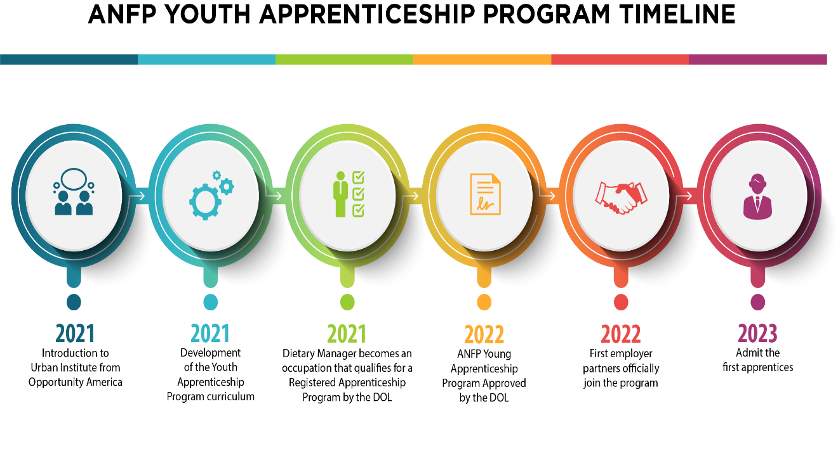

What is the ANFP Apprenticeship Program?
The ANFP Apprenticeship Program provides structured opportunities for those interested in becoming a Certified Dietary Manager, Certified Food Protection Professional (CDM, CFPP). For students ages 16-21, the Youth Apprenticeship Program provides a stipend to offset the cost of the program. Apprenticeships combine academic and competency based technical instruction with paid work experience across healthcare. The ANFP Apprenticeship offers graduates expanded pathways in foodservice management as a CDM, CFPP

e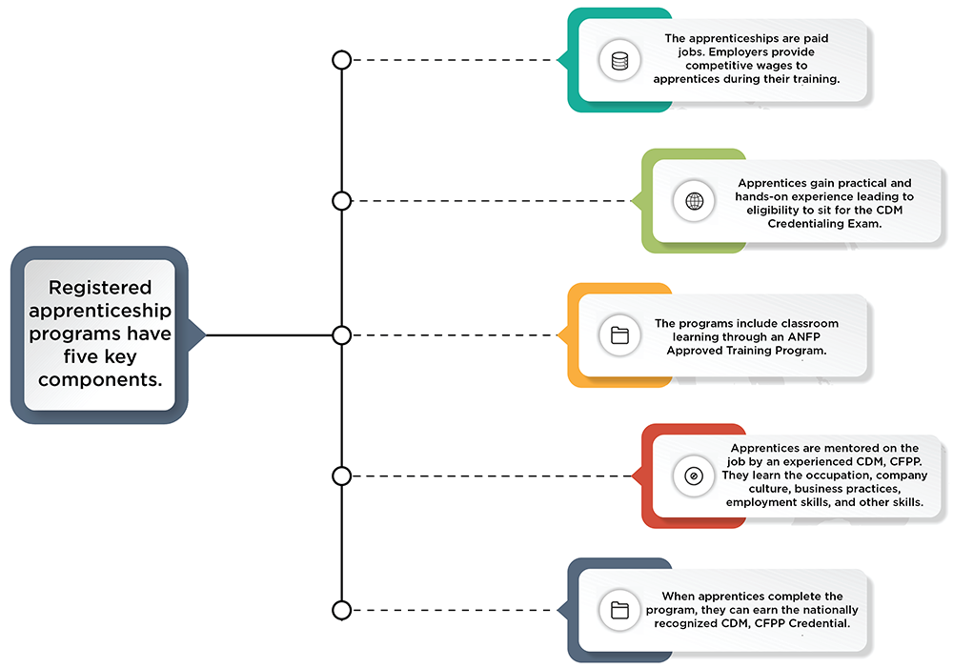

The ANFP Apprenticeship Program is unique, in that we use our Certified Dietary Manager curriculum offered through ANFP Approved Training Programs. Our program offers the following:
- ANFP as the sponsor
- An approved ANFP education provider with an established curriculum to provide the related competencies instruction
- The following employers have partnered with ANFP and agree to hire and pay apprentices:
  - Compass Group
  - Creative Solutions in Healthcare
  - Presbyterian Homes
  - Sodexo
- CDM, CFPP professionals to support the apprentices' learning

ANFP is the sponsor organization that operates the ANFP Registered Youth Apprenticeship Program. The sponsor assumes full responsibility for the administering and operating the program. As the sponsor, we are responsible for the following:
- Designing and registering the program standards with the U.S. Department of Labor's (DOL) Office of Apprenticeship (OA) or State Apprenticeship Agency (SAA)
- Engaging with, supporting, and signing up employer partners to employ apprentices (as applicable)
- Collecting and submitting apprenticeship agreements
- Registering apprentices in the Registered Apprenticeship Partners Information Database System (RAPIDS) or a state data system; RAPIDS is the OA's software database for collecting information about RAPs and apprentices
- Maintaining records including records documenting the following:
  - Apprentices' competency completion
  - Apprentices' progress through the program's on-the-job training
  - Showing required wage increases during the program
  - The sponsor's affirmative action plan (due after the program has been operating for two years)
  - Employer hiring procedures and human resources records
- Reporting apprentice progress to the DOL through RAPIDS
- Participating in periodic DOL program and EEO reviews

More About the Program
The ANFP apprenticeship program meets National Program Standards (NPS) of Apprenticeship consisting of uniform occupational standards, which were developed and sponsored by ANFP. Our program is demonstrably national and multistate in its design, suitability, and scope based on consideration of the NPS criteria; and we comply with DOL registered apprenticeship requirements.
ANFP Apprentices learn their occupation through on-the-job training (OJT) in a healthcare setting. It provides them structured on-the-job learning that apprentices will receive from an experienced CDM, CFPP mentor for at least one year. The training was developed by mapping the competencies and knowledge the apprentice must learn throughout the program to be fully proficient as a CDM, CFPP.
The ANFP Youth Apprenticeship Program is a competency-based apprenticeship; the apprentice's progress is measured by their ability to demonstrate and apply relevant knowledge, competencies, and abilities on the job. Though no requirement for time spent in OJT exists, the apprenticeship must last at least 12 months.

Probationary Period
The apprentice will spend 200 hours of OJT over the course of the program. There is a 1-1-1 ratio of apprentice to CDM, CFPP mentor. All registered apprenticeships have a probationary period. During this period, either the apprentice or the sponsor may terminate the apprenticeship agreement, without stated cause, by notifying the other party in writing.
- After reviewing the probationary period, any probationary apprentice evaluated as satisfactory must be given full credit for the probationary period and continue in the program.
- A probationary period is set at 25% or less of the apprenticeship program's total length.

Additional Information
An ANFP Approved Training Program or school will provide the organized and systematic curriculum designed to provide the apprentice with the knowledge of the theoretical and technical subjects directly related to becoming a CDM, CFPP. In registered apprenticeships, programs will provide at least 144 hours of RTI a year.
The ANFP Youth Apprenticeship Program was developed in partnership with Urban Institute through a project developed with the U.S. Department of Labor. Pursuant to the National Apprenticeship Act, the Department of Labor works to expand opportunities related to apprenticeship programs. This project has been funded, either wholly or in part, with federal funds from the Department of Labor, Employment & Training Administration under contract number/work order 47QRAA18D003Z/1630DC-19-F-00038. The contents of this portal do not necessarily reflect the views or policies of the Department of Labor, nor does mention of trade names, commercial products, or organizations imply endorsement of the same by the US government.

