Winter 2025
CRAB CHATTER
WINTER EDITION
Winter
  Presidents Message  Hello Everyone,  January is here and it sure does feel and look like it outside my Dining Room window as I watch the snow fall.  Hope everyone is having a good new year so far.  We are moving forward in the planning of the Spring Workshop.  The date is Tuesday, May 6th and is being at my workplace, Homewood at Frederick  in Frederick Maryland.  Will be at the Lodge, which is the new apartment building across from the Main building.  Several speakers have already been assigned and working on several more.  Vendors are also being reviewed.  Hope to see everyone on May 6th in Frederick.  Sincerely,  Patrick Dellinger, CDM, CFPP |  | The Maryland Crab Chatter is published 4 times a year.  Article contributions are welcomed!  Please send submis-sions Dayna Dietz, CDM, CFPP to daynadietz@outlook.com  or  Stephen Caretti, CDM,CFPP to  The editor reserves the right to edit , condense or postpone articles.  Volume Issue  Inside  Presidents Message 1  Past Presidents Message 2  National News 3  CDM positions 3  Volunteer Opportunities 4  Board Members 4  Board Minutes 5


Past-President’s Message Winter 2025
I have officially hit the 15 year mark as a CDM, CFPP. I have been active as a committee chair for the past 10 years to the chapter as the vendor chair helping out for our workshops, as president elect and the past 5 years as President. I will be concluding my term as Past President this May, 2025 and wanted to thank each and every one of you for your support and contributions to the chapter making it successful. While I will no longer be part of the chapter’s board, I will be doing speaking at upcoming workshops and will continue my commitment for the success of the chapter behind the scenes. Please give Patrick and the current board the same helpfulness and support you always gave to me.
Recipe for Success:
· Set goals: People who know what they want and have set a course for achieving their goals are generally happier than those that just let life happen to them. This wisdom is not new. Earl Nightingale once said, “Don't wait for something outside of yourself to make you happy in the future.”
· Don’t Fear Failure: So often we are taught in our lives that failing is a bad thing. Failure is almost always placed at odds with success. Yet without failure few would know the way to success. No one ever did it right all the time. But most that have experienced some successes have failed at some point.
· Take Risks: Life is more fun and exciting when we take risks. At the end of the day there is truth to the statement, “Nothing ventured, nothing gained.” But be calculated - risk should not be taken for risk’s sake. Opportunity may knock, but it may not stand around very long. Be ready to go on an adventure at the knock of a door. A successful life includes not having regrets for not having taken enough risks.
· Don’t Stop Learning: The more you know, the more you realize you do not know. Formal education just scratches the surface and is a drop of our capacity to learn. Knowledge, no matter how insignificant it may appear to be, gives us a reason to get out of bed every morning. Make it a habit to learn something new each day. Treat knowledge like a new friend. Life is so much more satisfying when we make a new friend every day.
· Do Not Settle: Success is a process – not an event. Some goals may happen overnight. Others require more time, energy, and alignment of some planets. Do not get discouraged. Keep plotting forward with your plan. Evaluate your progress and make course corrections. Keep your goal top of mind and keep your feet moving.
· Live a Balanced Life: There are not enough hours in a day to carve out time for each demand. However, over the intermediate- and long-term, we can achieve balance. Balance means taking time to treat the body well and keeping it running properly with good foods, exercise, and rest. Balance means being present for the family. Few can give the family all the time it demands. But giving it “quality time” will keep the family healthy and happy. Balance means taking some time for oneself to recharge the batteries. Balance means being of service to the community and giving back. Balance means feeding the soul through religion and/or spirituality.
· Seek a Mentor: The best way to achieve success and limit failure is to work with someone that has already been down the same road. There is plenty that can go wrong as we travel down the road towards success. By eliminating the low hanging fruit on the tree of failure we improve the odds of success and ensure that we experience only the worthiest type of failure. Remember to thank your earliest mentors, your parents, teachers, and others, who inspired you to succeed and set you on your journey.
· Zip it and Listen: Too often we spend our time doing all the talking and not doing any listening. Even when we’re listening, we’re thinking about the next thing we’re going to say. By truly listening we can fully understand what we are being told and properly engage in the conversation. If we do not listen, we cannot provide what is needed. We cannot give the needed advice, solution, or shoulder to cry on.
· Network: No one in this world achieved success on their own. Success requires that you lean on someone for support. That’s where the network comes in. True networking means being of service to those in the network – and not expecting something in return. Then when needed, the network will find a way to return the favor.
· Carry a Notebook: Our lives are busy and getting busier. Over the course of a day, we’ll have ideas, solutions, and epiphanies. If we do not have a way to capture them, we risk losing them forever. A notebook, whether hardcopy or electronic, helps us record our thoughts, release the mental storage, and move on to the next great idea or solution.
To End: Thank you for all you do, every day, day-in and day-out making a difference in the lives for so many. You make a much bigger impact on those lives you touch than you think!
Robert McKeon, Past-President of the MD/DE/DC ANFP Chapter

NATIONAL NEWS

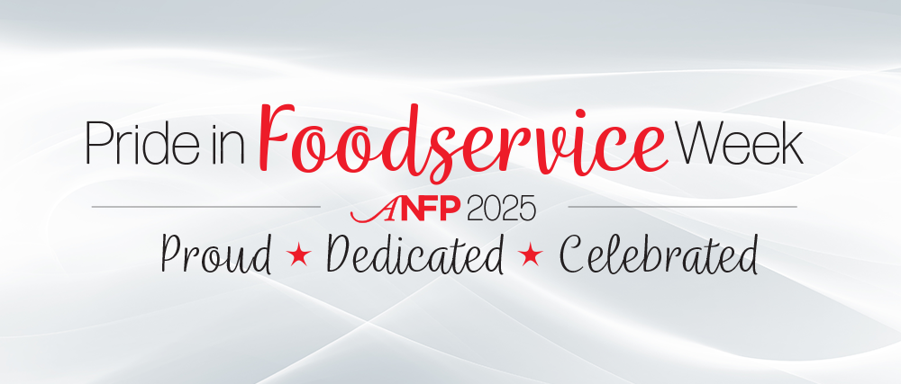

CDM positions available

ACTS Senior Living, Fairhaven, Sykesville, MD: Executive Chef

Westminster Canterbury, Winchester, VA: CDM

Bedford Court Sunrise, Silver Spring, MD: CDM

Contact Chef Robert for more information ChefRobert1966@hotmail.com

Save the Date for Pride in Foodservice Week!
Pride in Foodservice Week is coming up! Our 34th annual Pride in Foodservice Week will be celebrated February 3-7, 2025. This week of celebration encourages foodservice industry employees, employers, and friends to celebrate the vital work non-commercial nutrition and foodservice professionals perform on a daily basis.

Do you have talents to share with your ANFP chapter?
Contact any board member to help our chapter, any help is appreciated.
PRESIDENT ELECT- This position assists and works alongside the President, Treasurer and Secretary. You would be part of the Board of Directors making decisions that directly impact on the direction of the chapter. Some benefits are paid workshops and mileage reimbursement to board meetings and workshops. Even if you are on the fence, consider taking on this role and making a difference for your chapter, members and your career!

Board and Committee Members Contact Information
Board of Directors
Patrick Dellinger | 717-353-0916 | Patwd37@centurylink.net | President
Bonnie Hollingsworth | 443-789-4461 | bhollingsworth55@icloud.com | Treasurer
Debi Canfield | 240-291-2360 | dacanfield@myactv.net | Secretary
Committee Chairs
Dayna Dietz  Stephen Caretti | 719-200-1935  724-221-0766 | Daynadietz@outlook.com | Publisher: Crab Chatter Newsletter Editor
Robert McKeon | 301-648-7119 | ChefRobert1966@hotmail.com | Immediate Past Presi-dent
Kyrese Johnson |  | Kyrese.Johnson@fda.hhs.gov> | State Representative
Gregory Vink | 717-729-0224 | gvink@chambersburgpa.gov | Director at Large
John Dankulich | 240-818-2495 | Jadankulich@hagerstowncc.edu | Director of New Membership
Jeff Whary | 443-812-8675 | chefcubmd@yahoo.com. | Director of Education
Steve Plaster | 301-223-1414 | slplasterer@hmwd.org | Director at Large

Board Meeting Notes
1/13/25 Zoom 7 pm
Debi- Robert
Patrick- Bonnie
-Patrick updated officers on the ANFP website
-membership is low, 270 members
-completed the 2025 Chapter Rebate form, Patrick will upload and submit on 1/14/24
-SPRING WORKSHOP
May 6 ,2025 Homewood ( lodge area)
Homewood is not charging for the use of the room, but we will pay for the food
Maybe we can utilize vendors for desserts and drinks
Possible speakers for the Spring…
John Trouts
Food Pro
Director ( from Homewood)
Dietician (from Homewood)
Robert will reach out to some vendors
-Patrick and Robert will attend The Maryland Restaurant and Hotel Assoc. workshop in February and set up a chapter booth
Robert will be speaking at two of the sessions

-TBD—we will meet again in February at Gladchuks
** meeting End 7:30 pm

Like us on Facebook
MD-DE-DC ANFP

The Maryland, Delaware, & DC Chapter of ANFP is an affiliate of the national not-for-profit association. ANFP was established in 1960 that today has over 14,000 professionals dedicated to the mission of providing optimum nutritional care through foodservice management.
Vision -The Certified Dietary Manager is the cornerstone of the col-laborative Dietetics profession. Mission - Position the Certified Dietary Manager as the expert in foodservice management and food safety.

