**Please join Georgia-ANFP**

**At our Spring Meeting 2024**

**LEADING WITH VISION AND PURPOSE!!**

***April-16th, 2024-April 19th, 2024***

**Summary of Topics**

***Sanitation Chronic Disease Management***

***Ethics in Foodservice Health Inspections 101***

***IDDSI 2.0 Food Allergies***

***Rubicon MDS***

***Hormel Health Labs***

***In addition to a wonderful speaker line-up***

***We have been offered a free Dolphin Cruise for the first 35 members who register by March 1st, 2024, Details provided on the next page!!***

***On behalf of Scott Henderson of***



[This Photo](https://bisakimia.com/2019/03/01/lowongan-kerja-kimia-ecolab-2019/) by Unknown Author is licensed under [CC BY-NC-ND](https://creativecommons.org/licenses/by-nc-nd/3.0/)

***The Dolphin cruise will set sail Tuesday April 16th, 2024 @ 4:00pm- until sunset.***

**This cruise will include beverages and light snacks.**

**More details to come!** [**Scott.Henderson@ecolab.com**](mailto:Scott.Henderson@ecolab.com)

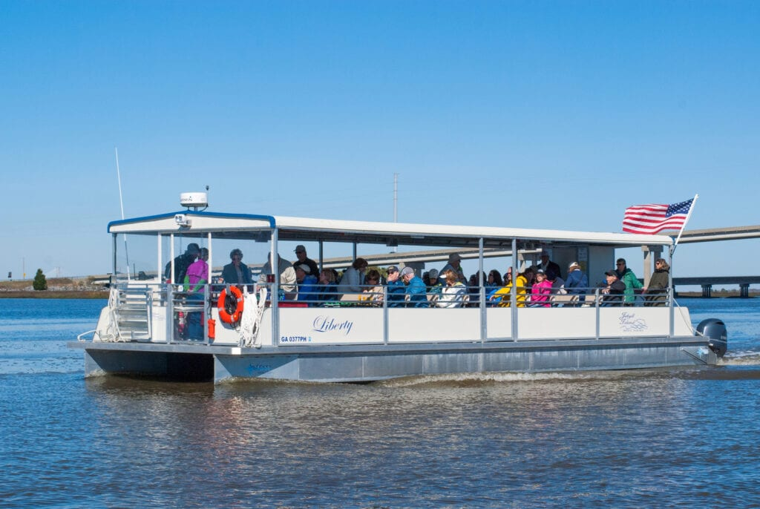

***Hotel information***

**Marriott Courtyard / Residence Inn 178 South Beachview Drive Jekyll Island Georgia 31527**

**1-912-635-2764**

[**Book your group rate for GANFSP 2024**](https://na01.safelinks.protection.outlook.com/?url=https%3A%2F%2Fwww.marriott.com%2Fevents%2Fstart.mi%3Fid%3D1696446231231%26key%3DGRP&data=05%7C02%7C%7C9fd89f87e4034bfd0d9108dc1c25eb80%7C84df9e7fe9f640afb435aaaaaaaaaaaa%7C1%7C0%7C638416196407757079%7CUnknown%7CTWFpbGZsb3d8eyJWIjoiMC4wLjAwMDAiLCJQIjoiV2luMzIiLCJBTiI6Ik1haWwiLCJXVCI6Mn0%3D%7C3000%7C%7C%7C&sdata=KAU2zXuk7QWjn%2Fs%2FbAl536h%2FehhWxVBdzYsjd41raL0%3D&reserved=0)

**(Hyperlink for hotel)**

**

4054 Foxborough Blvd

*LEADING WITH VISION & PURPOSE*

*2024-Spring Meeting*

Valdosta, Georgia 31602-6740

[rilmark@aol.com](mailto:rilmark@aol.com)

1.706.562.5165

**Registration Form**

|  |  |  |  |  |  |
| --- | --- | --- | --- | --- | --- |
| Full Name: | | Georgia-ANFP I.D. | | | |
| Name preferred for name tag: | | Other Credentials: | | | |
| Day Phone: | | Email: | | | |
| **Registration** |  | |  | |  |
| **Fall Meeting Members Full Access**  **Fall Meeting Students/Retirees**  **Full Access** | **$115.00 Early Bird** rates  Good until **2/29/2024**  **$95.00** | | **$125.00**  **Fee Begins**  **3/1/24** | |  |
| **Fall Meeting Non-Members**  **Full Access** | **$135.00** | |  | |  |
| **Late Fee-Added to Registration if not paid by March 31, 2024**  **Processing Fee for using a credit card.** | **$15.00**  **$8.00** | |  | |  |
| **Total Fees:** |  | |  | |  |
| Please note you must pay a fee to use your credit card! If you prefer to mail a check, please have it postmarked by **03/31/2024**  Or pay by at the door for **$150.00/ CHECK or CREDIT CARDS** |  | |  | |  |
|  |  | |  | |  |
| **Total Amount Due** |  | |  | |  |
| **Method of Payment to Guarantee Registration**  ▫ Check (**payable to Georgia-ANFP**) ▫ Visa ▫ MC ▫Square (Over the phone & at the door) | | | | | |
| Name as it appears on card: | | | | | |
| Cardholder Signature: | | | | | |
| Card #:  CV# Zip Code | | | | Exp. Date: | |