
FROM THE DESK OF THE PRESIDENT

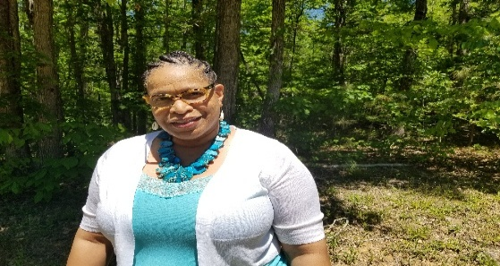
05/18/2026
Revised 07/01/2026
Hello Georgia ANFP Members,
I hope your week is off to a good start. I’m writing to let you know that the Georgia-ANFP Board has appointed Latoya Preston as Treasurer. Tony Lassic has been serving as both Treasurer and President-Elect, and balancing both roles has been difficult. Latoya will work with Tony to learn the Treasurer’s duties and is expected to serve in the role for about one year.
In February 2027, the Nominating Chair will begin the process to fill the position. If Latoya decides to run for Treasurer, her name will appear on the ballot, along with any other interested board members. Once the candidates are presented to the membership, you will have the opportunity to vote. The newly elected Treasurer will begin serving on June 1, 2027.
Breaking News Georgia won the Diamond Award for the third time, GO GEORGIA-ANFP it was presented at ANFP ACE Orlando in June.
In the meantime, we are actively planning our Fall Meeting. As shared during our Spring 60th Anniversary Meeting, members strongly prefer to continue meeting in person. The Fall Meeting is scheduled for September 16th–17th, 2026, (Sea Palms Resort 515 N Windward Dr. St. Simons Island, Georgia)
If you know of any vendors or speakers who may be a good fit, we would be glad to connect with them. Tony and I will be working on this project together. Please feel free to reach out at georgiaanfp@gmail.com.
Sincerely,
Regina St. Clair
President GA-ANFP
770.827.6076
r.st.clair50@outlook.com

