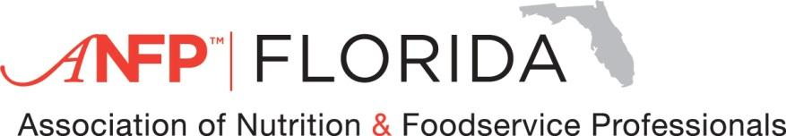
Florida 2025 Spring “2 day “ Workshop
Thurs. April 17 & Fri. 18, 2025
Wed. April 16, 2025 6pm, audit the board meeting

Theme: Shining bright like a Diamond, the Brilliance of the CDM

THURSDAY APRIL 17, 2025 “DAY 1”

7:30 - 8:30 Registration (Beverage Station served)
7:45 – 8:00 President Welcome ……….. … .... Nicola Burke, CDM, CFPP
G- 8:00 - 9:00 Reasons Why we need Vit D......Cindy Cysewski MS, RD, LDN
G- 9:00 -10:00 Leadership and Management 2025----Regina St.Clair BS, CDM, CFPP
F -10:00 –12:00 FOOD EXPO/SHOW
12:00 -2:00 60TH ANNIVERSARY LUNCHEON BANQUET
G- 2:00 - 3:00 Managing Diversity in the food service...Dr. Dewayne Harvey ADM, BS, RD, PHD
G -3:00 – 4:00 The Quest to Longevity-- ------------Laurie VanCleft MS,RD, CPT
G- 4:00 - 5:00 How much is adequate hydration for elderly?…......Dawn Gill CDM, CFPP

FRIDAY APRIL 18, 2025 “DAY 2”

7:30 – 8:30 Registration (Beverage station available)
7:45 - 8:00 President Welcome-------------------------Linda Wynn CDM, CFPP
E-8:00- 9:00 ETHICS-----------------------------------Linda Blackshear Smith NHA
G-9:00-10:00 The Marketing of it all- Dr. Dewayne Harvey ADM, RD, BS, PHD
G-10.00-11:00 Mg yourself-Don’t take work stress home with you –Linda Wynn
CDM, CFPP
11:00-12:00 LUNCH/BREAK
S- 12😊-1:00 The Servsafe Manager………………..……Andrew Mullins CDM,CFPP
G- 1:00 – 2:00 Who are the Customers? ----------------Clara Poole CDM,CFPP
S – 2:00- 3:00 The Hidden places in the kitchen escaping sanitation--Dawn Gill
CDM, CFPP
3:00 – 3😊0 Wrap it up. Turn in evaluations

CEU”S 8 General, 2 Sanitation, 1 Ethics, 2 food show =13
For information contact: Linda Wynn Pres. Elect- 850-417-2160 Or Pres. Nicola Burke - 610-329-1852

