SOUTHERN NEW ENGLAND CHAPTER

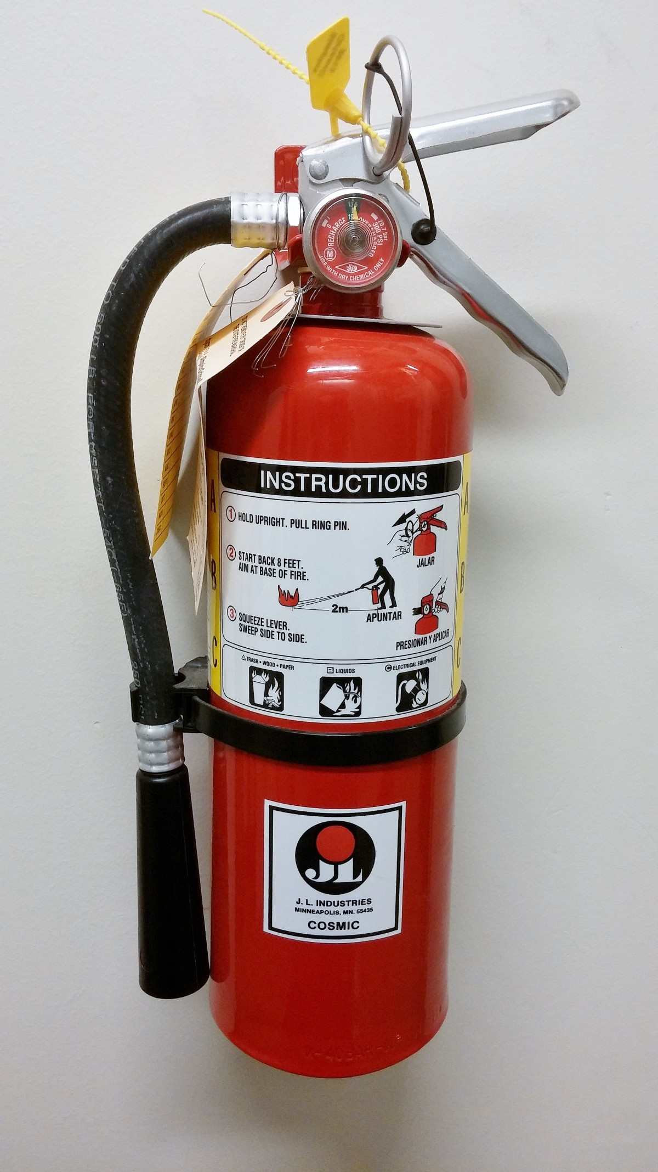
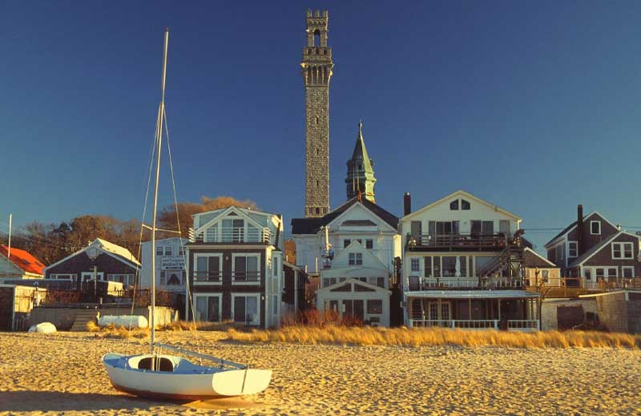

Fire safety:

did you know?
Kitchens need to have both Class K and ABC fire extinguishers.

:

most impacting learning subject:
Presenter: Faron Boreham, Executive Director at Solstice Senior Living
“Servant Leadership”
“ A servant-leader is a person who begins with the natural feeling of wanting to serve first-to help, support, encourage, and lift up others. And because of their noble role model, others begin to lead by serving.”

SNEC News!!
We’ve got exciting updates about our
Spring 2025 Meeting. Our meeting was engaging & very informative. Thank you to all the Presenters that gave the best educational sessions to our members..
Save the Date: Fall Meeting
October 7, 2025.

few Food Code Updates:  - There is a new Allergen= Sesame  - Unpackaged & Bulk food labeling=if remove from original container allergen labeling must be included in new container.  - Food Donations=not allowed in high risk population establishments | Special Thanks to one Particular CDM who has been present at every meeting we host.  Penny Deary,CDM,CFPP  From: Essex Meadows.  Thank you for all you do and for taking the time to come to our meetings no matter how far we host.  Thank you from your SNEC Chapter. |   Thank you to the University of North Dakota for the amazing swags they sent us for our members.
Ingredients for Recipe for the Best Clam Chowder in the Country. Right from the New Englanders:  New England Clam Chowder:  Ingredietns:4 Slices of bacon, 1 medium onion, 2 celery stalks, 2 cloves of garlic, 2 tbs. flour, 3 cups diced potatoes, 1 c. clam juice, 1 c. of water or seafood stock, 1 bay leaf, ½ tsp. dried thyme, salt & pepper to taste, 2 c. chopped clams, 1 1/12 c. heavy cream, 2 tbs. unsalted butter, | 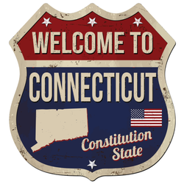  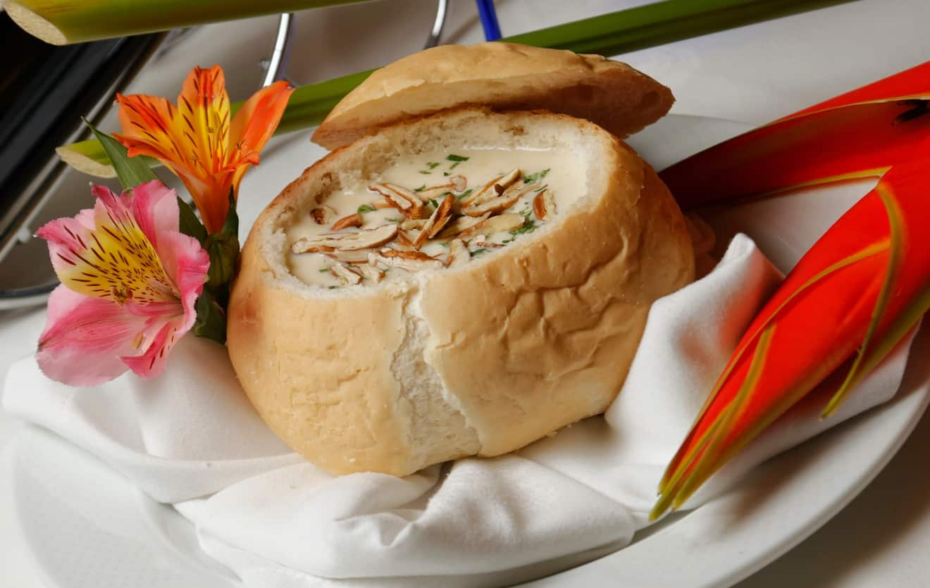 | Call for Volunteers!!:  Your Expertise Matters!!  Are you ready to make a meaningful impact in your profession??  As a valued CDM,CFPP your time, experience, talent and creativity can make a real difference within our SNEC Chapter!!  If you would like to be part of an amazing Board within the Southern New England Chapter and want to make a difference! Please email  Amarilyssaluk@gmail.com  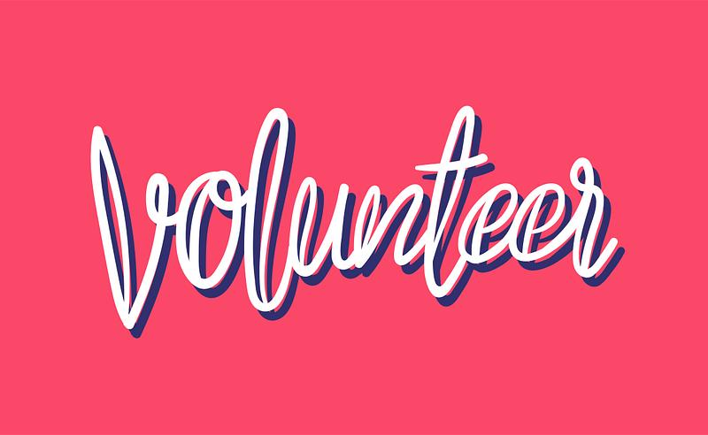
 | 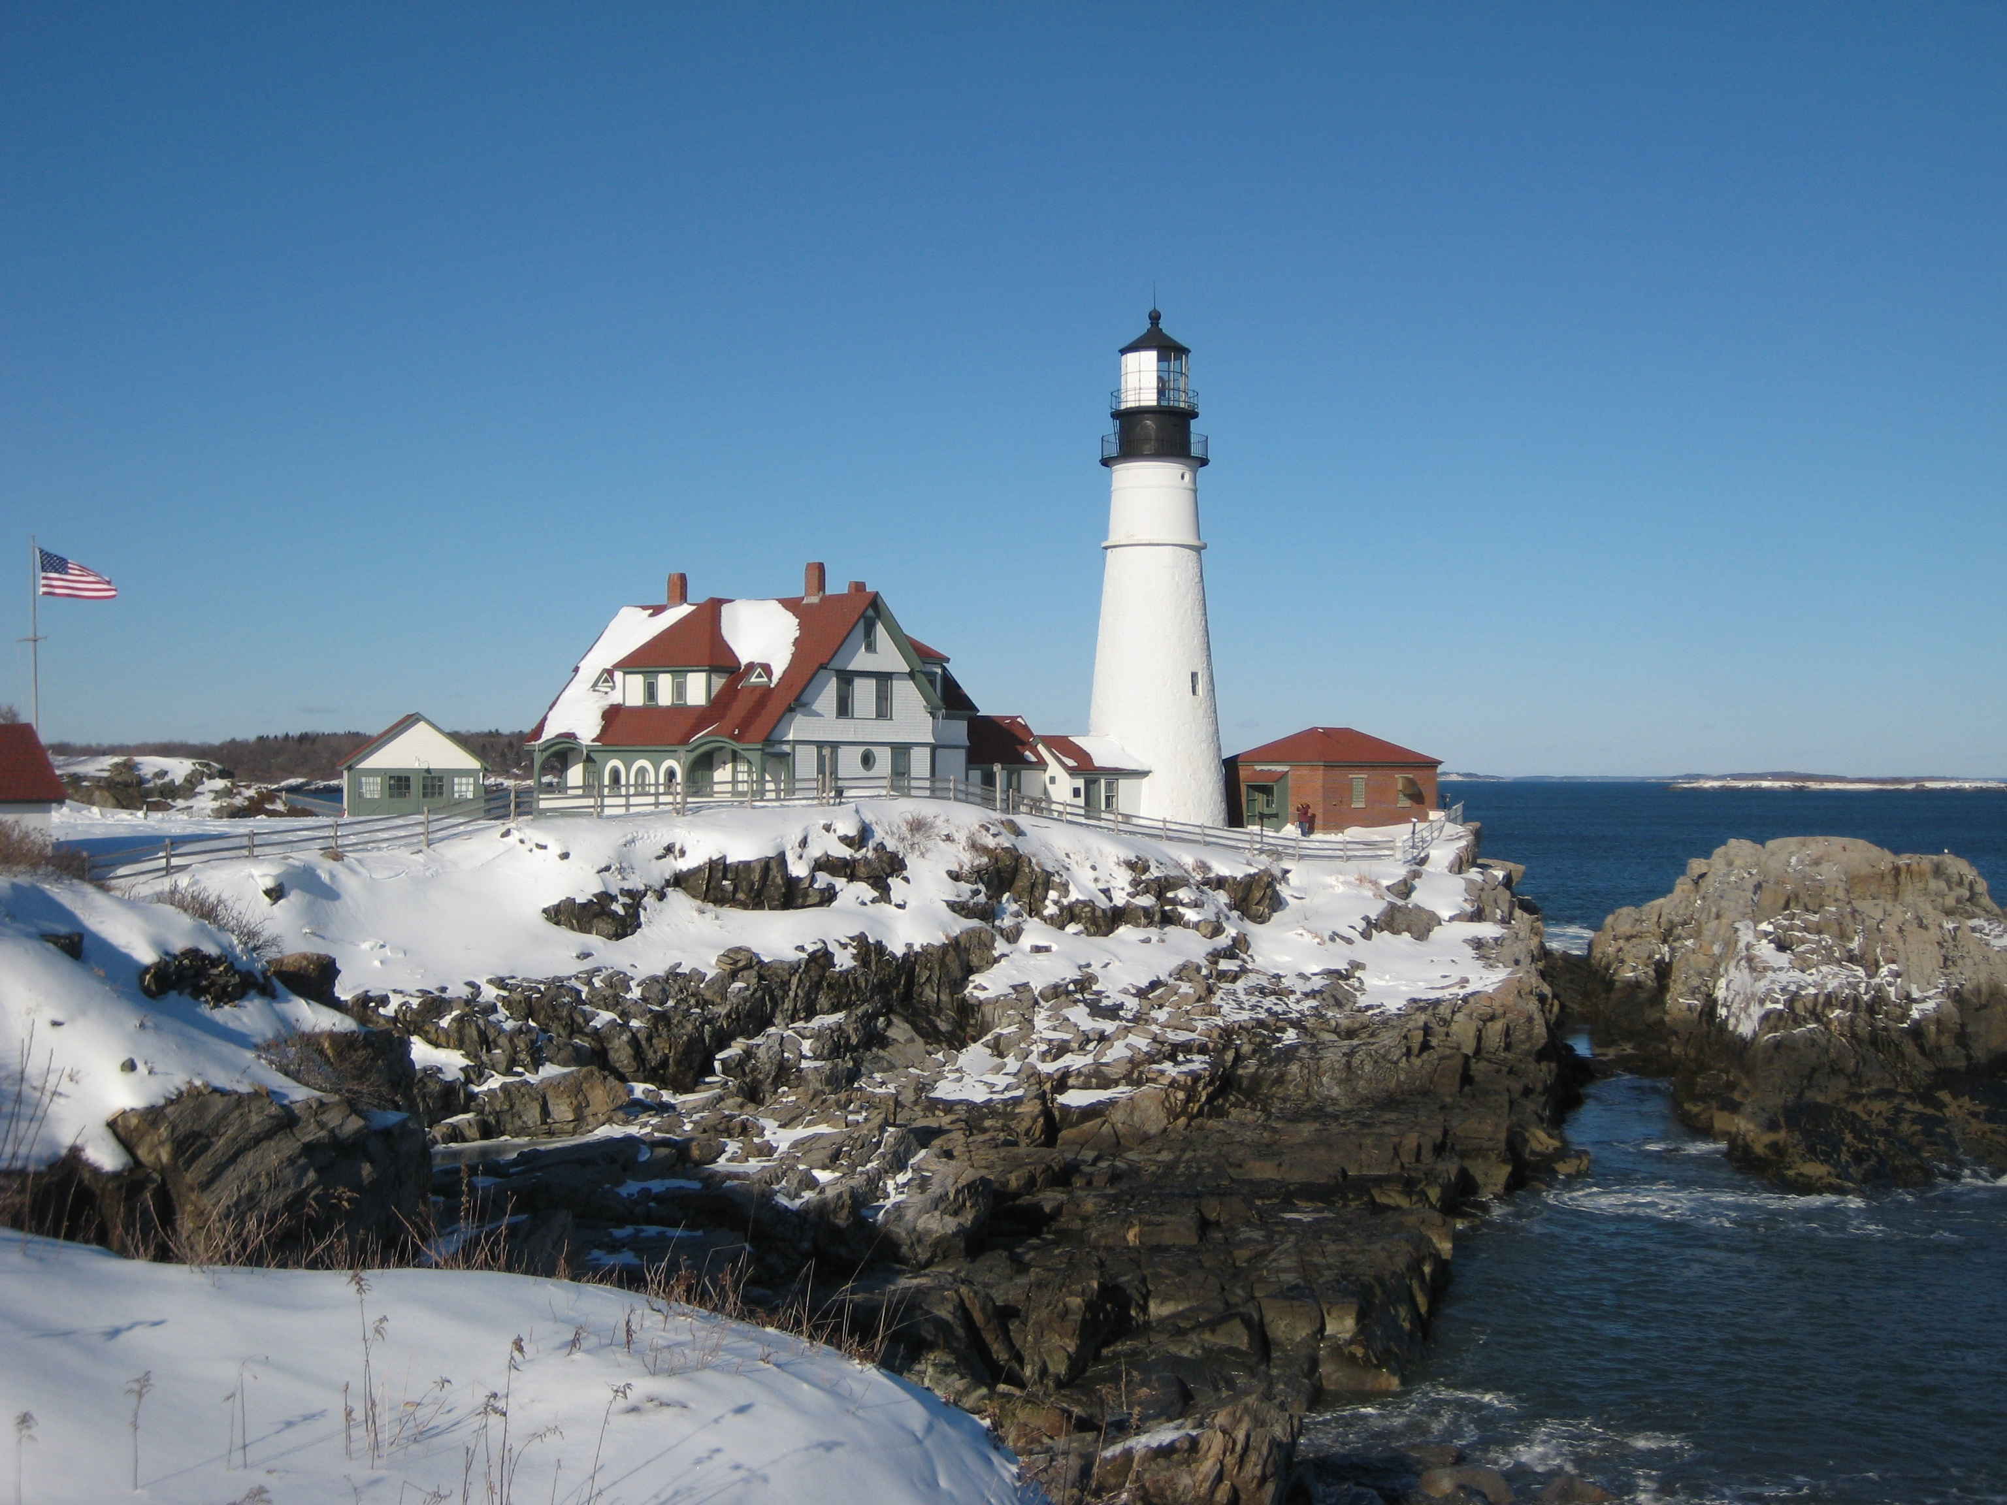
Thank you to all of our Presenters/Speakers:

- Chalene Swink, MPH,REHS/RS-Town Sanitarian
- Porcia Bennett,LPN,CWN
- Kathleen Peterson, Community Safety Educator
- Spencer Bauch, Certified Fire Marshall
- Faron Boreham,Executive Administrator
- Thomas Harris,Executive Administrator

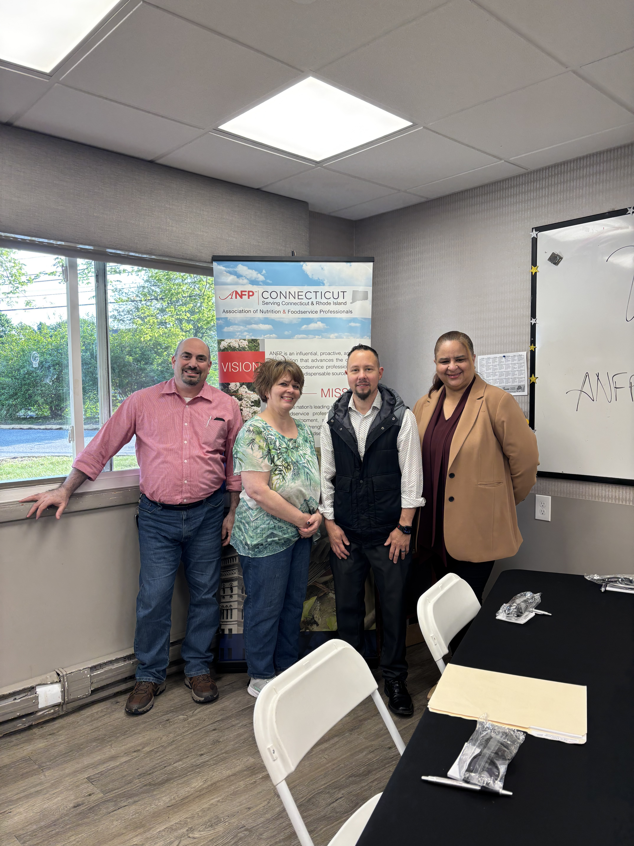 | Meet the SNEC Board Members:  Paul DeMaida,CDM,CFPP-State Treasurer  Hunter Merrill,CDM,CFPP-State Newsletter  Editor  Terra Land,CDM,CFPP-State Secretary  Amarilys Saluk CDM,CFPP, State President

