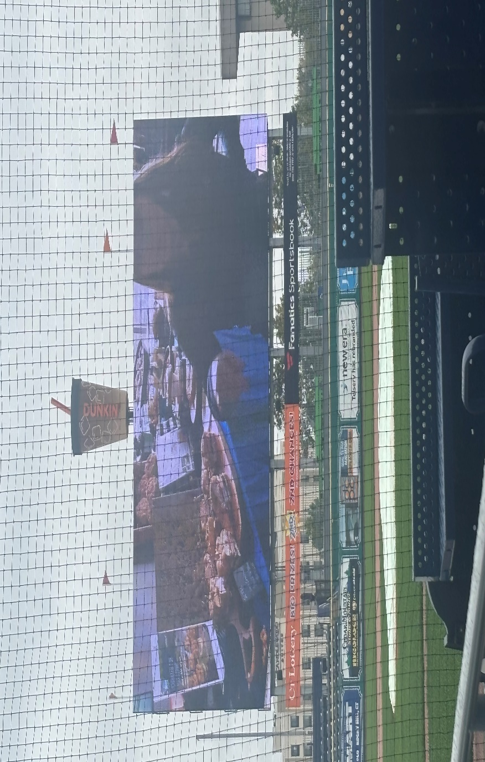
Save The Date!! Tuesday March 3, 2026

Southern New England Spring Meeting/Food Show & Expo!!

Location:
Dunkin Park
1214 Main Street, Hartford, CT 06103
Stay Tuned for the Exciting Agenda!!!!

