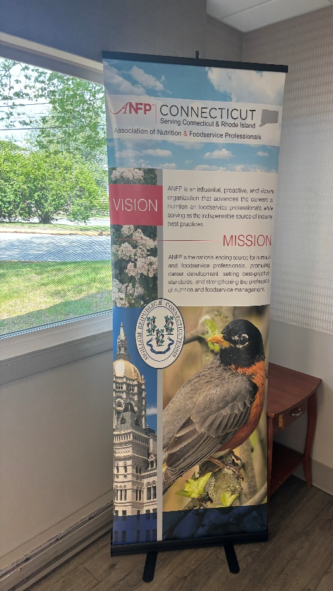
Greeting from the President’s Desk,
My name is Amarilys Saluk, President of the SNEC Chapter. It is an honor to serve you.
Our Spring Meeting concluded with excellent speakers and great food, though we missed your presence. We thank those who continue to support us.
We aim to provide our members with the best continuing education available.
Please join us on Tuesday October 7, 2025 for our Fall Meeting. The Venue for this event TBD.
The Board of Directors and I look forward to spending time with you.
Feel free to contact me if you have any questions at amarilyssaluk@gmail.com.

Warm Regards,

Amarilys Saluk,CDM,CFPP
SNEC President

