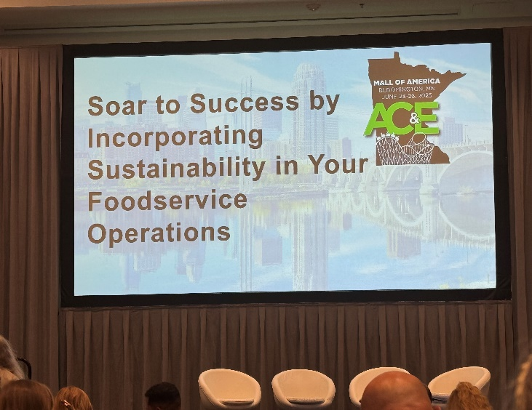

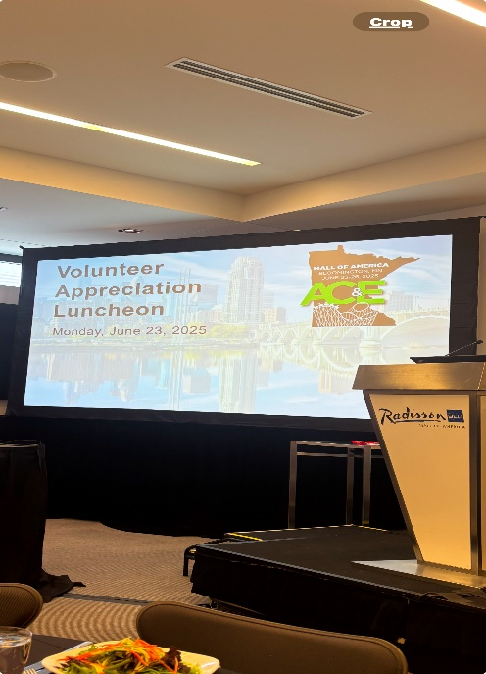
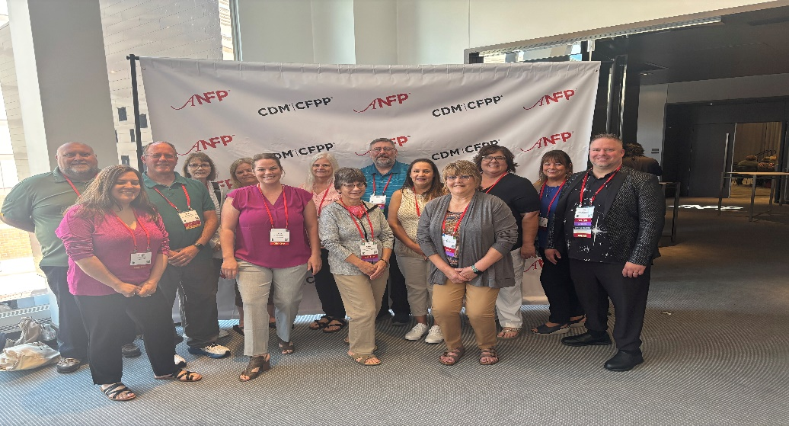
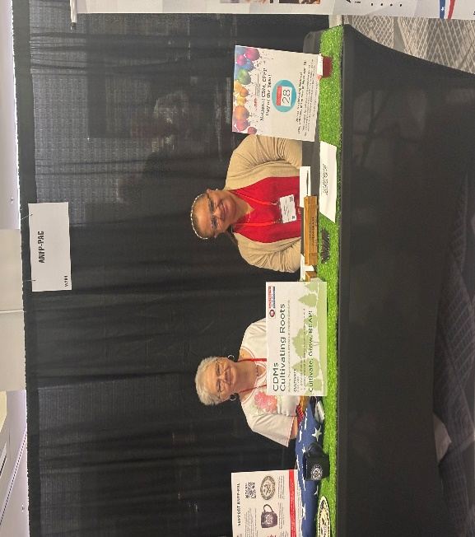
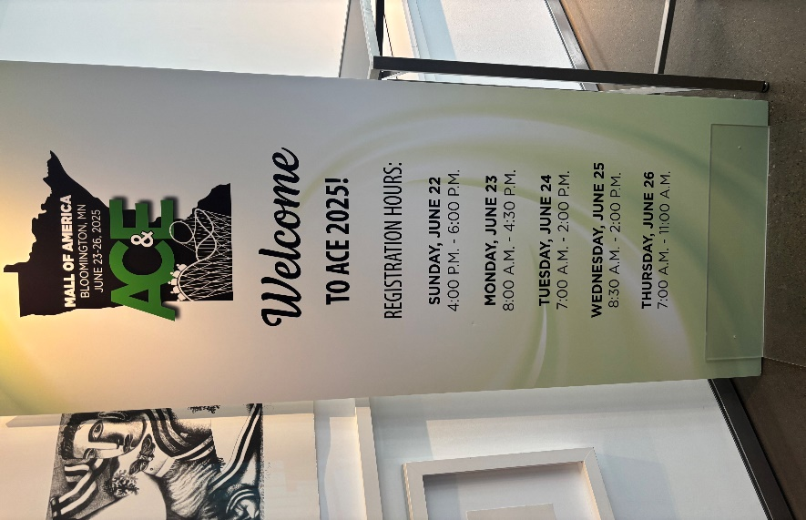
ACE Blazer Twinsies!!! 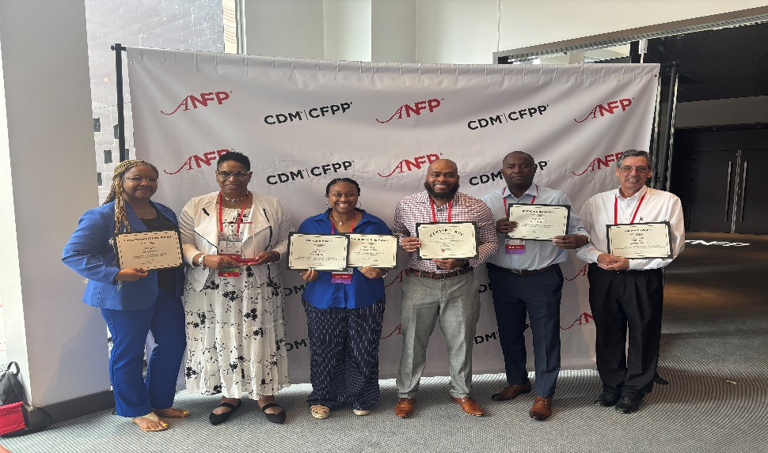 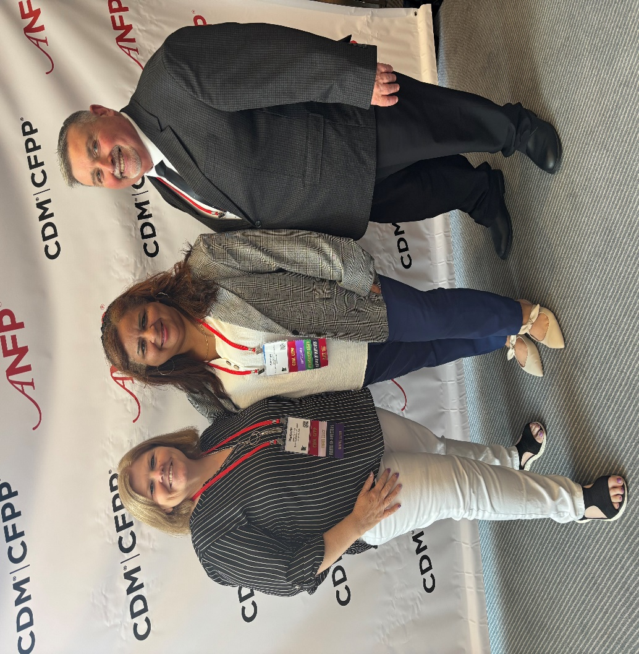 The Three Amigos!!! Minnesota, Southern New England & Texas what a Combo!!
Ace Minnesota
What an Experience!!!
Atlanta’s Chapter Champs!!
Smiling Faces at ACE!!!
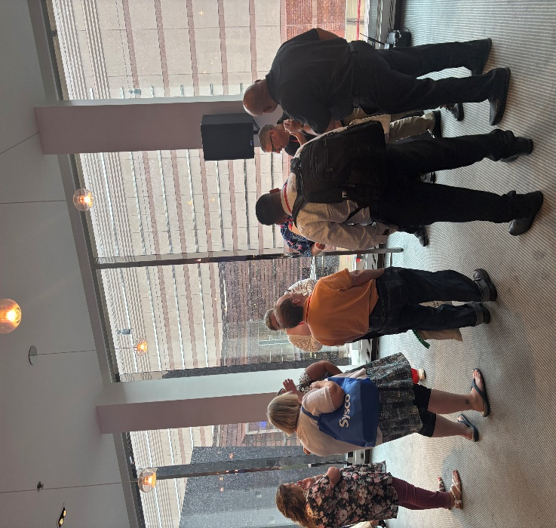
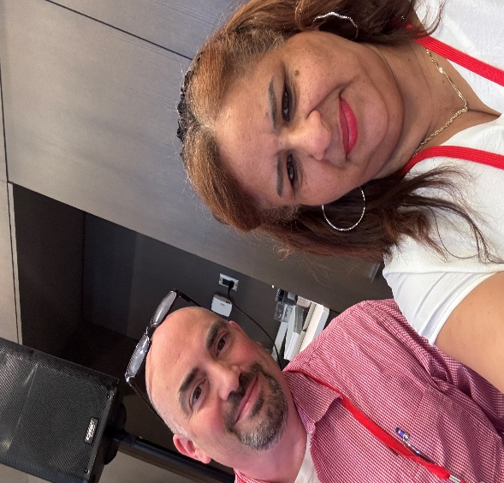
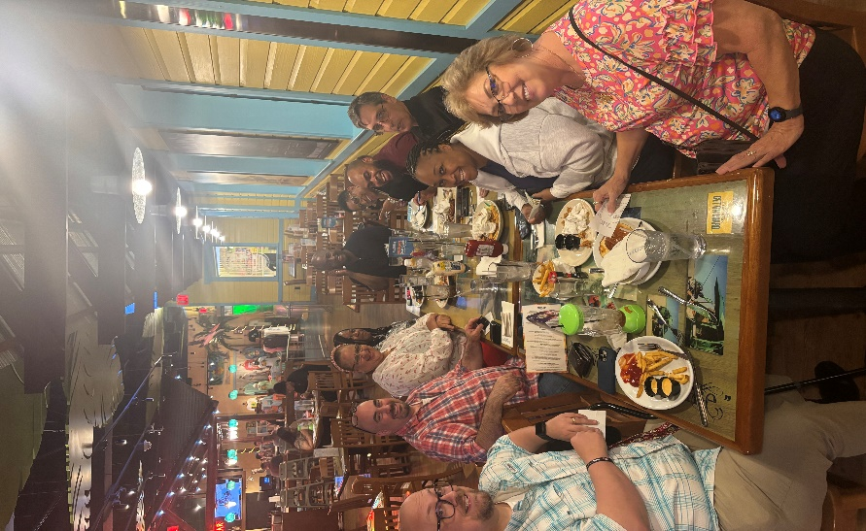
SNEC Chapter President and Treasurer Amarilys & Paul Representing Southern New England at ACE 2025!

2 Great Chapters having Dinner and Networking
SNEC & Atlanta!!!
Networking at it’s Best! So Many New Faces!!

