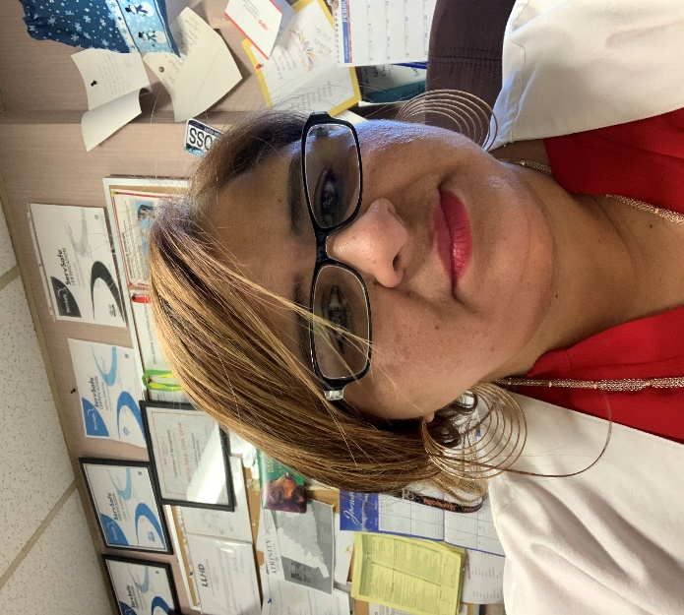




amarilyssaluk@gmail.com
New London Rehab
88 Clark Lane, Waterford, CT 06385
860-501-2256

AmarilysSaluk,CDM,CFPP

A Note from your President:
Dear Members,
I would like to take a moment to introduce myself, especially to those who have recently joined our amazing chapter. My name is Amarilys Saluk, and I am the President of the SNEC Chapter (Southern New England Chapter). Welcome we are excited to have you as part of our community!
I would also like to share a few reminders about our upcoming Spring Meeting on Tuesday, March 3, 2026. The meeting will be held at Dunkin’ Donuts Park in Hartford, Connecticut, and will feature an engaging Food Show along with outstanding presenters. Our goal is to continue providing our members with the highest quality continuing education opportunities available.
The Board of Directors and I truly look forward to welcoming you to our Spring Meeting. Please stay tuned for the finalized agenda and additional details regarding this exciting event.
If you have any questions in the meantime, feel free to contact me using the information below.
We look forward to seeing everyone this spring!
Warm Regards,
Amarilys Saluk
President, SNEC Chapter (Southern New England Chapter)

