FALL HEALTHCARE SEMINAR 2025
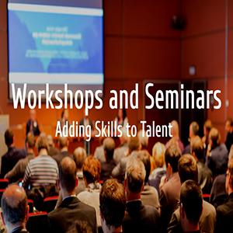


Please fill in this form for a free ticket to 6.5 CEUS, raffle prizes, networking and learning opportunities, and product demonstrations.
Registration Form
FRIDAY, OCTOBER 3, 2025
Sysco Food Services of San Francisco, Inc - 5900 Stewart Ave, Fremont, CA 94538
FREE 6.5 CEU for CDM applied
SPACE IS LIMITED RESERVE YOUR SEAT!
(Awaiting CBDM prior approval)

Name____________________________________Member #____________________________
Address_______________________________________________________________________
Phone_______________________________Email_____________________________________
Employer_______________________________________

Email this form to Karmen.kortie@gmail.com
Questions? Text 916-761-2567

