“CDM’s…the food and nutrition experts”

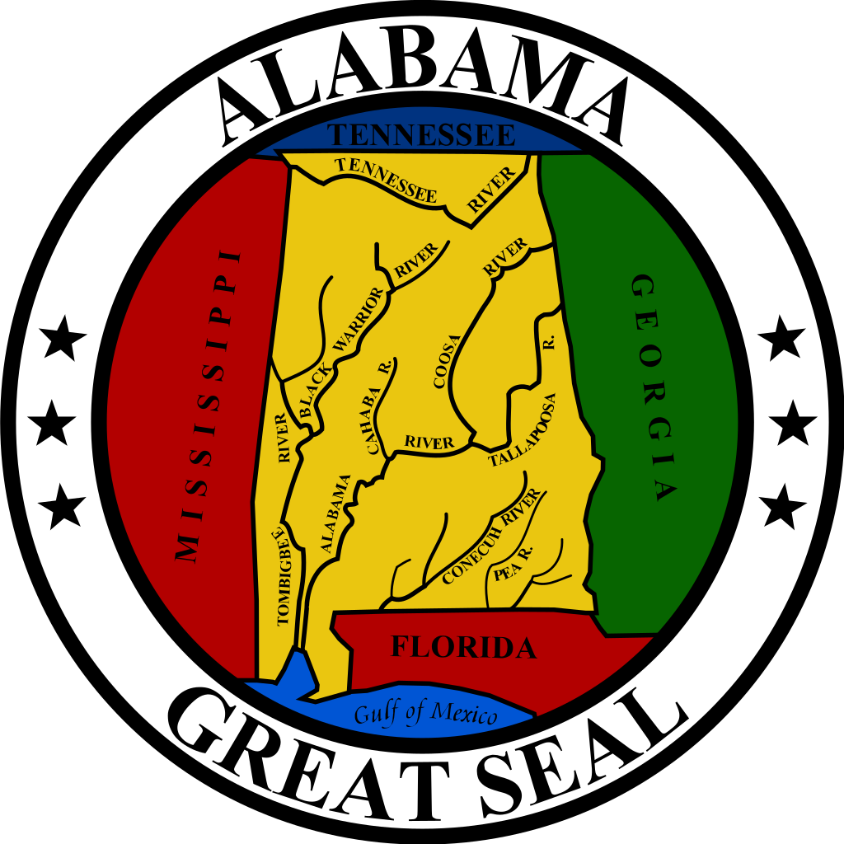

Alabama ANFP
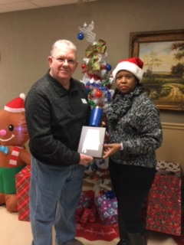
January 2020 Newsletter

Hello and Happy 2020 AL ANFP members!
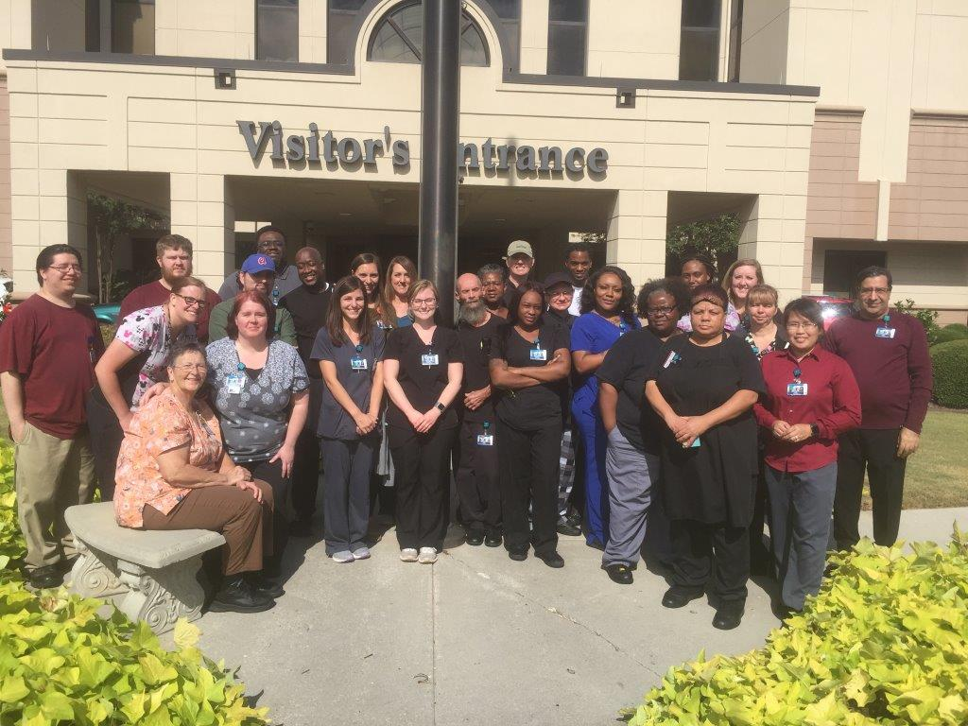
Since our last conference we’ve celebrated National Healthcare Food Service Appreciation Week and I received a picture from one of our members. Thank you, Lloyd Morrow, for sharing a picture of your team from the Crestwood Medical Centers Food Service Department.
Your executive board continued planning the Spring conference.

I’m happy to report, I completed unfinished business. Our Administrator of the Year, Mr. Barry Bell, couldn’t make it to our Fall Conference/Meeting in September, on the campus of Auburn University. Mr. Bell is the Administrator at Brookshire Healthcare Center, in Huntsville, Alabama. Mr. Bell was nominated by Angela Mims for his unwavering support and dedication to her and her nutrition department. Thank you, Mr. Bell and thank you Angela for highlighting his efforts.

I hope you all spent time with family and friends during the holidays.

Our Spring Conference/Meeting will be here before you know it. Our date is February 26-28, 2020 in Montgomery, AL. You should have received the agenda and registration in your email. I hope you will all plan to attend.

Before we get together, make sure your take time to strut your stuff, February 3-7, Pride in Foodservice Week. Please email me some pictures of your team and I’ll share them at our conference.

FYI, our National Organization, ANFP, is celebrating 60 years!!!! Make sure you checkout their website to see all the things they have to offer.

We are always looking for volunteers to assist us with our state responsibilities and ways to improve. Please let me know if you are interested or have ways to make us better.

Bionca Lindsey, President, AL ANFP

