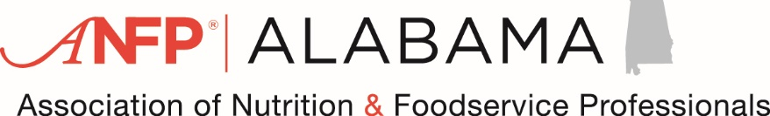

2025 Fall Conference Agenda
Chasing Sunsets and Dreams…CDMs, are the Food and Nutrition Experts
Fairfield Inn & Suites Orange Beach
3111 Loop Rd Orange Beach, Alabama, USA, 36561

Wednesday, September 17, 2025
3:00 pm-3:30 pm Finance Meeting-LaTasha Allen-President-Elect, CDM, CFPP
3:30 pm-4:00 pm Board Meeting-Blake Williams, President, CDM, CFPP
4:00 pm – until Board Members assembled folders, bags, and other items for Conference.

Day One, Thursday, September 18, 2025
6:30-8:00 am Breakfast (Hotel)
8:00-8:30 am Registration
8:45-9:00 am Welcome-Blake Willams, President, CDM, CFPP
9:00-10:00 am Let Me Show You Something, the Importance of Demonstration and Repetition in Training (1)
10:00-11:30 am Implementing IDDS at Facility, Sandra Baker, MS, RDN, LDN (1.5)
11:30-12:00 pm Let’s play Kahoot and find out…Who knows their sanitation Standards? (5) Sanitation

Day Two, Friday, September 19, 2025
7:45-8:00 am Welcome – Blake Williams, President, CDM, CFPP
8:00-9:00 am – What’s new with ANFP? Regina St. Clair, CDM CFPP (1)
9:00-10:00 am – Giving yourself a fresh start-Heather Harbert, CDM, CFPP (1)
10:00-11:00 am – Surfing the Seas of Sanitation in a Food Service Operation. (1) Sanitation

Total Conference CEUS: General – 3.5 Sanitation -1.5 = 6

We hope you have enjoyed this conference and hope you will attend again.
Have a safe trip! See you next year!

