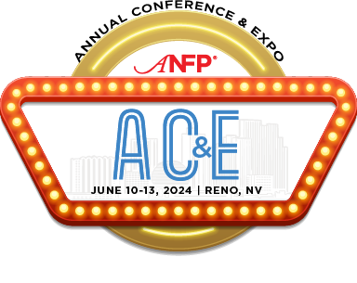
To:

From:
Subject: ANFP Annual Conference & Expo Registration Request

Dear [Insert Supervisor Name],

I am requesting approval to attend the ANFP Annual Conference & Expo (ACE), taking place June 10-13, 2024, in Reno, NV. This three-day event includes education sessions, an expo with the industry’s most relevant vendors, and various networking events, all intended to help foodservice professionals achieve success in their workplace.

The ANFP Annual Conference is the premier conference for learning the latest foodservice trends from some of the industry’s top experts. The 2024 agenda includes several education sessions on various relevant topics. I am particularly interested in the following education topics: [education session title], [education session title], and [education session title]. I have the opportunity to receive hours of continuing education credits for attending ACE, towards maintenance of my CDM, CFPP credential.

Attending this conference will include registration fees plus travel and hotel expenses.

I would love the opportunity to bring back the ideas and knowledge I gained from ACE to enhance our operations, and will provide you with a post-conference summary that we could discuss.

You can learn more about the ANFP Annual Conference at www.ANFPonline.org/ACE24.

Thank you for considering this request.

Sincerely,

