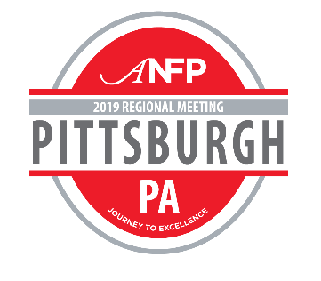

To:

From:
Subject: ANFP Regional Meeting Registration Request

Dear [Insert Supervisor Name],

I am requesting approval to attend the ANFP Spring Regional Meeting, taking place April 4-5, 2019 in Pittsburgh, PA. This two-day event includes education sessions, a one-hour expo with the industry’s most relevant vendors, and two networking events, all intended to help foodservice professionals learn helpful knowledge to bring back to their workplace.

The 2019 agenda includes nine education sessions on topics including zero-deficiency surveys, food safety, food allergies, leadership skills, and more. The meeting will also feature a chef demo! I am particularly interested in the following education sessions: [education session title], [education session title], and [education session title]. For attending this meeting, I will receive up to 13 hours of continuing education credits towards maintenance of my CDM, CFPP credential.

Attending this meeting will include registration fees plus travel and hotel expenses. Registration to this event is discounted if I register by the priority deadline of March 14, 2019.

I would love the opportunity to bring back the ideas and knowledge I gained from this meeting to enhance our operations and will provide you with a post-meeting summary that we could discuss.

You can learn more about the Spring Regional Meeting in Pittsburgh at www.ANFPonline.org/pittsburgh.

Thank you for considering this request.

Sincerely,

