**How to Pull a Chapter Roster**

1. Login to [www.ANFPonline.org](http://www.ANFPonline.org). Then, go to View Profile.
2. On the right-hand side of the screen a menu will appear. Click Chapter Portal on right side. (If you do not see this option, contact Abigail at 800.323.1908 x123.)



1. Then, Choose Roster tab.

1. Use “filter results” button” if you want to see only those registered for an event, in one city, etc.
2. For a full roster, that includes all members of the chapter, scroll to the bottom of the page and click on the button titled ‘Export this List’.
3. Once you push the export button, the following pop-up box will appear. (No information will need to be entered.) Click ‘Go’

An Excel spreadsheet will automatically download in the same window. Double click to open the spreadsheet which will appear as below.

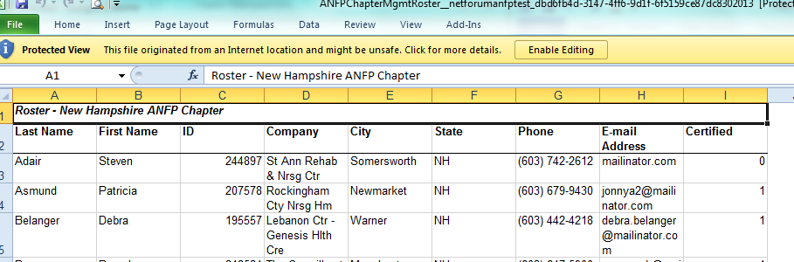

Filter the results as needed.