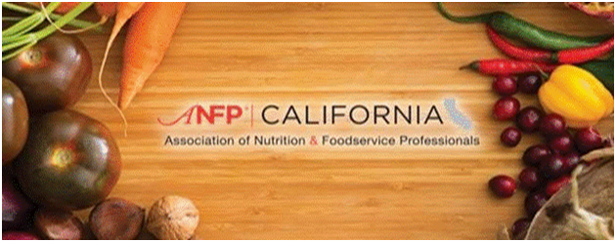

**SPRING SEMINAR**

**WHEN: Friday April 20, 2018**

**WHERE:** **US Foods - 300 Lawrence Dr. Livermore, CA 94551**

**EARN**

**12 CEU's for CDM's**

**&**

**12 CPE's for RDN, NDTR**

(Awaiting CBDM & CDR prior approval)

**We are bringing you the hottest topics!**

**Things you need to know NOW!**

**THE LINE UP:**

**Linda Handy MS RD CA (Retired) State Surveyor Author, Consultant**

**HOT OFF THE PRESS: NEW INFO & NEW MANUAL**

3 Main Objectives: Participants will be able to:

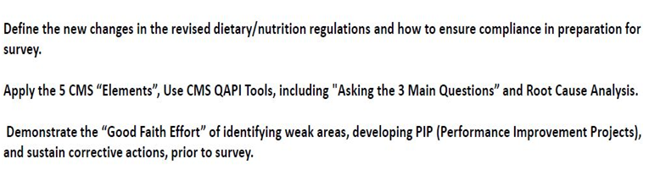

--------------------------------

**Jo Miller, MPH RD - Meals For All:**

**New Disaster Regulations and Planning**

--------------------------------

**Karmen Kortie CDM: Simply Thick**

**IDDSI in-depth and informative: Including hands on demo!**

--------------------------------

**Christi Krueger MS RD:**

**Employee Competencies**

**---------------->REGISTRATION FORM ATTACHED<------------------------------**

**If you have any questions please contact:**[**jsosoren@gmail.com**](mailto:jsosoren@gmail.com)