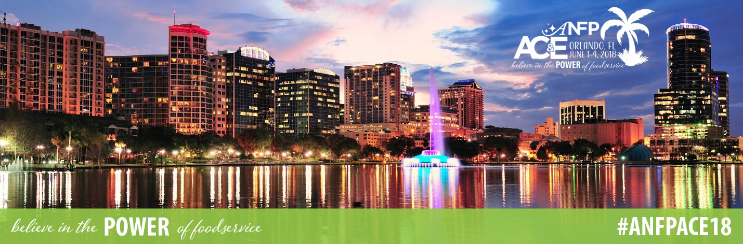

To:

From:
Subject: ANFP Annual Conference & Expo Registration Request

Dear [Insert Supervisor Name],

I am requesting approval to attend the ANFP Annual Conference & Expo (ACE), taking place June 1-4, 2018 in Orlando, FL. This four-day event includes education sessions, a three-hour expo with the industry’s most relevant vendors, and various networking events, all intended to help foodservice professionals achieve stellar outcomes in their workplace.

The ANFP Annual Conference is the premier conference for learning the latest foodservice trends from some of the industry’s top experts. The 2018 agenda includes more than 15 education sessions on topics including food safety & sanitation, management skills, regulations, person-centered dining, professional competency, culinary, kitchen design, and much more. I am particularly interested in the following education sessions: [education session title], [education session title], and [education session title]. I will receive up to 20 hours of continuing education credits for attending ACE, towards maintenance of my CDM, CFPP credential.

Attending this conference will include registration fees plus travel and hotel expenses. Registration to this event is discounted if I register by the priority deadline. The conference hotel has a discounted rate of $169/night, which is available until Monday, May 21, 2018.

I would love the opportunity to bring back the ideas and knowledge I gained from ACE to enhance our operations, and will provide you with a post-conference summary that we could discuss.

You can learn more about the ANFP Annual Conference at www.ANFPonline.org/ACE18.

Thank you for considering this request.

Sincerely,

