Texas ANFP
Fall Workshop
October 25-27, 2017
Sysco Food Service
10710 Greens Crossing Blvd.
Houston, TX 77038

“Who’s Gonna Fill Their Shoes”

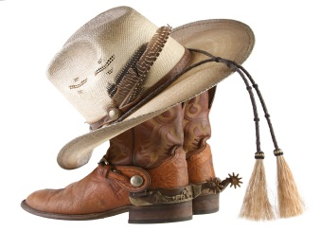

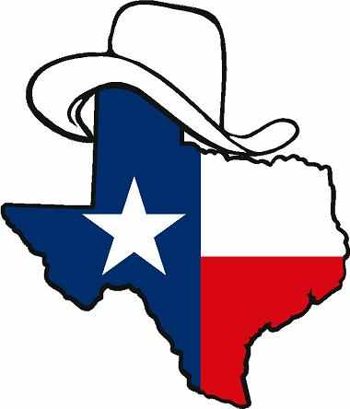
Hotel Information
Tell them you are with “TX ANFP”
Hilton Garden Inn Houston Cypress 160 Wagon Point Houston, TX 77090 281-929-0111
$99.00 night - Single/Double
Breakfast Included
Cutoff is October 10, 2017

TX ANFP Workshop Registration

Name: ________________________________

Address: ______________________________

City/State/Zip: __________________________

Phone #: ______________________________

Member #: _____________________________

Email: _________________________________

Registration Fee Pre-Register On-Site
( ) ANFP Member $60.00 $70.00

( ) Non-Member $70.00 $80.00

( ) Retired Member $45.00 $50.00

( ) Student $40.00 $50.00

( ) First Time to attend a state workshop ($20 discount coupon) $40.00 $50.00

Service project donation:
( ) Rise Against Hunger $30.00 or $ ______
(any amount you would like)

Total Enclosed $ ________________________

Make Checks or Money Orders Payable:
TX ANFP

Send Payment & Registration form to:
Mary Valdez CDM, CFPP
722 Drexel Dr.
Corpus Christi, TX 78412

Pre-registration deadline September 21st
Workshop Contact - Ken Owens CDM, CFPP 281-404-1037 Ken.Owens@uhsinc.com

TX ANFP FALL WORKSHOP
Wednesday, October 25, 2017
Sysco Food Service Meeting Room

11am- 5pm Registration

11:30am Welcome – President

12pm – 1:30 “CDM Legacy - Where Are My Shoes?” Ken Owens CDM, CFPP
Director Food Service, Kingwood Pines Hospital

1:30pm - 2:30 “Knowing Quality – Don’t
Settle For Less”
Dennis Clifford
Produce Manager,
Sysco / FreshPoint - Houston

2:30pm - 3pm Break / Table Networking

3pm – 4pm “Food Safety in the Age of Social Media”
Dave Chaney CP-FS PCQI
Ecolab

4pm – 5pm Officer / Committee Training

5pm – 6pm Board of Directors Meeting

6pm – 9pm Reception

Hilton Garden Inn hosted by District 4
Food, Fun & Games!

*Sysco is a smoke free facility.
You must go to the street to smoke.
Thank you for abiding by their policy!
TX ANFP FALL WORKSHOP
Thursday, October 26, 2017
Sysco Food Service Meeting Room

7:30am-12pm Registration
8am Welcome – President
8:15am – 9:45am “Inspirational Leadership” John Forsythe BBA Regional Manager, Basic American Foods

9:45am – 10am Break
10am – 11:30am “The Exceptional Cranberry – A Nutritional Approach to Fighting Infection”
Lori A. Kaley MS, RDN, LD, MSB
11:30am Lunch - Provided by General Mills & Hormel
12pm – 2pm Vendor Show (next door)
2pm – 3pm “Rise Against Hunger Presentation” Mike Bell, Program Manager Rise Against Hunger, Houston, Texas

3pm – 5:30pm “Rise Against Hunger” work project packing meals for those in need. Goal is 10,000

TX ANFP FALL WORKSHOP
Friday, October 27, 2017
Sysco Food Service Meeting Room

7:30am-9am Registration
8am Welcome – President
8:15am – 9:45am “Quality, Sustainability, Traceability” Greg East, Seafood Specialist, Sysco Houston
9:45am – 10am Break
10am – 11:30am “Books Are Just the Beginning” Marianne Pack RD/LD, Consultant Dietitian, KPH
11:30am Lunch – Provided by Affinity Group Synergy, Jil Strickland
12pm – 1:15pm Business Meeting
1:30pm – 3pm “Someone Filled My Shoes” Carol Persinger (Retired CDM, CFPP)
3pm Door Prizes, Raffle Drawing & Adjourn

Requested 14 CE’s
(11 General, 1 Sanitation, 2 Food Show)

