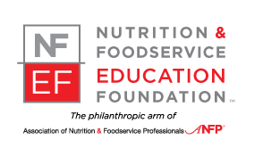
Nutrition & Foodservice Education Foundation
Corporate Sponsor Recognition Program
Every gift, no matter the size, is critical. Thank you for your support of the Foundation.

Pinnacle Level - $10,000+
Recognition on NFEF Home Page Banner
Recognition in Edge Magazine
Recognition on Donor Wall at ACE
Recognition on Foundation Website Donors Page
Recognition in Annual Report
X-Large Brick on Foundation Walkway (1st year)

Visionary Level - $5,000 - $9,999
Recognition in Edge Magazine
Recognition on Donor Wall at ACE
Recognition on Foundation Website Donors Page
Recognition in Annual Report
Large Brick on Foundation Walkway (1st year)

Patron Level - $1,000 - $4,999
Recognition in Edge Magazine
Recognition on Donor Wall at ACE
Recognition on Foundation Website Donors Page
Recognition in Annual Report
Standard Brick on Foundation Walkway (1st year)

Friend Level - $250 - $999
Recognition in Edge Magazine
Recognition on Donor Wall at ACE
Recognition on Foundation Website Donors Page
Recognition in Annual Report

Donor Level - $1 - $249
Recognition in Edge Magazine
Recognition on Foundation Website Donors Page
Recognition in Annual Report

Nutrition & Foodservice Education Foundation | 406 Surrey Woods Dr., Saint Charles, IL 60174
(P) 630.587.6336 (F) 630.587.6308 | E-mail: nfef@ANFPonline.org.

